Moonachie School District
Mathematics Curriculum:
Grade 4

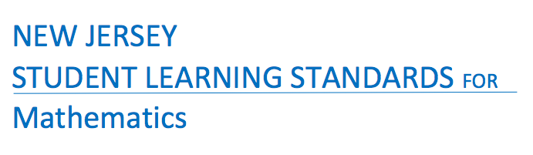

Born On & Board Approved: July 25, 2017
Re-Adopted: August 23, 2022

The following maps outline the New Jersey Student Learning Standards for grade four mathematics determined by the State Standards Initiative. Below is a list of assessment tools that are recommended for tracking student progress in these areas. In addition, resources that can be used in conjunction with instruction of these standards are provided but not limited to the list below.

Assessment:
Formative Assessment Class-Work Review
Open-Ended Problems Project-Based Assessment
Self-Assessment Timed Drills
Teacher Observation End of Year Assessment
Benchmark Assessment Math Software (ex. Study Island)
Homework Review Group & Cooperative Work
Summative Assessment

Resources: _
Counters (variety) Tangrams Protractors
Flashcards Ten Frame Geometric Shapes
Math Word Wall Blocks Geo-Board
Connecting Cubes Calendar Textbooks
Number Line 100 Chart Attribute Blocks
Work Mats Math Songs/Poems Craft Sticks
Computer Software Calculators Wiki-Sticks
Interactive White Board Money/Coins Pattern Blocks
Flannel Board Measurement Tools Three Dimensional Shapes
Center Games Rulers Fraction Tiles
Concrete Objects Bar Models Math/Pocket Charts
Mini White Boards Base Ten Blocks
Manipulatives Math Journals

Websites:
www.ixl.com _ www.Envision 2020.com www.xtramath.com
www.aplusmath.com www.tenmarks.com www.superteacherworksheets.com
www.brainpop.com www.commoncoresheets.com www.mrnussbaum.com
www.brainpopjr.com www.fun4thebrain.com www.learnzillion.com
www.funbrain.com www.math-play.com www.k6.thinkcentral.com
www.mathplayground.com www.smartexchange.com www. interactivesites.weebly.com/math.html
www.sheppardssoftware.com http://www.k-5mathteachingresources.com
www.songsforteaching.com

References:
http://www.state.nj.us/education/aps/cccs/math/
NJ Technology Standards: http://www.state.nj.us/education/cccs/2014/tech/8.pdf
NJ Career Ready Practices: http://www.state.nj.us/education/aps/cccs/career/

Standards for Mathematical Practice
MP. 1 - Make Sense of problems and persevere in solving them.
MP. 2 - Reason Abstractly and Quantitatively
Mp. 3 - Construct Viable Arguments and Critique the Reasoning of Others
MP. 4 - Model with Mathematics
MP. 5 - Use Appropriate Tools Strategically
MP. 6 - Attend to Precision
MP. 7 - Look for and make use of Structure
MP. 8 - Look for and Express Regularity in Repeated Reasoning

Curriculum Details
Mathematics - Grade 4
Core Materials | Envision 2020 Math, Numbers World
Interdisciplinary Connections | ELA:  NJSLSA.R1 Read closely to determine what the text says explicitly and to make logical inferences and relevant connections from it; cite specific textual evidence when writing or speaking to support conclusions drawn from the text.  RI.4.4. Determine the meaning of general academic and domain-specific words or phrases in a text relevant to grade 4 topic or subject area  RI.4.5 Describe the overall structure (eg. chronology, comparison, cause/effect, problem/solution) of events, ideas, concepts, or information in a text or part of a text.  RI4.7 Interpret information presented visually, orally, or quantitatively (e.g. in charts, graphs, diagrams, timelines, animations, or interactive elements on Web pages) and explain how the information contributes to an understanding of the text in which it appears.  NJSLSA.W2. Write informative/explanatory texts to examine and convey complex ideas and information clearly and accurately through the effective selection, organization, and analysis of content  NJSLSA.L1 Demonstrate command of the conventions of standard English grammar and usage when writing or speaking.  SL.4.3. Identify the reasons and evidence a speaker provides to support particular points  SL.4.6. Differentiate between contexts that call for formal English (e.g. presenting ideas) and situations where informal discourse is appropriate (e.g. small-group discussion); use formal English when appropriate to task and situation
Career Ready Practices | CRP2. Apply appropriate academic and technical skills.  CRP4. Communicate clearly and effectively and with reason.  CRP6. Demonstrate creativity and innovation.  CRP7. Employ valid and reliable research strategies.  CRP8. Utilize critical thinking to make sense of problems and persevere in solving them.  CRP12. Work productively in teams while using cultural global competence.
Career Readiness, Life Literacies, and Key Skills | 9.1.5.EG.1: Explain and give examples of what is meant by the term ‘tax’.  9.1.5.EG.2: Describe how tax monies are spent  9.1.5.FP.2: Identify the elements of being a good steward of money.  9.1.5.PB.2: Describe choices consumers have with money (e.g. save, spend, donate).  9.2.5.CAP.1: Evaluate personal likes and dislikes and identify careers that might be suited to personal likes.  9.2.5.CAP.2: Identify how you might like to earn an income.  9.4.5.CT.1: Identify and gather relevant data that will aid in the problem-solving process.  9.4.5.CT.4: Apply critical thinking and problem-solving strategies to different types of problems such as personal, academic, community, and global.
Computer Science and Design Thinking | 8.1.5.DA.1: Collect, organize, and display data in order to highlight relationships or support a claim.  8.1.5.DA.3: Organize and present collected data visually to communicate insights gained from different views of the data.  8.1.5.DA.5: Propose cause and effect relationships, predict outcomes, or communicate ideas using data.  8.2.5.ED.2: Collaborate with peers to collect information, brainstorm to solve a problem, and evaluate all possible solutions to provide the best results with supporting sketches or models.  8.2.5.ED.3: Follow step by step directions to assemble a product or solve a problem, using appropriate tools to accomplish the task.

Math Curriculum: Grade 4
Operations & Algebraic Thinking
Math Standards 4.OA.A.1, 4.OA.A.2, 4.OA.A.3

Essential Question(s): How do we solve problems using the four operations?
Vocabulary: Multiplicative comparison, fact families, quotient, additive comparison, equations, estimation, variable
Content: Operations & Algebraic Thinking
SLS Anchor Standards: A. Use the four operations with whole numbers to solve problems.
SLS: 4.OA.A.1, 4.OA.A.2, 4.OA.A.3
Standards for Mathematical Practice: MP 1, MP 2, MP 4, MP 5, MP 7
Skills | Instructional Procedures |  | Explanations and Examples |  |  | Interdisciplinary Connections
1. Interpret a multiplication equation as a comparison, e.g., interpret 35 = 5 × 7 as a statement that 35 is 5 times as many as 7 and 7 times as many as 5. Represent verbal statements of multiplicative comparisons as multiplication equations.  (MP 2, MP 4) | - Modeling and review arrays  - Construct equations  35=a x 7 or a x 5+35 |  | A multiplicative comparison is a situation in which one quantity is multiplied by a specified number to get another quantity (e.g., “a is n times as much as b”). Students should be able to identify and verbalize which quantity is being multiplied and which number tells how many times. |  |  | Literacy:  Explain in own words/create a definition for multiplicative comparison  Art:  Create visual representations demonstrating multiplicative comparisons
2. Multiply or divide to solve word problems involving multiplicative comparison, e.g., by using drawings and equations with a symbol for the unknown number to represent the problem, distinguishing multiplicative comparison from additive comparison.¹  (MP 1, MP 4, MP 5) | - Construct a visual representation for solving word problems  - Create equations |  | Students need many opportunities to solve contextual problems. Table 2 includes the following multiplication problem:  “A blue hat costs $6. A red hat costs 3 times as much as the blue hat.  How much does the red hat cost?”  In solving this problem, the student should identify $6 as the quantity that is being multiplied by 3. The student should write the problem using a symbol to represent the unknown.  ($6 x 3 = )  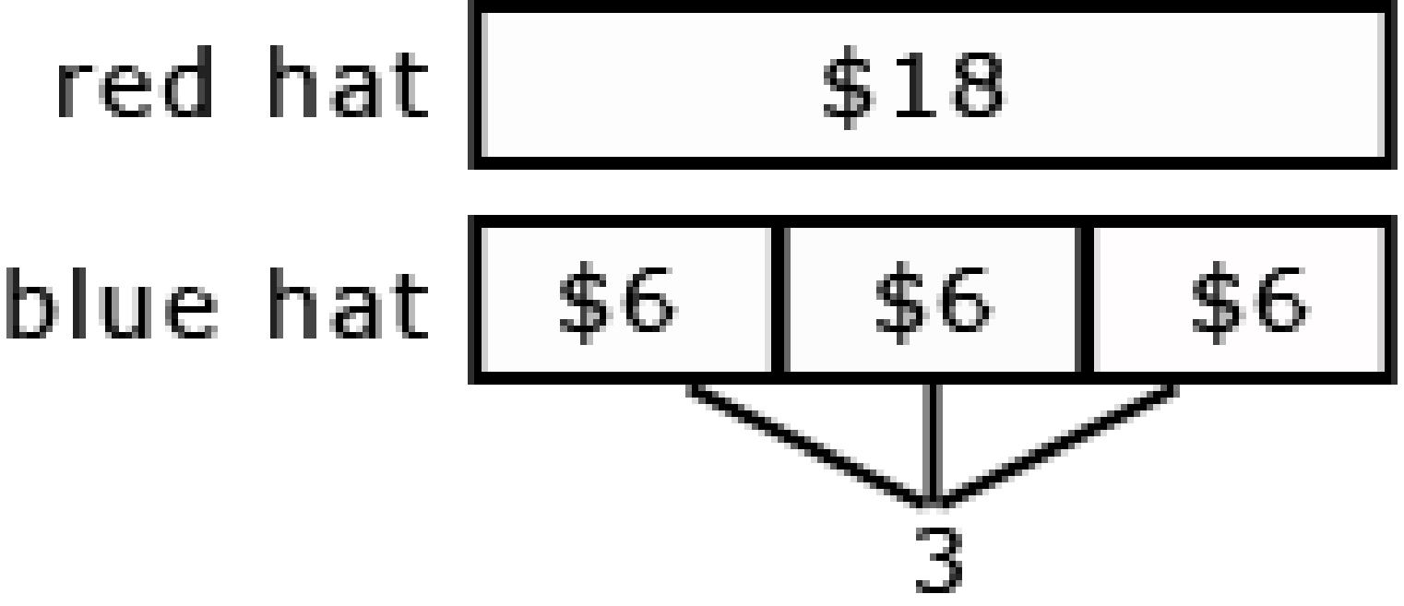  Table 2 includes the following division problem:  A red hat costs $18 and a blue hat costs $6. How many times as much does the red hat cost as the blue hat?  In solving this problem, the student should identify $18 as the quantity being divided into shares of $6.  The student should write the problem using a symbol to represent the unknown. ($18 ÷ $6 = )  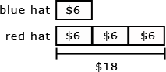  When distinguishing multiplicative comparison from additive comparison, students should note that  - additive comparisons focus on the difference between two quantities (e.g., Deb has 3 apples and Karen has 5 apples. How many more apples does Karen have?). A simple way to remember this is, “How many more?”  multiplicative comparisons focus on comparing two quantities by showing that one quantity is a specified number of times larger or smaller than the other (e.g., Deb ran 3 miles. Karen ran 5 times as many miles as Deb. How many miles did Karen run?). A simple way to remember this is “How many times as much?” or “How many times as many?” |  |  | Literacy:  Create own word problem and solve and have partner solve  Can group by level high with low or high with high etc.
3. Solve multistep word problems posed with whole numbers and having whole-number answers using the four operations, including problems in which remainders must be interpreted. Represent these problems using equations with a letter standing for the unknown quantity. Assess the reasonableness of answers using mental computation and estimation strategies including rounding.  (MP 1, MP 2, MP 4, MP 7) | ∙ Solve word problems using the four operations  ∙ Create visual representations to solve word problems  ∙ Identify when estimation is appropriate and use estimation skills, including rounding |  | Students need many opportunities solving multistep story problems using all four operations.  An interactive whiteboard, document camera, drawings, words, numbers, and/or objects may be used to help solve story problems.  Example:  Chris bought clothes for school. She bought 3 shirts for $12 each and a skirt for $15. How much money did Chris spend on her new school clothes?  3 x $12 + $15 = a  In division problems, the remainder is the whole number left over when as large a multiple of the divisor as possible has been subtracted.  Example:  Kim is making candy bags. There will be 5 pieces of candy in each bag. She had 53 pieces of candy. She ate 14 pieces of candy. How many candy bags can Kim make now?  (7 bags with 4 leftover)  Kim has 28 cookies. She wants to share them equally between herself and 3 friends. How many cookies will each person get?  (7 cookies each) 28 ÷ 4 = a  There are 29 students in one class and 28 students in another class going on a field trip. Each car can hold 5 students. How many cars are needed to get all the students to the field trip?  (12 cars, one possible explanation is 11 cars holding 5 students and the 12th holding the remaining 2 students) 29 + 28 = 11 x 5 + 2  Estimation skills include identifying when estimation is appropriate, determining the level of accuracy needed, selecting the appropriate method of estimation, and verifying solutions or determining the reasonableness of situations using various estimation strategies. Estimation strategies include, but are not limited to:  - front-end estimation with adjusting (using the highest place value and estimating from the front end, making adjustments to the estimate by taking into account the remaining amounts),  - clustering around an average (when the values are close together an average value is selected and multiplied by the number of values to determine an estimate),  - rounding and adjusting (students round down or round up and then adjust their estimate depending on how much the rounding affected the original values),  - using friendly or compatible numbers such as factors (students seek to fit numbers together - e.g., rounding to factors and grouping numbers together that have round sums like 100 or 1000),  - using benchmark numbers that are easy to compute (students select close whole numbers for fractions or decimals to determine an estimate). |  |  | Literacy & Career & Life Skills:  - Have students create and solve word problems using real world problems or scenarios  - Plan for a shopping trip with a certain amount of money
Differentiation/Modifications/Accommodations
Gifted and Talented |  | English Language Learners |  | Students with Disabilities | Students At Risk of School Failure

- Envision 2020 advanced/enrichment practice  - Create multistep real life word problems with answer key  - Solve equations with missing factors, showing all work to reach final answer  - Evaluate a peer’s argument or explanation and provide an alternative solution to the problem | - Using demonstration: (ie: Create three visual representations of the same multiplication or division problem)  - Using manipulatives  - Using small group interactions and peer questioning  - Using pictures and graphic organizers  - Envision 2020 ELL activities  - For more, see http://www.state.nj.us/education/modelcurriculum/ela/ellscaffolding/3u1.pdf | - RTI approaches: prevent misconceptions, error intervention, reteaching set, reteaching worksheets  - Extended time  - Modified assignments  - Small group, alternate location  - Modeling  - Manipulatives  - Video tutorials  - Color coding methods  - Flashcards  - Refer to each student’s IEP for more specific modifications | - Using demonstration: (ie: Create three visual representations of the same multiplication or division problem)  - Using manipulatives  - Using small group interactions and peer questioning  - Using pictures and graphic organizers  - Envision 2020 ELL activities  - Morning tutoring  - After school program  - Parental contact  - Tier II and Tier III Intervention

Math Curriculum: Grade 4
Operations & Algebraic Thinking
Math Standards 4.OA.B.4

Essential Question(s): What are factors, multiples, prime numbers and composites? What are the differences between prime and composite numbers?
Vocabulary: factor, prime composite, squares, square root, multiple, divisibility, array
Content: Operations & Algebraic Thinking
SLS Anchor Standards: B. Gain familiarity with factors and multiples.
SLS Standards: 4.OA.B.4
Standards for Mathematical Practice: MP 2, MP 7, MP 8
Skills | Instructional Procedures | Explanations and Examples | Interdisciplinary Connections
4. Find all factor pairs for a whole number in the range 1–100. Recognize that a whole number is a multiple of each of its factors. Determine whether a given whole number in the range 1–100 is a multiple of a given one-digit number. Determine whether a given whole number in the range 1–100 is prime or composite.  (MP 2, MP 7,  MP 8) | - Find all factor pairs and put in order  - Teach divisibility rule  - Tax Man Game (Prime and composite)  http://www.dsm.fordham.edu/~moniot/taxman.html  - Recognize arrays in the shapes of squares are square numbers whose factors are square root | Students should understand the process of finding factor pairs so they can do this for any number 1 -100,  Example:  Factor pairs for 96: 1 and 96, 2 and 48, 3 and 32, 4 and 24, 6 and 16, 8 and 12.  Multiples can be thought of as the result of skip counting by each of the factors. When skip counting, students should be able to identify the number of factors counted e.g., 5, 10, 15, 20 (there are 4 fives in 20).  Example:  Factors of 24: 1, 2, 3, 4, 6, 8,12, 24  Multiples : 1,2,3,4,5…24  2,4,6,8,10,12,14,16,18,20,22,24  3,6,9,12,15,18,21,24  4,8,12,16,20,24  8,16,24  12,24  24  To determine if a number between1-100 is a multiple of a given one-digit number, some helpful hints include the following:  - all even numbers are multiples of 2  - all even numbers that can be halved twice (with a whole number result) are multiples of 4  - all numbers ending in 0 or 5 are multiples of 5  Prime vs. Composite:  A prime number is a number greater than 1 that has only 2 factors, 1 and itself. Composite numbers have more than 2 factors.  Students investigate whether numbers are prime or composite by  - building rectangles (arrays) with the given area and finding which numbers have more than two rectangles (e.g. 7 can be made into only 2 rectangles, 1 x 7 and 7 x 1, therefore it is a prime number)  finding factors of the number | Art:  ∙Create factor trees  ∙Create poster of key words indicating estimations is necessary  Physical Education:  ∙Create human arrays to find prime and composite numbers  Social Studies:  ∙Use NJ statistics to pull whole numbers for students to factor  Ex. NJ has 21 counties, 40 legislative districts, etc.

Differentiation/Modifications/Accommodations
Gifted and Talented | English Language Learners | Students with Disabilities | Students At Risk of School Failure

- Envision 2020 advanced/enrichment practice  - Play “Swat the Prime” students will create 20 prime and composite numbers on individual index cards. On student is the swatter the other is the dealer. The dealer will turn over two cards and the swatter has 3 seconds to swat the prime. If they get it correct, they keep swatting. If not they switch.  - Factor game – provide students with three dice and a cup. Students will shake and roll to create a 3-digit number in order to factor it.  - A group of 3 students will be given a 5-digit number on a storm cloud that they must factor. Any prime number within the factorization must be placed on a single lightning bolt. Any composite numbers will be placed on raindrops. | - Using demonstration: (ie: Create three visual representations of the same multiplication or division problem)  - Using manipulatives  - Using small group interactions and peer questioning  - Using pictures and graphic organizers  - Envision 2020 ELL activities  - For more, see http://www.state.nj.us/education/modelcurriculum/ela/ellscaffolding/3u1.pdf | - RTI approaches: prevent misconceptions, error intervention, reteaching set, reteaching worksheets  - Extended time  - Modified assignments  - Small group, alternate location  - Modeling  - Manipulatives  - Video tutorials  - Color coding methods  - Flashcards  - Refer to each student’s IEP for more specific modifications | - Using demonstration: (ie: Create three visual representations of the same multiplication or division problem)  - Using manipulatives  - Using small group interactions and peer questioning  - Using pictures and graphic organizers  - Envision 2020 ELL activities  - Morning tutoring  - After school program  - Parental contact  - Tier II and Tier III Intervention

Math Curriculum: Grade 4
Operations & Algebraic Thinking
Math Standards 4.OA.C.5

Essential Question(s): How do we interpret patterns?
Vocabulary: Input/ output table, consecutive, repeating pattern
Content: Operations & Algebraic Thinking
SLS Anchor Standards: C. Generate and analyze patterns.
SLS Standards: 4.OA.C.5
Standards for Mathematical Practice: MP 8
Skills | Instructional Procedures | Explanations and Examples | Interdisciplinary Connections
5. Generate a number or shape pattern that follows a given rule. Identify apparent features of the pattern that were not explicit in the rule itself. For example, given the rule “Add 3” and the starting number 1, generate terms in the resulting sequence and observe that the terms appear to alternate between odd and even numbers. Explain informally why the numbers will continue to alternate in this way.  (MP 8) | - Create input output table  - Complete pattern and have students explain the patterns using numbers or shapes  - Identify patterns on multiplication chart and 100’s chart | Patterns involving numbers or symbols either repeat or grow. Students need multiple opportunities creating and extending number and shape patterns. Numerical patterns allow students to reinforce facts and develop fluency with operations.  Patterns and rules are related. A pattern is a sequence that repeats the same process over and over. A rule dictates what that process will look like. Students investigate different patterns to find rules, identify features in the patterns, and justify the reason for those features.  Examples:  Pattern Rule Feature(s)  3, 8, 13, 18, 23, 28, … Start with 3, add 5 The numbers alternately end with a 3 or 8  5, 10, 15, 20 … Start with 5, add 5 The numbers are multiples of 5 and end with either 0 or 5. The numbers that end with 5 are products of 5 and an odd number. The numbers that end in 0 are products of 5 and an even number.  After students have identified rules and features from patterns, they need to generate a numerical or shape pattern from a given rule.  Example:  Rule: Starting at 1, create a pattern that starts at 1 and multiplies each number by 3. Stop when you have 6 numbers.  Students write 1, 3, 9, 27, 81, 243. Students notice that all the numbers are odd and that the sums of the digits of the 2 digit numbers are each 9. Some students might investigate this beyond 6 numbers. Another feature to investigate is the patterns in the differences of the numbers (3 - 1 = 2, 9 - 3 = 6, 27 - 9 = 18, etc.) | Create and test input/output table (or shape pattern) that repeats a minimum of 3 times  Science/ Social Studies:  Have students identify patterns in graphs

Differentiation/Modifications/Accommodations
Gifted and Talented | English Language Learners | Students with Disabilities | Students At Risk of School Failure

- Envision 2020 advanced/enrichment practice  - Pattern race: students will roll a dice to determine the rule to follow and the number to start with. They will race against their partner to reach the final answer after 8 missing numbers.  - Create function machine that incorporates two operations  - Function War – students will create playing cards with functions (including all four operations) students will flip a card and the player that has the higher rule wins both cards. (ie: card 1 has input 16 output 25 card 2 has input 8 output 4. Player 1 has a rule of add 9 and wins the hand) | - Using demonstration: (ie: Create three visual representations of the same multiplication or division problem)  - Using manipulatives  - Using small group interactions and peer questioning  - Using pictures and graphic organizers  - Envision 2020 ELL activities  - For more, see http://www.state.nj.us/education/modelcurriculum/ela/ellscaffolding/3u1.pdf | - RTI approaches: prevent misconceptions, error intervention, reteaching set, reteaching worksheets  - Extended time  - Modified assignments  - Small group, alternate location  - Modeling  - Manipulatives  - Video tutorials  - Color coding methods  - Flashcards  - Refer to each student’s IEP for more specific modifications | - Using demonstration: (ie: Create three visual representations of the same multiplication or division problem)  - Using manipulatives  - Using small group interactions and peer questioning  - Using pictures and graphic organizers  - Envision 2020 ELL activities  - Morning tutoring  - After school program  - Parental contact  - Tier II and Tier III Intervention

Math Curriculum: Grade 4
Operations & Algebraic Thinking
Math Standards 4.NBT.A.1, 4.NBT.A.2, 4.NBT.A.3

Essential Question(s): How do you use place value to compare, express and represent numbers?
Vocabulary: word form, standard form, expanded form, digit, greater than, less than, equal, rounding, place value, whole numbers
Content: Numbers and Operations in Base Ten
SLS Anchor Standards: A. Generalize place value understanding for multi-digit whole numbers.
SLS Standards 4.NBT.A.1, 4.NBT.A.2, 4.NBT.A.3
Standards for Mathematical Practice: MP 7
Skills | Instructional Procedures | Explanations and Examples | Interdisciplinary Connections
1. Recognize that in a multi-digit whole number, a digit in one place represents ten times what it represents in the place to its right. For example, recognize that 700 ÷ 70 = 10 by applying concepts of place value and division.  (MP 7) | - Explain and apply why the value of a digit changes when the place value changes | Students should be familiar with and use place value as they work with numbers. Some activities that will help students develop understanding of this standard are:  - Investigate the product of 10 and any number, then justify why the number now has a 0 at the end. (7 x 10 = 70 because 70 represents 7 tens and no ones, 10 x 35 = 350 because the 3 in 350 represents 3 hundreds, which is 10 times as much as 3 tens, and the 5 represents 5 tens, which is 10 times as much as 5 ones.) While students can easily see the pattern of adding a 0 at the end of a number when multiplying by 10, they need to be able to justify why this works.  - Investigate the pattern 6, 60, 600, 6,000, 60,000, 600,000 by dividing each number by the previous number. | Language Arts/ Science:  Partners write a number between 10,000 and 100,000 on an index card and take turns telling a brief science fiction story reading their partners number
2. Read and write multi-digit whole numbers using base-ten numerals, number names, and expanded form. Compare two multi-digit numbers based on meanings of the digits in each place, using >, =, and < symbols to record the results of comparisons.  (MP 7) | - Read, compare and order numbers according to the place value of their digits | The expanded form of 275 is 200 + 70 + 5. Students use place value to compare numbers. For example, in comparing 34,570 and 34,192, a student might say, both numbers have the same value of 10,000s and the same value of 1000s however, the value in the 100s place is different so that is where I would compare the two numbers. | Social Studies:  Display or research city populations. Have students write each number in words and expanded form. Then have them arrange the cities in order from greatest to least population.
3. Use place value understanding to round multi-digit whole numbers to any place.  (MP 7) | - Use knowledge of place value to round multiple digit whole numbers | When students are asked to round large numbers, they first need to identify which digit is in the appropriate place.  Example: Round 76,398 to the nearest 1000.  - Step 1: Since I need to round to the nearest 1000, then the answer is either 76,000 or 77,000.  - Step 2: I know that the halfway point between these two numbers is 76,500.  - Step 3: I see that 76,398 is between 76,000 and 76,500.  Step 4: Therefore, the rounded number would be 76,000. | Extension: Round the city population to a selected place value.

Differentiation/Modifications/Accommodations
Gifted and Talented | English Language Learners | Students with Disabilities | Students At Risk of School Failure

- Envision 2020 advanced/enrichment practice  - Create place value question task cards with answer key  - Create function machine that incorporates two operations  - Place Value War – students will create playing cards up to the ten thousands place. Students will flip cards and the player that has the highest value of the number underlined wins both cards.  - Place Value Match: create visuals that represent a number up to the ten thousands in the following forms: written form, expanded form, visual form and standard form | - Using demonstration: (ie: Create three visual representations of a number up to the hundreds place)  - Using manipulatives  - Visuals  - Ten frames/base ten blocks (the manipulative or smartboard version)  - Using small group interactions and peer questioning  - Using pictures  - Place value charts  - Envision 2020 ELL activities  - For more, see http://www.state.nj.us/education/modelcurriculum/ela/ellscaffolding/3u1.pdf | - RTI approaches: prevent misconceptions, error intervention, reteaching set, reteaching worksheets  - Extended time  - Modified assignments  - Small group, alternate location  - Modeling  - Manipulatives  - Video tutorials  - Color coding/highlighting methods  - Using pictures  - Visuals  - Ten frames/base ten blocks (the manipulative or smartboard version)  - Place value charts  - Refer to each student’s IEP for more specific modifications | - Using demonstration: (ie: Create three visual representations of a number up to the hundreds place)  - Using manipulatives  - Using small group interactions and peer questioning  - Using pictures and  - Envision 2020 ELL activities  - Morning tutoring  - After school program  - Parental contact  - Tier II and Tier III Intervention

Math Curriculum: Grade 4
Operations & Algebraic Thinking
Math Standards 4.NBT.B.4, 4.NBT.B.5, 4.NBT.B.6

Essential Question(s): How do we use properties of operations to multiply and divide? How do you use the standard algorithm to add and subtract with or without regrouping?
Vocabulary: algorithm, array,
Content: Numbers and Operations in Base Ten
SLS Anchor Standards: B. Use place value understanding and properties of operations to perform multi-digit arithmetic.
SLS Standards: 4.NBT.B.4, 4.NBT.B.5, 4.NBT.B.6
Standards for Mathematical Practice: MP 7, MP 8,
Skills | Instructional Procedures | Explanations and Examples | Interdisciplinary Connections
4. Fluently add and subtract multi-digit whole numbers using the standard algorithm.  (MP 7, MP 8) | - Demonstrate your understanding of place value and other strategies to add and subtract all multi-digit whole numbers. | Students build on their understanding of addition and subtraction, their use of place value and their flexibility with multiple strategies to make sense of the standard algorithm. They continue to use place value in describing and justifying the processes they use to add and subtract.  When students begin using the standard algorithm their explanation may be quite lengthy. After much practice with using place value to justify their steps, they will develop fluency with the algorithm. Students should be able to explain why the algorithm works.  3892  + 1567  Student explanation for this problem:  - Two ones plus seven ones is nine ones.  - Nine tens plus six tens is 15 tens.  - I am going to write down five tens and think of the10 tens as one more hundred.(notates with a 1 above the hundreds column)  - Eight hundreds plus five hundreds plus the extra hundred from adding the tens is 14 hundreds.  - I am going to write the four hundreds and think of the 10 hundreds as one more 1000. (notates with a 1 above the thousands column)  - Three thousands plus one thousand plus the extra thousand from the hundreds is five thousand.  3546  - 928  Student explanation for this problem:  - There are not enough ones to take 8 ones from 6 ones so I have to use one ten as 10 ones. Now I have 3 tens and 16 ones. (Marks through the 4 and notates with a 3 above the 4 and writes a 1 above the ones column to be represented as 16 ones.)  - Sixteen ones minus 8 ones is 8 ones. (Writes an 8 in the ones column of answer.)  - Three tens minus 2 tens is one ten. (Writes a 1 in the tens column of answer.)  - There are not enough hundreds to take 9 hundreds from 5 hundreds so I have to use one thousand as 10 hundreds. (Marks through the 3 and notates with a 2 above it. (Writes down a 1 above the hundreds column.) Now I have 2 thousand and 15 hundreds.  - Fifteen hundreds minus 9 hundreds is 6 hundreds. (Writes a 6 in the hundreds column of the answer).  - I have 2 thousands left since I did not have to take away any thousands. (Writes 2 in the thousands place of answer.)  Note: Students should know that it is mathematically possible to subtract a larger number from a smaller number but that their work with whole numbers does not allow this as the difference would result in a negative number. | Social studies:  Choose 3 landmarks within your state, plan a trip to visit all 3 landmarks and calculate the total distance of the trip
5. Multiply a whole number of up to four digits by a one-digit whole number, and multiply two two-digit numbers, using strategies based on place value and the properties of operations. Illustrate and explain the calculation by using equations, rectangular arrays, and/or area models.  (MP 7) | - Use different methods to multiply up to 4 digit numbers by a 1 digit numbers with or without regrouping  - Multiply by 2 digit numbers with or without regrouping | Students who develop flexibility in breaking numbers apart have a better understanding of the importance of place value and the distributive property in multi-digit multiplication. Students use base ten blocks, area models, partitioning, compensation strategies, etc. when multiplying whole numbers and use words and diagrams to explain their thinking. They use the terms factor and product when communicating their reasoning. Multiple strategies enable students to develop fluency with multiplication and transfer that understanding to division. Use of the standard algorithm for multiplication is an expectation in the 5th grade.  Students may use digital tools to express their ideas.  Use of place value and the distributive property are applied in the scaffolded examples below.  - To illustrate 154 x 6 students use base 10 blocks or use drawings to show 154 six times. Seeing 154 six times will lead them to understand the distributive property, 154 X 6 = (100 + 50 + 4) x 6 = (100 x 6) + (50 X 6) + (4 X 6) = 600 + 300 + 24 = 924.  - The area model shows the partial products.  14 x 16 = 224  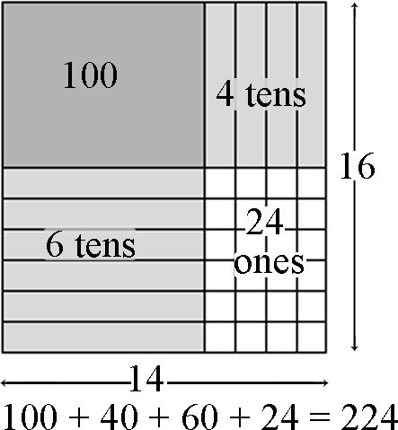  Using the area model, students first verbalize their understanding:  10 x 10 is 100  4 x 10 is 40  10 x 6 is 60, and  4 x 6 is 24.  They use different strategies to record this type of thinking.  - Students explain this strategy and the one below with base 10 blocks, drawings, or numbers.  25  x24  400 (20 x 20)  100 (20 x 5)  80 (4 x 20)  20 (4 x 5)  600  - 25  x24  500 (20 x 25)  100 (4 x 25)  600  - Matrix model  This model should be introduced after students have facility with the strategies shown above.  20 5  20 400 100 500  4 80 20 100  480 + 120 600 | Physical Education:  Have partners time each other for 15 seconds and count the number of times each can jump up and down. Then have them calculate how many times they would each jump if they could continue jumping for one minute, then one hour.
6. Find whole-number quotients and remainders with up to four-digit dividends and one-digit divisors, using strategies based on place value, the properties of operations, and/or the relationship between multiplication and division. Illustrate and explain the calculation by using equations, rectangular arrays, and/or area models.  (MP 7, MP 8) | Divide up to a four digit number by a one digit number with regrouping and with or without remainders | In fourth grade, students build on their third grade work with division within 100. Students need opportunities to develop their understandings by using problems in and out of context.  Examples:  A 4th grade teacher bought 4 new pencil boxes. She has 260 pencils. She wants to put the pencils in the boxes so that each box has the same number of pencils. How many pencils will there be in each box?  - Using Base 10 Blocks: Students build 260 with base 10 blocks and distribute them into 4 equal groups. Some students may need to trade the 2 hundreds for tens but others may easily recognize that 200 divided by 4 is 50.  - Using Place Value: 260 ÷ 4 = (200 ÷ 4) + (60 ÷ 4)  - Using Multiplication: 4 x 50 = 200, 4 x 10 = 40, 4 x 5 = 20; 50 + 10 + 5 = 65; so 260 ÷ 4 = 65  Students may use digital tools to express ideas.  - Using an Open Array or Area Model  After developing an understanding of using arrays to divide, students begin to use a more abstract model for division. This model connects to a recording process that will be formalized in the 5th grade.  Example: 150 ÷ 6  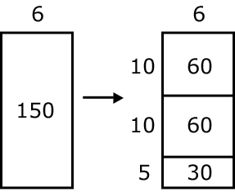  Students make a rectangle and write 6 on one of its sides. They express their understanding that they need to think of the rectangle as representing a total of 150.  - Students think, 6 times what number is a number close to 150? They recognize that 6 x 10 is 60 so they record 10 as a factor and partition the rectangle into 2 rectangles and label the area aligned to the factor of 10 with 60. They express that they have only used 60 of the 150 so they have 90 left.  - Recognizing that there is another 60 in what is left they repeat the process above. They express that they have used 120 of the 150 so they have 30 left.  - Knowing that 6 x 5 is 30. They write 30 in the bottom area of the rectangle and record 5 as a factor.  - Students express their calculations in various ways:  - 150 150 ÷ 6 = 10 + 10 + 5 = 25  - 60 (6 x 10)  90  - 60 (6 x 10)  30  - 30 (6 x 5)  0  - 150 ÷ 6 = (60 ÷ 6) + (60 ÷ 6) + (30 ÷ 6) = 10 + 10 + 5 = 25  Example 2:  1917 ÷ 9  A student’s description of his or her thinking may be:  I need to find out how many 9s are in 1917. I know that 200 x 9 is 1800. So if I use 1800 of the 1917, I have 117 left. I know that 9 x 10 is 90. So if I have 10 more 9s, I will have 27 left. I can make 3 more 9s. I have 200 nines, 10 nines and 3 nines. So I made 213 nines. 1917 ÷ 9 = 213.

Differentiation/Modifications/Accommodations
Gifted and Talented | English Language Learners | Students with Disabilities | Students At Risk of School Failure

- Envision 2020 advanced/enrichment practice  - Play “Speak & Write” : two students are responsible for completing a problem (any operation) when one student has the pencil, the other student must dictate step by step directions for that part. Students will switch roles for every step in the problem.  - Play “Missing Numbers”- students will circulate the room, beginning at the first problem, and answer it correctly in order to solve the next problem that has a missing number. (that missing number will be the previous problem’s answer) Teacher is responsible for creating the problem cards and place around the room.  - “Race to the Answer” students will flip an operation card and race to solve it correctly. Whoever solves it first and correctly will receive a point. | - Using demonstration: (ie: Create three visual representations of a number up to the hundreds place)  - Songs/Rhymes for all operations  - Using manipulatives  - Visuals  - Ten frames/base ten blocks (the manipulative or smartboard version)  - Using small group interactions and peer questioning  - Using pictures  - Calculators  - Grid paper  - Place value charts  - Envision 2020 ELL activities  - For more, see http://www.state.nj.us/education/modelcurriculum/ela/ellscaffolding/3u1.pdf | - RTI approaches: prevent misconceptions, error intervention, reteaching set, reteaching worksheets  - Extended time  - Modified assignments  - Small group, alternate location  - Modeling  - Manipulatives  - Video tutorials  - Color coding/highlighting methods  - Using pictures  - Visuals  - Calculators  - Grid paper  - Ten frames/base ten blocks (the manipulative or smartboard version)  - Place value charts  - Refer to each student’s IEP for more specific modifications | - Using demonstration: (ie: Create three visual representations of a number up to the hundreds place)  - Using manipulatives  - Using small group interactions and peer questioning  - Calculators  - Grid paper  - Using pictures and  - Envision 2020 ELL activities  - Morning tutoring  - After school program  - Parental contact  - Tier II and Tier III Intervention

Math Curriculum: Grade 4
Operations & Algebraic Thinking
Math Standards 4.NF.A.1, 4.NF.A.2

Essential Question(s): How can our knowledge of fractions be used to generate equivalent fractions and compare fractions?
Vocabulary: numerator, denominator, benchmark, common denominator, equivalent fraction, less than, greater than
Content: Numbers and Operations -Fractions
SLS Anchor Standards: A. Extend understanding of fraction equivalence and ordering.
SLS Standards: 4.NF.A.1, 4.NF.A.2
Standards for Mathematical Practice: MP 1, MP 4, MP 5, MP 6, MP 7,
Skills | Instructional Procedures | Explanations and Examples | Interdisciplinary Connections
1. Explain why a fraction a/b is equivalent to a fraction (n × a)/(n × b) by using visual fraction models, with attention to how the number and size of the parts differ even though the two fractions themselves are the same size. Use this principle to recognize and generate equivalent fractions.  (MP 1, MP 4, MP 5, MP 6, MP 7) | ∙Explain how multiplying a fraction by a form of one (1=1/2=3/3=4/4=etc.)  ∙Generate equivalent fractions | This standard extends the work in third grade by using additional denominators (5, 10, 12, and 100).  Students can use visual models or applets to generate equivalent fractions.  All the models show 1/2. The second model shows 2/4 but also shows that 1/2 and 2/4 are equivalent fractions because their areas are equivalent. When a horizontal line is drawn through the center of the model, the number of equal parts doubles and size of the parts is halved.  Students will begin to notice connections between the models and fractions in the way both the parts and wholes are counted and begin to generate a rule for writing equivalent fractions.  1/2 x 2/2 = 2/4.  1 2 = 2 x 1 3 = 3 x 1 4 = 4 x 1  2 4 2 x 2 6 3 x 2 8 4 x 2  Technology Connection: http://illuminations.nctm.org/activitydetail.aspx?id=80 | Language Arts/ Literacy:  Have students choose a fraction topic from this lesson and write a letter about it to a friend, describing what they have learned. Encourage them to include examples. Invite students to read letters aloud.
2. Compare two fractions with different numerators and different denominators, e.g., by creating common denominators or numerators, or by comparing to a benchmark fraction such as 1/2. Recognize that comparisons are valid only when the two fractions refer to the same whole. Record the results of comparisons with symbols >, =, or <, and justify the conclusions, e.g., by using a visual fraction model.  (MP 1, MP 4, MP 5, MP 6, MP 7) | - Compare fractions by using various modes such as benchmarks, common denominator or common numerator | Benchmark fractions include common fractions between 0 and 1 such as halves, thirds, fourths, fifths, sixths, eighths, tenths, twelfths, and hundredths.  Fractions can be compared using benchmarks, common denominators, or common numerators. Symbols used to describe comparisons include <, >, =.  Fractions may be compared using as a benchmark.  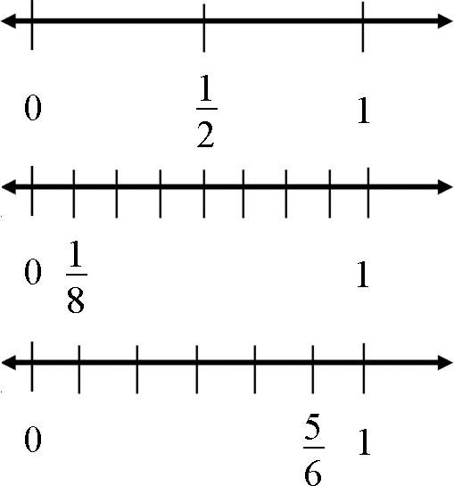  Possible student thinking by using benchmarks:  - is smaller than because when 1 whole is cut into 8 pieces, the pieces are much smaller than when 1 whole is cut into 2 pieces.  Possible student thinking by creating common denominators:  - > because 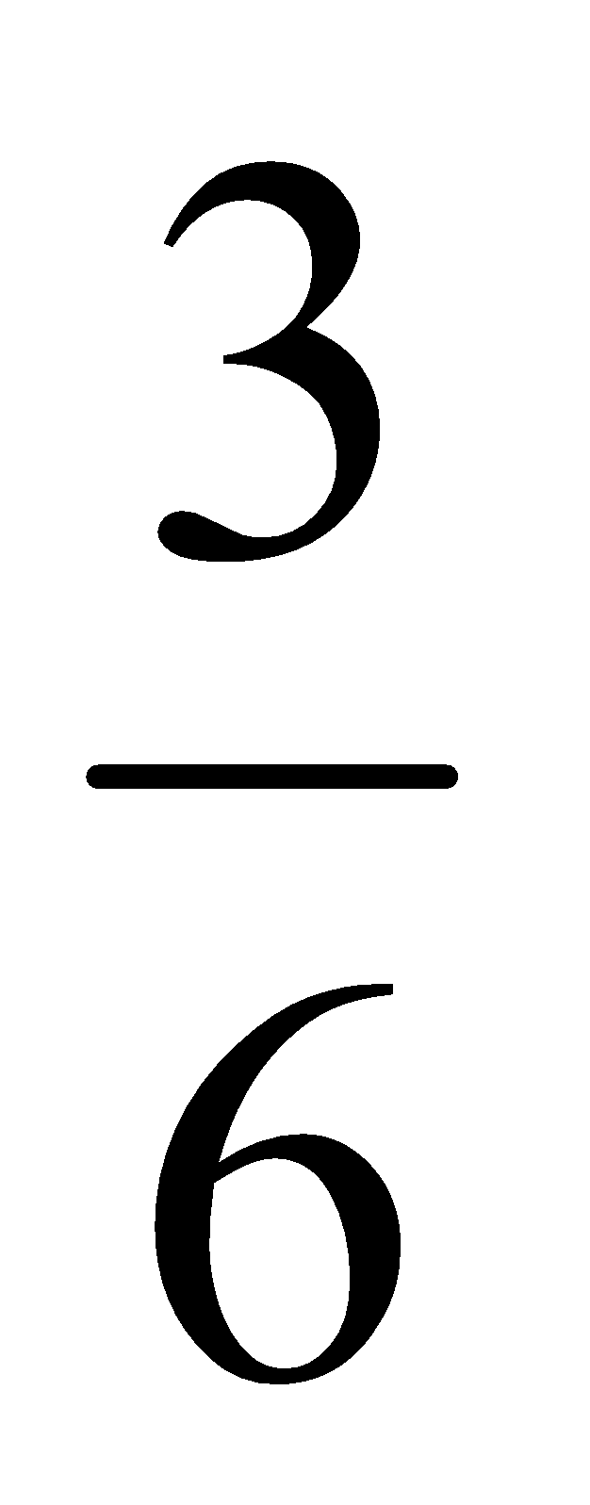= and >  Fractions with common denominators may be compared using the numerators as a guide.  - < <  Fractions with common numerators may be compared and ordered using the denominators as a guide.  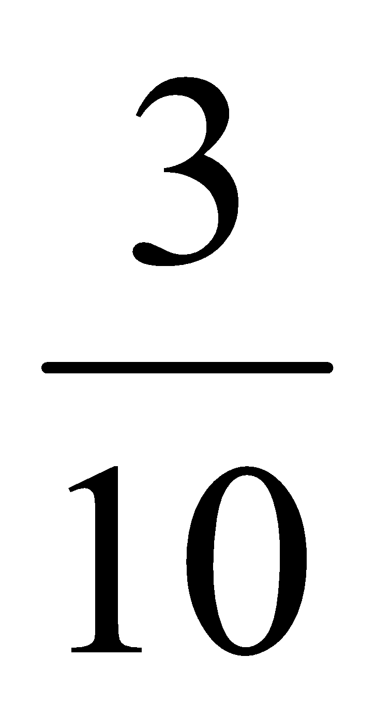 < 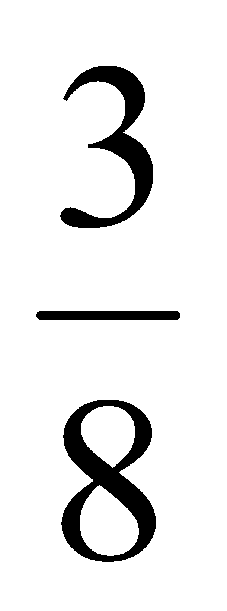 < 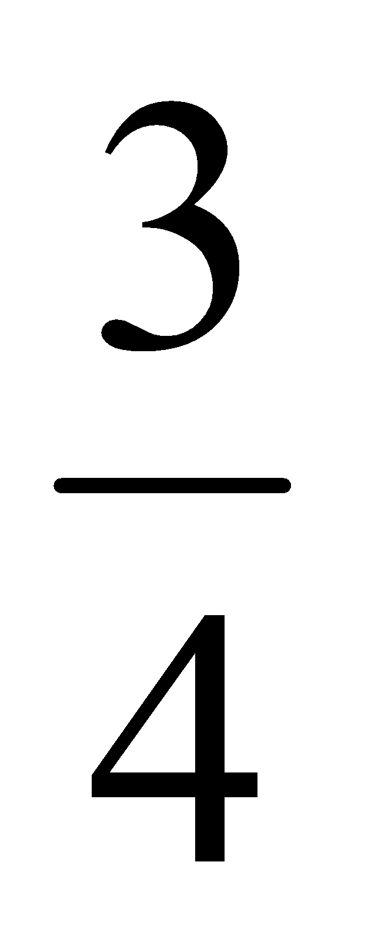

Differentiation/Modifications/Accommodations
Gifted and Talented | English Language Learners | Students with Disabilities | Students At Risk of School Failure

- Envision 2020 advanced/enrichment practice  - Compare fractions war  - Create fraction cards: represent a fraction in three different ways using visuals  - Create and complete (with a peer) a performance based task activity regarding fractions (The student must create a real life situation including 5 scenarios that build upon each other. The scenarios must involve sorting fractions, creating a graph, plotting on a number line and showing equivalence) | - Using demonstration: (ie: Create visual to represent fraction)  - Using manipulatives  - Visuals  - Fraction bars (the manipulative or smartboard version)  - Using small group interactions and peer questioning  - Color coded pictures  - Grid paper  - Envision 2020 ELL activities  - For more, see http://www.state.nj.us/education/modelcurriculum/ela/ellscaffolding/3u1.pdf | - RTI approaches: prevent misconceptions, error intervention, reteaching set, reteaching worksheets  - Extended time  - Modified assignments  - Small group, alternate location  - Using manipulatives  - Visuals  - Fraction bars (the manipulative or smartboard version)  - Using small group interactions and peer questioning  - Color coded pictures  - Grid paper  - Video tutorials  - Refer to each student’s IEP for more specific modifications | - Using demonstration: (ie: Create three visual representations of a number up to the hundreds place)  - Using small group interactions and peer questioning  - Grid paper  - Video tutorials  - Envision 2020 ELL activities  - Morning tutoring  - After school program  - Parental contact  - Tier II and Tier III Intervention

Math Curriculum: Grade 4
Operations & Algebraic Thinking
Math Standards 4.NF.B.3, 4.NF.B.4

Essential Question(s): How can we apply and extend previous understandings of operations on whole numbers to build fractions from unit fractions?
Vocabulary: unit fraction, numerator, denominator
Content: Numbers and Operations -Fractions
SLS Anchor Standards: B. Build fractions from unit fractions by applying and extending previous understandings of operations on whole numbers.
SLS Standards: 4.NF.B.3, 4.NF.B.4
Standards for Mathematical Practice: MP 1, MP 2, MP 3, MP 4, MP 5, MP 6, MP 7
Skills | Instructional Procedures | Explanations and Examples | Interdisciplinary Connections
3. Understand a fraction a/b with a > 1 as a sum of fractions 1/b.  a) Understand addition and subtraction of fractions as joining and separating parts referring to the same whole.  b) Decompose a fraction into a sum of fractions with the same denominator in more than one way, recording each decomposition by an equation. Justify decompositions, e.g., by using a visual fraction model. Examples: 3/8 = 1/8 + 1/8 + 1/8 ; 3/8 = 1/8 + 2/8 ; 2 1/8 = 1 + 1 + 1/8 = 8/8 + 8/8 + 1/8.  c) Add and subtract mixed numbers with like denominators, e.g., by replacing each mixed number with an equivalent fraction, and/or by using properties of operations and the relationship between addition and subtraction.  d) Solve word problems involving addition and subtraction of fractions referring to the same whole and having like denominators, e.g., by using visual fraction models and equations to represent the problem.  (MP 1, MP 2, MP 3, MP 4, MP 5, MP 6, MP 7) | - Define unit fraction  - Decompose fractions into a combination of several unit fractions  - Convert mixed numbers into improper fractions  - Add/subtract fractions with like denominators  - Solve word problems involving addition and subtraction of fractions with like denominators  - Provide visual representation to represent word problems | A fraction with a numerator of one is called a unit fraction. When students investigate fractions other than unit fractions, such as 2/3, they should be able to decompose the non-unit fraction into a combination of several unit fractions.  Example: 2/3 = 1/3 + 1/3  Being able to visualize this decomposition into unit fractions helps students when adding or subtracting fractions. Students need multiple opportunities to work with mixed numbers and be able to decompose them in more than one way. Students may use visual models to help develop this understanding.  Example:  - 1 ¼ - ¾ =  4/4 + ¼ = 5/4  5/4 – ¾ = 2/4 or ½  Example of word problem:  - Mary and Lacey decide to share a pizza. Mary ate 3/6 and Lacey ate 2/6 of the pizza. How much of the pizza did the girls eat together?  Solution: The amount of pizza Mary ate can be thought of a 3/6 or 1/6 and 1/6 and 1/6. The amount of pizza Lacey ate can be thought of a 1/6 and 1/6. The total amount of pizza they ate is 1/6 + 1/6 + 1/6 + 1/6 + 1/6 or 5/6 of the whole pizza.  A separate algorithm for mixed numbers in addition and subtraction is not necessary. Students will tend to add or subtract the whole numbers first and then work with the fractions using the same strategies they have applied to problems that contained only fractions.  Example:  - Susan and Maria need 8 3/8 feet of ribbon to package gift baskets. Susan has 3 1/8 feet of ribbon and Maria has 5 3/8 feet of ribbon. How much ribbon do they have altogether? Will it be enough to complete the project? Explain why or why not.  The student thinks: I can add the ribbon Susan has to the ribbon Maria has to find out how much ribbon they have altogether. Susan has 3 1/8 feet of ribbon and Maria has 5 3/8 feet of ribbon. I can write this as 3 1/8 + 5 3/8. I know they have 8 feet of ribbon by adding the 3 and 5. They also have 1/8 and 3/8 which makes a total of 4/8 more. Altogether they have 8 4/8 feet of ribbon. 8 4/8 is larger than 8 3/8 so they will have enough ribbon to complete the project. They will even have a little extra ribbon left, 1/8 foot.  Example:  - Trevor has 4 1/8 pizzas left over from his soccer party. After giving some pizza to his friend, he has 2 4/8 of a pizza left. How much pizza did Trevor give to his friend?  Solution: Trevor had 4 1/8 pizzas to start. This is 33/8 of a pizza. The x’s show the pizza he has left which is 2 4/8 pizzas or 20/8 pizzas. The shaded rectangles without the x’s are the pizza he gave to his friend which is 13/8 or 1 5/8 pizzas.  x  x  x  x  x  x  x  x  x  x  x  x  x  x  x  x  x  x  x  x | Career and Life Skills:  Double recipes
4. Apply and extend previous understandings of multiplication to multiply a fraction by a whole number.  a) Understand a fraction a/b as a multiple of 1/b. For example, use a visual fraction model to represent 5/4 as the product 5 × (1/4), recording the conclusion by the equation 5/4 = 5 × (1/4).  b) Understand a multiple of a/b as a multiple of 1/b, and use this understanding to multiply a fraction by a whole number. For example, use a visual fraction model to express 3 × (2/5) as 6 × (1/5), recognizing this product as 6/5. (In general, n × (a/b) = (n × a)/b.)  c) Solve word problems involving multiplication of a fraction by a whole number, e.g., by using visual fraction models and equations to represent the problem. For example, if each person at a party will eat 3/8 of a pound of roast beef, and there will be 5 people at the party, how many pounds of roast beef will be needed? Between what two whole numbers does your answer lie?  (MP 1, MP 4, MP 5, MP 7) | - Review concept of unit fraction as a multiple  - Multiply a fraction by a whole number  - Solve word problems involving multiplication of a fraction by a whole number  - Provide visual representation for word problems | Students need many opportunities to work with problems in context to understand the connections between models and corresponding equations. Contexts involving a whole number times a fraction lend themselves to modeling and examining patterns.  Examples:  - 3 x (2/5) = 6 x (1/5) = 6/5  - If each person at a party eats 3/8 of a pound of roast beef, and there are 5 people at the party, how many pounds of roast beef are needed? Between what two whole numbers does your answer lie?  A student may build a fraction model to represent this problem:  3/8 3/8 3/8 3/8 3/8  3/8 + 3/8 + 3/8 + 3/8 + 3/8 = 15/8 = 1 7/8 | World Language:  Use multiplication to figure out how to increase amount of ingredients in a burrito recipe

Differentiation/Modifications/Accommodations
Gifted and Talented | English Language Learners | Students with Disabilities | Students At Risk of School Failure

- Envision 2020 advanced/enrichment practice  - Develop a visual representation of a fraction number sentence using any three dimensional object (ie: play dough, straws, candy, etc)  - Compare fractions war  - Create TenMarks inspired word problems using fractional representations on the smartboard and provide answer key  - Create a smartboard presentation that explains how to decompose fractions | - Using demonstration: (ie: Create visual to represent fraction)  - Using manipulatives  - Visuals  - Fraction bars (the manipulative or smartboard version)  - Using small group interactions and peer questioning  - Color coded pictures  - Grid paper  - Envision 2020 ELL activities  - For more, see http://www.state.nj.us/education/modelcurriculum/ela/ellscaffolding/3u1.pdf | - RTI approaches: prevent misconceptions, error intervention, reteaching set, reteaching worksheets  - Extended time  - Modified assignments  - Small group, alternate location  - Using manipulatives  - Visuals  - Fraction bars (the manipulative or smartboard version)  - Using small group interactions and peer questioning  - Color coded pictures  - Grid paper  - Video tutorials  - Refer to each student’s IEP for more specific modifications | - Using demonstration: (ie: Create three visual representations of a number up to the hundreds place)  - Using small group interactions and peer questioning  - Grid paper  - Video tutorials  - Envision 2020 ELL activities  - Morning tutoring  - After school program  - Parental contact  - Tier II and Tier III Intervention

Math Curriculum: Grade 4
Operations & Algebraic Thinking
Math Standards 4.NF.C.5, 4.NF.C.6, 4.NF.C.7

Essential Question(s): How do we read and write decimals and fractions to hundredths?
Vocabulary: decimals, decimal notation, tenths, hundredths, denominator, numerator, equivalent to, equivalent fractions, comparison
Content: Numbers and Operations -Fractions
SLS Anchor Standards: C. Understand decimal notation for fractions, and compare decimal fractions.
SLS Standards: 4.NF.C.5, 4.NF.C.6, 4.NF.C.7
Standards for Mathematical Practice: MP 5, MP 7
Skills | Instructional Procedures | Explanations and Examples | Interdisciplinary Connections
5. Express a fraction with denominator 10 as an equivalent fraction with denominator 100, and use this technique to add two fractions with respective denominators 10 and 100.² For example, express 3/10 as 30/100, and add 3/10 + 4/100 = 34/100.  (MP 7) | - Demonstrate 7/10=70/100  - Base ten blocks to visualize equivalent fractions  - Demonstrate addition of fractions with denominators of 10 and 100 | Students can use base ten blocks, graph paper, and other place value models to explore the relationship between fractions with denominators of 10 and denominators of 100.  Students may represent 3/10 with 3 longs and may also write the fraction as 30/100 with the whole in this case being the flat (the flat represents one hundred units with each unit equal to one hundredth). Students begin to make connections to the place value chart as shown in 4.NF.6.  This work in fourth grade lays the foundation for performing operations with decimal numbers in fifth grade. | Physical Education:  Kobe Bryant takes 10 free throws and makes 8. If he continues at this rate, how many would he make if he took 100?
6. Use decimal notation for fractions with denominators 10 or 100. For example, rewrite 0.62 as 62/100; describe a length as 0.62 meters; locate 0.62 on a number line diagram.  (MP 7) | - Demonstrate place value chart (see next column)  - Demonstrate on number line decimal numbers  - Relate fraction to decimal | Students make connections between fractions with denominators of 10 and 100 and the place value chart. By reading fraction names, students say 32/100 as thirty-two hundredths and rewrite this as 0.32 or represent it on a place value model as shown below.  Hundreds Tens Ones ∙ Tenths Hundredths  ∙ 3 2  Students use the representations explored in 4.NF.5 to understand 32/100 can be expanded to 3/10 and 2/100.  Students represent values such as 0.32 or 32/100 on a number line. 32/100 is more than 30/100 (or 3/10) and less than 40/100 (or 4/10). It is closer to 30/100 so it would be placed on the number line near that value.  0.5  0.8  0.1  0  0.2  0.3  0.4  0.6  0.7  0.9  1.0  0.32 | Career and Life Skills:  32 pennies are 32/100 or .32.
7. Compare two decimals to hundredths by reasoning about their size. Recognize that comparisons are valid only when the two decimals refer to the same whole. Record the results of comparisons with the symbols >, =, or <, and justify the conclusions, e.g., by using a visual model.  (MP 5, MP 7) | - Provide visual representation of fractions or decimals and have students identify which picture is greater than, less than, or equal to | Students build area and other models to compare decimals. Through these experiences and their work with fraction models, they build the understanding that comparisons between decimals or fractions are only valid when the whole is the same for both cases. Each of the models below shows 3/10 but the whole on the right is much bigger than the whole on the left. They are both 3/10 but the model on the right is a much larger quantity than the model on the left.  When the wholes are the same, the decimals or fractions can be compared.  Example:  - Draw a model to show that 0.3 < 0.5. (Students would sketch two models of approximately the same size to show the area that represents three-tenths is smaller than the area that represents five-tenths.

Differentiation/Modifications/Accommodations
Gifted and Talented | English Language Learners | Students with Disabilities | Students At Risk of School Failure

- Envision 2020 advanced/enrichment practice  - Group students in pairs to act as “party planners”. Students must follow a given budget and research all materials to purchase and present their findings to their class party  - Create a grocery list within a budget and research coupons to help support their shopping.  - Research professional athletes averages and create a graph ranking their scores from least to greatest | - Using demonstration: (ie: Create visual to represent fraction)  - Using manipulatives  - Differentiated menus  - Visuals  - Using small group interactions and peer questioning  - Color coded charts  - Grid paper  - Envision 2020 ELL activities  - For more, see http://www.state.nj.us/education/modelcurriculum/ela/ellscaffolding/3u1.pdf | - RTI approaches: prevent misconceptions, error intervention, reteaching set, reteaching worksheets  - Extended time  - Differentiated menus  - Modified assignments  - Small group, alternate location  - Using manipulatives  - Visuals  - Using small group interactions and peer questioning  - Color coded charts  - Grid paper  - Video tutorials  - Refer to each student’s IEP for more specific modifications | - Using demonstration: (ie: Create three visual representations of a number up to the hundreds place)  - Using small group interactions and peer questioning  - Grid paper  - Differentiated menus  - Video tutorials  - Envision 2020 ELL activities  - Morning tutoring  - After school program  - Parental contact  - Tier II and Tier III Intervention

Math Curriculum: Grade 4
Operations & Algebraic Thinking
Math Standards 4.MD.A.1, 4.MD.A.2, 4.MD.A.3

Essential Question(s): How can measurement be used to solve problems?
Vocabulary: kilometer, meter, centimeter, kilogram, gram, pound, ounce, liter, milliliter, hour, minute, second, square units, formula, square, rectangle
Content: Measurement and Data
SLS Anchor Standards: A. Solve problems involving measurement and conversion of measurements from a larger unit to a smaller unit.
SLS Standards: 4.MD.A.1, 4.MD.A.2, 4.MD.A.3
Standards for Mathematical Practice: MP 2, MP 4, MP 5, MP 8
Skills | Instructional Procedures | Explanations and Examples | Interdisciplinary Connections
1. Know relative sizes of measurement units within one system of units including km, m, cm, mm; kg, g; lb, oz.; l, ml; hr, min, sec. Within a single system of measurement, express measurements in a larger unit in terms of a smaller unit. Record measurement equivalents in a two-column table. For example, know that 1 ft is 12 times as long as 1 in. Express the length of a 4 ft snake as 48 in. Generate a conversion table for feet and inches listing the number pairs (1, 12), (2, 24), (3, 36), …  (MP 5, MP 8) | - Introduce unit of measurement and their relative sizes  - Convert units of measure from larger to smaller  - Generate conversion tables  - Distinguish appropriate measurement system and measurement unit  - Measure items within each measurement | The units of measure that have not been addressed in prior years are pounds, ounces, kilometers, milliliters, and seconds. Students’ prior experiences were limited to measuring length, mass, liquid volume, and elapsed time. Students did not convert measurements. Students need ample opportunities to become familiar with these new units of measure.  Students may use a two-column chart to convert from larger to smaller units and record equivalent measurements. They make statements such as, if one foot is 12 inches, then 3 feet has to be 36 inches because there are 3 groups of 12.  Example:  kg g ft in lb oz  1 1000 1 12 1 16  2 2000 2 24 2 32  3 3000 3 36 3 48 | Science:  Metric system  Language Arts/Literacy:  Math Journal  Research origin of “lb.” for pound
2. Use the four operations to solve word problems involving distances, intervals of time, liquid volumes, masses of objects, and money, including problems involving simple fractions or decimals, and problems that require expressing measurements given in a larger unit in terms of a smaller unit. Represent measurement quantities using diagrams such as number line diagrams that feature a measurement scale.  (MP 4, MP 5) | - Build skills in addition, subtraction, multiplication, division, fractions, decimals, data analysis and measurement through problem solving  - Solve real world problems using above skills  - Represent measurement quantities using diagrams | Examples:  Division/fractions: Susan has 2 feet of ribbon. She wants to give her ribbon to her 3 best friends so each friend gets the same amount. How much ribbon will each friend get?  Students may record their solutions using fractions or inches. (The answer would be 2/3 of a foot or 8 inches. Students are able to express the answer in inches because they understand that 1/3 of a foot is 4 inches and 2/3 of a foot is 2 groups of 1/3.)  Addition: Mason ran for an hour and 15 minutes on Monday, 25 minutes on Tuesday, and 40 minutes on Wednesday. What was the total number of minutes Mason ran?  Subtraction: A pound of apples costs $1.20. Rachel bought a pound and a half of apples. If she gave the clerk a $5.00 bill, how much change will she get back?  Multiplication: Mario and his 2 brothers are selling lemonade. Mario brought one and a half liters, Javier brought 2 liters, and Ernesto brought 450 milliliters. How many total milliliters of lemonade did the boys have?  Number line diagrams that feature a measurement scale can represent measurement quantities. Examples include: ruler, diagram marking off distance along a road with cities at various points, a timetable showing hours throughout the day, or a volume measure on the side of a container. | Social Studies:  Maps  Science:  Experiments involving measurement (ex. Beaker)  Career and Life Skills:  Personal schedule/ time table  Store purchases
3. Apply the area and perimeter formulas for rectangles in real world and mathematical problems. For example, find the width of a rectangular room given the area of the flooring and the length, by viewing the area formula as a multiplication equation with an unknown factor.  (MP 2, MP 5) | - Explain area as an attribute of two dimensional figures  - Connect area measure to the area model for multiplication; use it to justify the formula for area of a rectangle  - Use properties of square/ rectangle to solve problems about area and perimeter | Students developed understanding of area and perimeter in 3rd grade by using visual models.  While students are expected to use formulas to calculate area and perimeter of rectangles, they need to understand and be able to communicate their understanding of why the formulas work.  The formula for area is I x w and the answer will always be in square units.  The formula for perimeter can be 2 l + 2 w or 2 (l + w) and the answer will be in linear units. | Language Arts/ Literacy:  Math Journal  Career and Life Skills:  Floor plan- ex. Restaurant design

Differentiation/Modifications/Accommodations
Gifted and Talented | English Language Learners | Students with Disabilities | Students At Risk of School Failure

- Envision 2020 advanced/enrichment practice  - Design a floor plan focused on area and perimeter (ie: restaurant, bedroom, field, waterpark, etc)  - Create an itinerary, based on a limited amount of time, for a daily trip using time increments to the nearest minute. Extension: weekend trip  - Interactive Lemonade Stand: whole group will create a beverage menu, including three different sized drinks within each flavor, including price. Students will “act out” buying and selling roles. | - Using demonstration:  - Using manipulatives  - Measurement cups  - Judy Clocks  - Smartboard manipulatives  - Visuals  - Using small group interactions and peer questioning  - Color coded charts  - Grid paper  - Popsicle sticks/straws  - Envision 2020 ELL activities  - For more, see http://www.state.nj.us/education/modelcurriculum/ela/ellscaffolding/3u1.pdf | - RTI approaches: prevent misconceptions, error intervention, reteaching set, reteaching worksheets  - Measurement cups  - Judy Clocks  - Smartboard manipulatives  - Visuals  - Using small group interactions and peer questioning  - Color coded charts  - Grid paper  - Popsicle sticks/straws  - Extended time  - Modified assignments  - Small group, alternate location  - Video tutorials  - Refer to each student’s IEP for more specific modifications | - Using demonstration:  - Using small group interactions and peer questioning  - Measurement cups  - Judy Clocks  - Smartboard manipulatives  - Visuals  - Color coded charts  - Grid paper  - Popsicle sticks/straws  - Grid paper  - Video tutorials  - Envision 2020 ELL activities  - Morning tutoring  - After school program  - Parental contact  - Tier II and Tier III Intervention

Math Curriculum: Grade 4
Operations & Algebraic Thinking
Math Standards 4.MD.B.4

Essential Question(s): How can data be used to solve problems?
Vocabulary: line plot
Content: Measurement and Data
SLS Anchor Standards: B. Represent and interpret data.
SLS Standards: 4.MD.B.4
Standards for Mathematical Practice: MP 4, MP 5
Skills | Instructional Procedures | Explanations and Examples | Interdisciplinary Connections
4. Make a line plot to display a data set of measurements in fractions of a unit (1/2, 1/4, 1/8). Solve problems involving addition and subtraction of fractions by using information presented in line plots. For example, from a line plot find and interpret the difference in length between the longest and shortest specimens in an insect collection.  (MP 4, MP 5) | - Construct line plot to display data  - Solve problems using addition and subtraction of fractions from line plot | Example:  Ten students in Room 31 measured their pencils at the end of the day. They recorded their results on the line plot below.  X X  X X X  X X X X X  _________________________________________  3 ½” 4” 4 ¼” 5 1/8” 5 1/2”  Possible questions:  - What is the difference in length from the longest to the shortest pencil?  - If you were to line up all the pencils, what would the total length be?  If the 5 1/8” pencils are placed end to end, what would be their total length? | Science:  Insect collection  Height project

Differentiation/Modifications/Accommodations
Gifted and Talented | English Language Learners | Students with Disabilities | Students At Risk of School Failure

- Envision 2020 advanced/enrichment practice  - Research the top 10 longest waterslides in the world and plot their findings on a piece of technology  - Research and plot the length of given objects (ie: bridge, land, animal, etc)  - Formulate real world questions (fraction forms) based on researched information from a previous project and have opposing groups answer the problems | - Using demonstration: (ie: Create visual to represent fraction)  - Using manipulatives  - Smartboard manipulatives  - Visuals  - Using small group interactions and peer questioning  - Premade plots  - Grid paper  - Popsicle sticks/straws  - Envision 2020 ELL activities  - For more, see http://www.state.nj.us/education/modelcurriculum/ela/ellscaffolding/3u1.pdf | - RTI approaches: prevent misconceptions, error intervention, reteaching set, reteaching worksheets  - Using manipulatives  - Smartboard manipulatives  - Visuals  - Using small group interactions and peer questioning  - Premade plots  - Grid paper  - Extended time  - Modified assignments  - Small group, alternate location  - Video tutorials  - Refer to each student’s IEP for more specific modifications | - Using demonstration: (ie: Create three visual representations of a number up to the hundreds place)  - Using small group interactions and peer questioning  - Using manipulatives  - Smartboard manipulatives  - Visuals  - Using small group interactions and peer questioning  - Premade plots  - Grid paper  - Grid paper  - Video tutorials  - Envision 2020 ELL activities  - Morning tutoring  - After school program  - Parental contact  - Tier II and Tier III Intervention

Math Curriculum: Grade 4
Operations & Algebraic Thinking
Math Standards 4.MD.C.5, 4.MD.C.6, 4.MD.C.7

Essential Question(s): How do we measure angles and classify them by their measurement? How can angle measurements be determined by addition and subtraction?
Vocabulary: angle, acute, right, obtuse, perpendicular, parallel, degree, protractor, ray
Content: Measurement and Data
SLS Anchor Standards: C. Geometric measurement: understand concepts of angle and measure angles.
SLS Standards: 4.MD.C.5, 4.MD.C.6, 4.MD.C.7
Standards for Mathematical Practice: MP 1, MP 2, MP 5, MP 7
Skills | Instructional Procedures | Explanations and Examples | Interdisciplinary Connections
5. Recognize angles as geometric shapes that are formed wherever two rays share a common endpoint, and understand concepts of angle measurement:  a) An angle is measured with reference to a circle with its center at the common endpoint of the rays, by considering the fraction of the circular arc between the points where the two rays intersect the circle. An angle that turns through 1/360 of a circle is called a “one-degree angle,” and can be used to measure angles.  b) An angle that turns through n one-degree angles is said to have an angle measure of n degrees.  (MP 2) | - Define angle  - Introduce angle measurement | The diagram below will help students understand that an angle measurement is not related to an area since the area between the 2 rays is different for both circles yet the angle measure is the same.  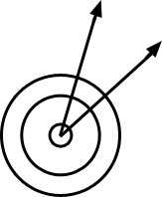
6. Measure angles in whole-number degrees using a protractor. Sketch angles of specified measure.  (MP 2, MP 5) | - Reinforce 90º, 180º and 360º using visuals  - Measure angles with a protractor  - Angle terminology, classify angles by their measurement | Before students begin measuring angles with protractors, they need to have some experiences with benchmark angles. They transfer their understanding that a 360º rotation about a point makes a complete circle to recognize and sketch angles that measure approximately 90º and 180º. They extend this understanding and recognize and sketch angles that measure approximately 45º and 30º. They use appropriate terminology (acute, right, and obtuse) to describe angles and rays (perpendicular). | Physical education:  Basketball game “Around the World”
7. Recognize angle measure as additive. When an angle is decomposed into non-overlapping parts, the angle measure of the whole is the sum of the angle measures of the parts. Solve addition and subtraction problems to find unknown angles on a diagram in real world and mathematical problems, e.g., by using an equation with a symbol for the unknown angle measure.  (MP 1, MP 7) | - Solve addition and subtraction problems to find unknown angles in real world problems | Examples  If the two rays are perpendicular, what is the value of m?  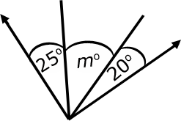  Examples:  - Joey knows that when a clock’s hands are exactly on 12 and 1, the angle formed by the clock’s hands measures 30º. What is the measure of the angle formed when a clock’s hands are exactly on the 12 and 4?  - The five shapes in the diagram are the exact same size. Write an equation that will help you find the measure of the indicated angle. Find the angle measurement. | Art:  Paper Plate Clock  Career and Life Skills:  Cut pie into slices by degree

Differentiation/Modifications/Accommodations
Gifted and Talented | English Language Learners | Students with Disabilities | Students At Risk of School Failure

- Envision 2020 advanced/enrichment practice  - Illustrate real life objects based on angles and geometric features  - Create riddles using geometric attributes for their partner to guess the name or angle of the given shape  - Design a model home, identify angles, shapes and attributes used. | - Using demonstration:  - Protractors/Rulers  - Smartboard manipulatives  - Visuals  - Using small group interactions and peer questioning  - Highlighters  - Grid paper/Dot paper  - Geoboards  - Envision 2020 ELL activities  - For more, see http://www.state.nj.us/education/modelcurriculum/ela/ellscaffolding/3u1.pdf | - RTI approaches: prevent misconceptions, error intervention, reteaching set, reteaching worksheets  - Protractors/Rulers  - Smartboard manipulatives  - Visuals  - Using small group interactions and peer questioning  - Highlighters  - Grid paper/Dot paper  - Geoboards  - Extended time  - Modified assignments  - Small group, alternate location  - Video tutorials  - Refer to each student’s IEP for more specific modifications | - Using demonstration  - Using small group interactions and peer questioning  - Protractors/Rulers  - Smartboard manipulatives  - Visuals  - Using small group interactions and peer questioning  - Highlighters  - Grid paper/Dot paper  - Geoboards  - Video tutorials  - Envision 2020 ELL activities  - Morning tutoring  - After school program  - Parental contact  - Tier II and Tier III Intervention

Math Curriculum: Grade 4
Operations & Algebraic Thinking
Math Standards 4.G.A.1, 4.G.A.2, 4.G.A.3

Essential Question(s): How do we use geometry to draw and classify figures?
Vocabulary: points, lines, line segments, rays, angles (right, acute, obtuse), perpendicular, parallel lines, symmetry, intersecting lines
Content: Geometry
SLS Anchor Standards: C. Geometric measurement: understand concepts of angle and measure angles.
SLS Standards: 4.G.A.1, 4.G.A.2, 4.G.A.3
Standards for Mathematical Practice: MP 5, MP 7,
Skills | Instructional Procedures | Explanations and Examples | Interdisciplinary Connections
1. Draw points, lines, line segments, rays, angles (right, acute, obtuse), and perpendicular and parallel lines. Identify these in two-dimensional figures.  (MP 5, MP 7) | - Drawing and identify in 2 dimensional figures | Examples of points, line segments, lines, angles, parallelism, and perpendicularity can be seen daily. Students do not easily identify lines and rays because they are more abstract.  Right angle  Acute angle  Obtuse angle  Straight angle  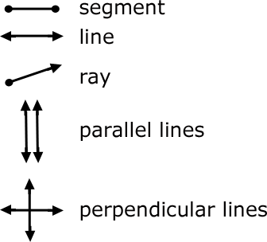 | Art:  Abstract drawing  Science:  Field trip to identify geometric attributes in outside world
2. Classify two-dimensional figures based on the presence or absence of parallel or perpendicular lines, or the presence or absence of angles of a specified size. Recognize right triangles as a category, and identify right triangles.  (MP 5, MP 7) | - Identify parallel and perpendicular lines in two dimensional figures  - Classify polygons with regard to perpendicular and parallel attributes  - Identify right, acute, and obtuse angles in two dimensional figures  - Approximate angles using benchmark of 90º, 180º and 360º  - Classify right triangles in terms of number of congruent sides | Two-dimensional figures may be classified using different characteristics such as, parallel or perpendicular lines or by angle measurement.  Parallel or Perpendicular Lines:  Students should become familiar with the concept of parallel and perpendicular lines. Two lines are parallel if they never intersect and are always equidistant. Two lines are perpendicular if they intersect in right angles (90º).  Students may use transparencies with lines to arrange two lines in different ways to determine that the 2 lines might intersect in one point or may never intersect. Further investigations may be initiated using geometry software. These types of explorations may lead to a discussion on angles.  Parallel and perpendicular lines are shown below:  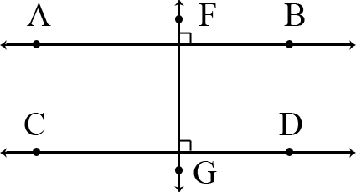  Example:  - Identify which of these shapes have perpendicular or parallel sides and justify your selection.  A possible justification that students might give is:  The square has perpendicular lines because the sides meet at a corner, forming right angles.  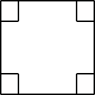  Angle Measurement:  This expectation is closely connected to 4.MD.5, 4.MD.6, and 4.G.1. Students’ experiences with drawing and identifying right, acute, and obtuse angles support them in classifying two-dimensional figures based on specified angle measurements. They use the benchmark angles of 90°, 180°, and 360° to approximate the measurement of angles.  Right triangles can be a category for classification. A right triangle has one right angle. There are different types of right triangles. An isosceles right triangle has two or more congruent sides and a scalene right triangle has no congruent sides.
3. Recognize a line of symmetry for a two-dimensional figure as a line across the figure such that the figure can be folded along the line into matching parts. Identify line-symmetric figures and draw lines of symmetry.  (MP 5, MP 7) | -Identify and draw lines of symmetry | Students need experiences with figures which are symmetrical and non-symmetrical. Figures include both regular and non-regular polygons. Folding cut-out figures will help students determine whether a figure has one or more lines of symmetry. | Art:  Cutting and decorating using symmetry  Science:  Symmetry in nature (ex. Butterfly)

Differentiation/Modifications/Accommodations
Gifted and Talented | English Language Learners | Students with Disabilities | Students At Risk of School Failure

- Envision 2020 advanced/enrichment practice  - Design a two dimensional object on the computer incorporating geometric attributes to represent symmetrical figure  - Highlight geometric attributes from an abstract design  - Pattern block symmetry: students must create a symmetrical figure using pattern blocks | - Using demonstration  - Kinesthetic movements to represent each vocabulary  - Protractors/Rulers  - Smartboard manipulatives  - Visual cards  - Using small group interactions and peer questioning  - Grid paper/Dot paper  - Geoboards  - Envision 2020 ELL activities  - For more, see http://www.state.nj.us/education/modelcurriculum/ela/ellscaffolding/3u1.pdf | - RTI approaches: prevent misconceptions, error intervention, reteaching set, reteaching worksheets  - Kinesthetic movements to represent each vocabulary  - Protractors/Rulers  - Smartboard manipulatives  - Visual cards  - Using small group interactions and peer questioning  - Grid paper/Dot paper  - Geoboards  - Extended time  - Modified assignments  - Small group, alternate location  - Video tutorials  - Refer to each student’s IEP for more specific modifications | - Using demonstration  - Using small group interactions and peer questioning  - Kinesthetic movements to represent each vocabulary  - Protractors/Rulers  - Smartboard manipulatives  - Visual cards  - Using small group interactions and peer questioning  - Grid paper/Dot paper  - Geoboards  - Video tutorials  - Envision 2020 ELL activities  - Morning tutoring  - After school program  - Parental contact  - Tier II and Tier III Intervention

