Mathematics Curriculum:
Grade Six

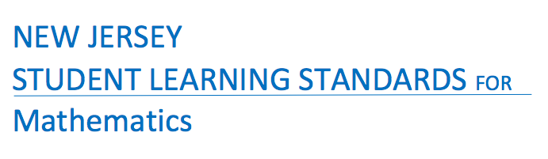

Born On & Board Approved: July 25, 2017
Re-Adopted: August 23, 2022

The following maps outline the New Jersey Student Learning Standards for grade six mathematics determined by the State Standards Initiative. Below is a list of assessment tools that are recommended for tracking student progress in these areas. In addition, resources that can be used in conjunction with instruction of these standards are provided but not limited to the list below.

Assessment:
Formative Assessment Class-Work Review
Open-Ended Problems Project-Based Assessment
Self-Assessment Teacher Observation
End of Year Assessment Group & Cooperative Work
Benchmark Assessment Math Software (ex. Study Island)
Homework Review
Summative Assessment

Resources: _
Math Journals Center Games Tangrams
Bar Models Ten Frame Geometric Shapes
Math Word Wall Protractors Geo-Board
Connecting Cubes Mini White Boards Textbooks
Number Line Manipulatives Rulers
Grid Paper Math Songs/Poems Three Dimensional Shapes
Computer Software Calculators Wiki-Sticks
Interactive White Board Fraction Tiles Pattern Blocks
Compass Measurement Tools

Websites:
http://www.aplusmath.com www.wolframalpha.com www.interactmath.com www.illustrativemathematics.org
http://www.studyisland.com www.kutasoftware.com www.number2.com www.buzzmath.com
http://www.funbrain.com www.illuminations.nctm.org www.khanacademy.org www.ixl.com
http://www.songsforteaching.com www.betterlesson.com
www.purplemath.com

References: http://www.state.nj.us/education/aps/cccs/math/
NJ Technology Standards: http://www.state.nj.us/education/cccs/2014/tech/8.pdf
NJ Career Ready Practices: http://www.state.nj.us/education/aps/cccs/career/

Standards for Mathematical Practice
MP. 1 - Make Sense of problems and persevere in solving them.
MP. 2 - Reason Abstractly and Quantitatively
Mp. 3 - Construct Viable Arguments and Critique the Reasoning of Others
MP. 4 - Model with Mathematics
MP. 5 - Use Appropriate Tools Strategically
MP. 6 - Attend to Precision
MP. 7 - Look for and make use of Structure
MP. 8 - Look for and Express Regularity in Repeated Reasoning

Curriculum Details
Mathematics - Grade 6
Core Materials | Holt-McDougal, Numbers World
Interdisciplinary Connections | ELA:  NJSLSA.R1 Read closely to determine what the text says explicitly to make logical inferences and relevant connections from it; cite specific textual evidence when writing or speaking to support conclusions drawn from the text.  NJSLSA.W2. Write informative/explanatory texts to examine and convey complex ideas and information clearly and accurately through the effective selection, organization, and analysis of content.  NJSLSA.L1 Demonstrate command of the conventions of standard English grammar and usage when writing or speaking.  RH.6-8.7 Integrate visual information (e.g., in charts, graphs, photographs, videos and maps) with other information in print and digital texts.
Career Ready Practices | CRP2. Apply appropriate academic and technical skills.  CRP4. Communicate clearly and effectively and with reason.  CRP6. Demonstrate creativity and innovation.  CRP7. Employ valid and reliable research strategies.  CRP8. Utilize critical thinking to make sense of problems and persevere in solving them.  CRP12. Work productively in teams while using cultural global competence.
Career Readiness, Life LIteracies, and Key Skills | 9.1.8.CDM.1: Compare and contrast the use of credit cards and debit cards for specific purchases and the advantages and disadvantages of using each.  9.1.8.CP.1: Compare the prices for the same goods and services.  9.1.8.FI.4: Analyze the interest rates and fees associated with financial products.  9.1.8.PB.3: Explain how to create a budget that aligns with financial goals.  9.1.8.PB.7: Brainstorm techniques that will help decrease expenses including comparison shopping, negotiating, and day-to-day expense management.  9.2.8.CAP.3: Explain how career choices, educational choices, skills, economic conditions, and personal behavior affect income.  92.8.CAP.14: Evaluate sources of income and alternative resources to accurately compare employment options.  9.4.8.GCA.1: Model how to navigate cultural differences with sensitivity and respect.  9.4.8.GCA.2: Demonstrate openness to diverse ideas and perspectives through active discussions to achieve a group goal.  9.4.8.TL.1: Construct a spreadsheet in order to analyze multiple data sets, identify relationships, and facilitate data-based decision-making.  9.4.8.TL.3: Select appropriate tools to organize and present information digitally.
Computer Science and Design Thinking | 8.1.8.DA.1: Organize and transform data collected using computational tools to make it usable for a specific purpose.  8.2.8.ED.3: Develop a proposal for a solution to a real-world problem that includes a model (e.g. physical prototype, graphical/technical sketch).  8.1.8.AP.2: Create clearly named variables that represent different data types and perform operations on their values.

Math Curriculum
Grade Six

Content: Ratios & Proportional Relationships
Essential Question(s):
How are ratios used to solve real-world problems?
Why does one need to compare numbers?
Standards: 6.RP
A. Understand ratio concepts and use ratio reasoning to solve problems.
Vocabulary: numerator, denominator, equivalent fractions, ratio, equivalent ratio, simplest form of a ratio, term of a ratio, rate, unit rate, speed, units of measure
Standards for Mathematical Practice: MP 2, MP 4, MP 5, MP 6, MP 7, MP 8
Grade Specific Standard | Skills |  | Instructional Procedures |  | Explanations and Examples
1. Understand the concept of a ratio and use ratio language to describe a ratio relationship between two quantities. For example, “The ratio of wings to beaks in the bird house at the zoo was 2:1, because for every 2 wings there was 1 beak.” “For every vote candidate A received, candidate C received nearly three votes.”  (MP 2) | - Use ratio language to describe a ratio relationship between two quantities |  | - Recall prior knowledge of equivalent fractions  - Understand the meaning of ratio  - Write and interpret ratios as fractions |  | A ratio is a comparison of two quantities which can be written as  a to b, 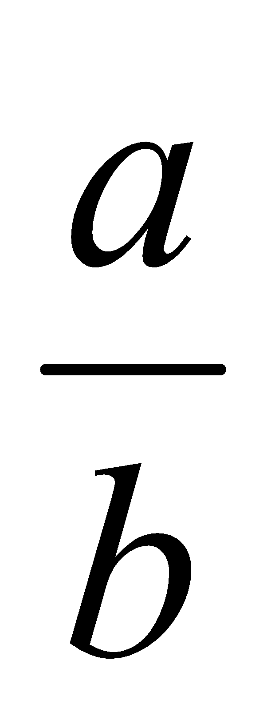, or a:b.  A rate is a ratio where two measurements are related to each other. When discussing measurement of different units, the word rate is used rather than ratio. Understanding rate, however, is complicated and there is no universally accepted definition. When using the term rate, contextual understanding is critical. Students need many opportunities to use models to demonstrate the relationships between quantities before they are expected to work with rates numerically.  A comparison of 8 black circles to 4 white circles can be written as the ratio of 8:4 and can be regrouped into 4 black circles to 2 white circles (4:2) and 2 black circles to 1 white circle (2:1).  Students should be able to identify all these ratios and describe them using “For every…., there are …”
2. Understand the concept of a unit rate a/b associated with a ratio a:b with b ≠ 0, and use rate language in the context of a ratio relationship. For example, “This recipe has a ratio of 3 cups of flour to 4 cups of sugar, so there is 3/4 cup of flour for each cup of sugar.” “We paid $75 for 15 hamburgers, which is a rate of $5 per hamburger.”¹  (MP 2) | - Use rate language in the context of a ratio relationship |  | - Define rate and use rate to compare two quantities with different units  - Express and compare unit rates in terms of time and other quantities  - Find an unit rate  - Find and compare unit rates |  | A unit rate compares a quantity in terms of one unit of another quantity. Students will often use unit rates to solve missing value problems. Cost per item or distance per time unit are common unit rates, however, students should be able to flexibly use unit rates to name the amount of either quantity in terms of the other quantity. Students will begin to notice that related unit rates are reciprocals as in the first example. It is not intended that this be taught as an algorithm or rule because at this level, students should primarily use reasoning to find these unit rates.  In Grade 6, students are not expected to work with unit rates expressed as complex fractions. Both the numerator and denominator of the original ratio will be whole numbers.  Examples:  - On a bicycle you can travel 20 miles in 4 hours. What are the unit rates in this situation, (the distance you can travel in 1 hour and the amount of time required to travel 1 mile)?  Solution: You can travel 5 miles in 1 hour written as 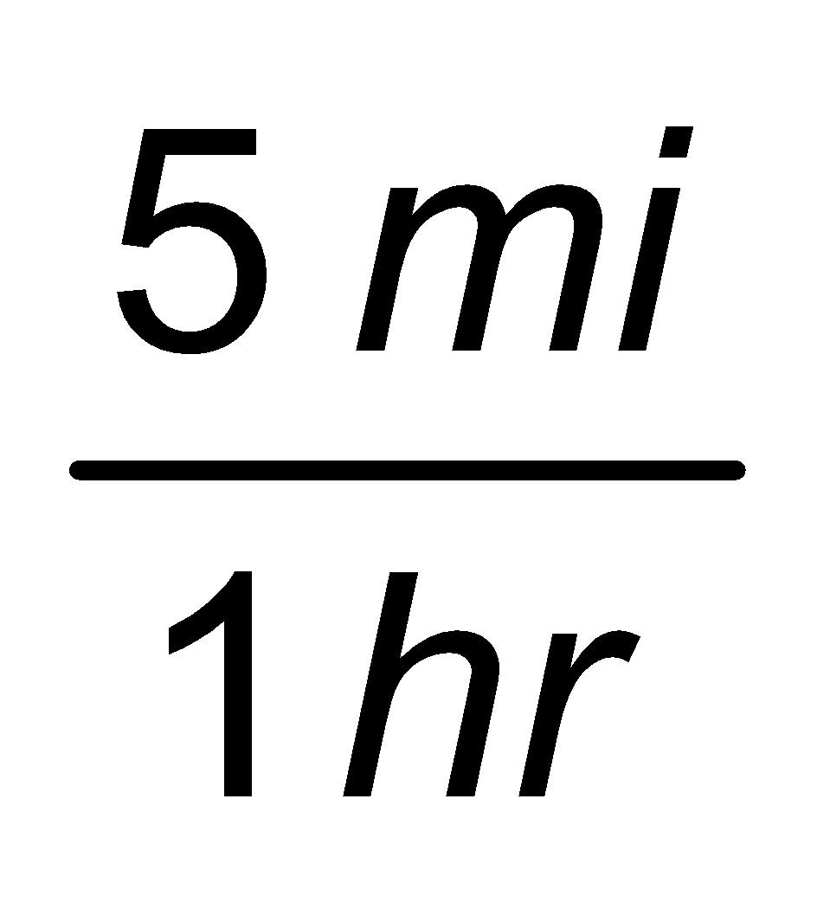and it takes 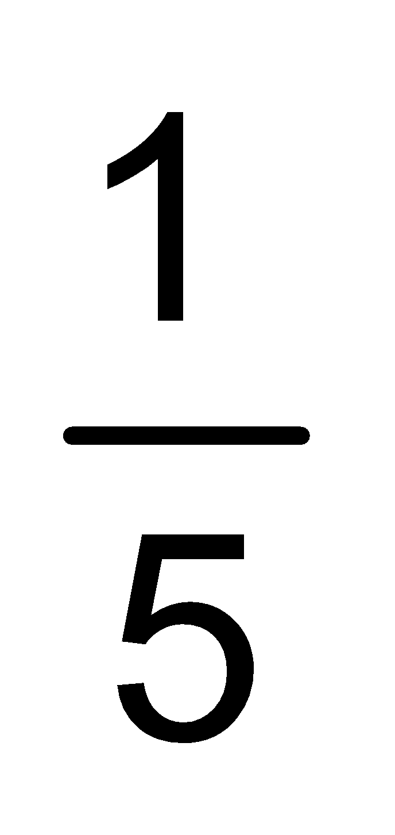of a hour to travel each mile written as 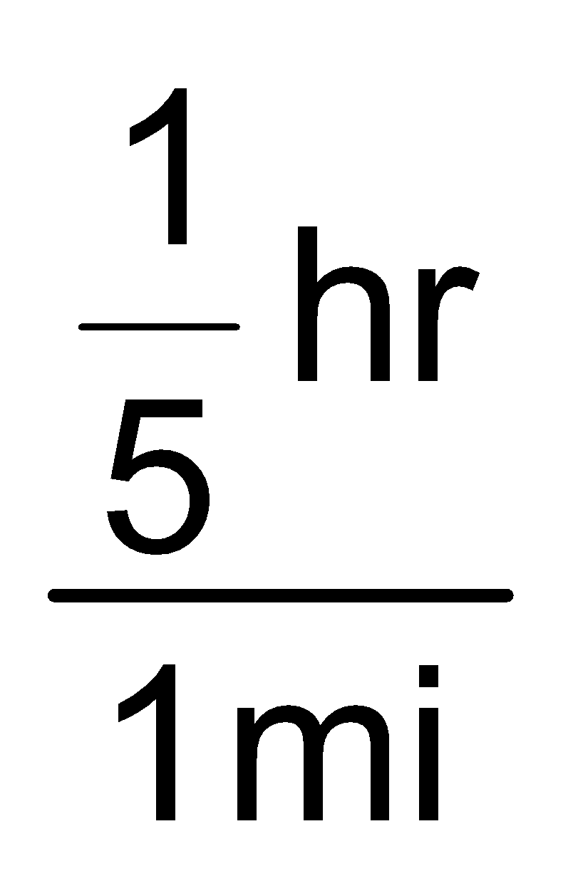. Students can represent the relationship between 20 miles and 4 hours.  1 mile  1 hour  A simple modeling clay recipe calls for 1 cup corn starch, 2 cups salt, and 2 cups boiling water. How many cups of corn starch are needed to mix with each cup of salt?
3. Use ratio and rate reasoning to solve real-world and mathematical problems, e.g., by reasoning about tables of equivalent ratios, tape diagrams, double number line diagrams, or equations.  3a: Make tables of equivalent ratios relating quantities with whole-number measurements, find missing values in the tables, and plot the pairs of values on the coordinate plane. Use tables to compare ratios.  3b: Solve unit rate problems including those involving unit pricing and constant speed. For example, if it took 7 hours to mow 4 lawns, then at that rate, how many lawns could be mowed in 35 hours? At what rate were lawns being mowed?  3c: Find a percent of a quantity as a rate per 100 (e.g., 30% of a quantity means 30/100 times the quantity); solve problems involving finding the whole, given a part and the percent.  3d: Use ratio reasoning to convert measurement units; manipulate and transform units appropriately when multiplying or dividing quantities.  (MP 2, MP 4, MP 5, MP 6,  MP 7, MP 8) | - Use ratio and rate reasoning to solve real-world and mathematical problems  - Make a table of equivalent ratios relating quantities with whole-number measures  - Solve unit rate problems including those involving unit pricing and constant rate  - Find a percent of a quantity as a rate per 100 and solve problems involving finding the whole, given a part of the percent  - Use ratio reasoning to convert measurement units  - Manipulate and transform units appropriately when multiplying or dividing quantities |  | - Work with tables of ratios  - Draw models to solve problems involving ratios  - Review coordinate plane  - Use tables and graphs to represent linear equations  - Use real-world problems to complete tables to compare ratios  - Find the speed or rate of travel of a moving object  - Solve simple word problems involving rates and unit rates  - Solve problems involving distance and speed  - Review the relationship between fractions and decimals  - Define percent  - Express a part of a whole as a fraction and a percent  - Find percent using fractions or decimals  - Find the quantity represented by a quantity  - Solve real-world problems involving percent  - Convert measurements given in one unit to another  - Find equivalent ratios by multiplication and division |  | Examples:  - Using the information in the table, find the number of yards in 24 feet.  Feet 3 6 9 15 24  Yards 1 2 3 5 ?  There are several strategies that students could use to determine the solution to this problem.  - Add quantities from the table to total 24 feet (9 feet and 15 feet); therefore the number of yards must be 8 yards (3 yards and 5 yards).  - Use multiplication to find 24 feet: 1) 3 feet x 8 = 24 feet; therefore 1 yard x 8 = 8 yards, or 2) 6 feet x 4 = 24 feet; therefore 2 yards x 4 = 8 yards.  - Compare the number of black to white circles. If the ratio remains the same, how many black circles will you have if you have 60 white circles?  Black 4 40 20 60 ?  White 3 30 15 45 60  - If 6 is 30% of a value, what is that value? (Solution: 20)  6  0%  30%  100%  ?  - A credit card company charges 17% interest on any charges not paid at the end of the month. Make a ratio table to show how much the interest would be for several amounts. If your bill totals $450 for this month, how much interest would you have to pay if you let the balance carry to the next month? Show the relationship on a graph and use the graph to predict the interest charges for a $300 balance.  Charges $1 $50 $100 $200 $450  Interest $0.17 $8.50 $17 $34 ?  Concept Map  Ratios of two quantities with different units  Real- life situations (in word problems)  Rates  Unit Rates  Unit Pricing  Constant speed:  Speed= Distance  Time  Average speed:  = Total distance traveled  Time  Time= Distance Speed  Distance= Speed x Time  Key Concepts:  - You can use a rate to compare two quantities with different units.  - A unit rate compares a quantity to one unit of another quantity.  - Speed is a special rate that expresses distance per unit time.  - Distance can be found using the formula; Distance= Speed x Time  - Time can be found using the formula: Time= Distance ⎟Speed
Differentiation/Accommodations/Modifications
Gifted and Talented |  | English Language Learners |  | Students with Disabilities |  | Students at Risk of School Failure
- Teacher gives students real life situations and students create an outcome  - Express unit rates as complex fractions or decimals  - Read a table to find the information to solve multi-step rate problems  - Solve multi-step word problems involving comparison of unit rates |  | - Video clips  - Choose excerpt(s) from book to focus on vocabulary development, comprehension  - Read aloud  - Word Wall  - Build background knowledge  - Picture Associations  - Partner Work  - For more, see http://www.state.nj.us/education/modelcurriculum/ela/ellscaffolding/3u1.pdf |  | - Extended time  - Modified assignments  - Small group, alternate location  - Real world ratio scenarios  - Modeling  - Read aloud problems  - Calculator  - Build background knowledge  - Oral/visual reminders  - Peer assistance  - Picture associations with vocabulary  - Build background knowledge of ratios  - Refer to each student’s IEP for more specific modifications |  | - RTI strategies including: reciprocal teaching, teacher modeling,  - Tier II and Tier III intervention  - More frequent STAR assessments  - Morning tutoring  - After school program  - Parental contact

Math Curriculum
Grade Six

Content: The Number System
Essential Question(s):
How do we extend prior knowledge to divide fractions?
What is represented by division of a fraction by a fraction?
What type of visual models can be used to represent divisions of fractions?
How are division and multiplication of a fraction by a fraction related?
Standards: 6.NS
A. Apply and extend previous understandings of multiplication and division
Vocabulary: multiples, factors, quotient, numerator, denominator, reciprocal, improper fractions, mixed number, whole numbers
Standards for Mathematical Practice: MP 4
Grade Specific Standard | Skills |  | Instructional Procedures |  | Explanations and Examples
1. Interpret and compute quotients of fractions, and solve word problems involving division of fractions by fractions, e.g., by using visual fraction models and equations to represent the problem. For example, create a story context for (2/3) ÷ (3/4) and use a visual fraction model to show the quotient; use the relationship between multiplication and division to explain that (2/3) ÷ (3/4) = 8/9 because 3/4 of 8/9 is 2/3. (In general, (a/b) ÷ (c/d) = ad/bc.) How much chocolate will each person get if 3 people share 1/2 lb of chocolate equally? How many 3/4-cup servings are in 2/3 of a cup of yogurt? How wide is a rectangular strip of land with length 3/4 mi and area 1/2 square mi? Compute fluently with multi-digit numbers and find common factors and multiples.  (MP 4) | - Compute quotients of fractions.  - Interpret quotients of fractions.  - Create a story context for division.  - Solve word problems involving divisions of fractions. |  | - Recall procedures to multiply fractions  - Divide a whole number by a fraction  - Divide a fraction by a fraction  - Divide a fraction by a mixed number  - Use visuals and models to solve real-world problems involving division of fractions |  | Contexts and visual models can help students to understand quotients of fractions and begin to develop the relationship between multiplication and division. Model development can be facilitated by building from familiar scenarios with whole or friendly number dividends or divisors. Computing quotients of fractions builds upon and extends student understandings developed in Grade 5. Students make drawings, model situations with manipulatives, or manipulate computer generated models.  Examples:  - Three people share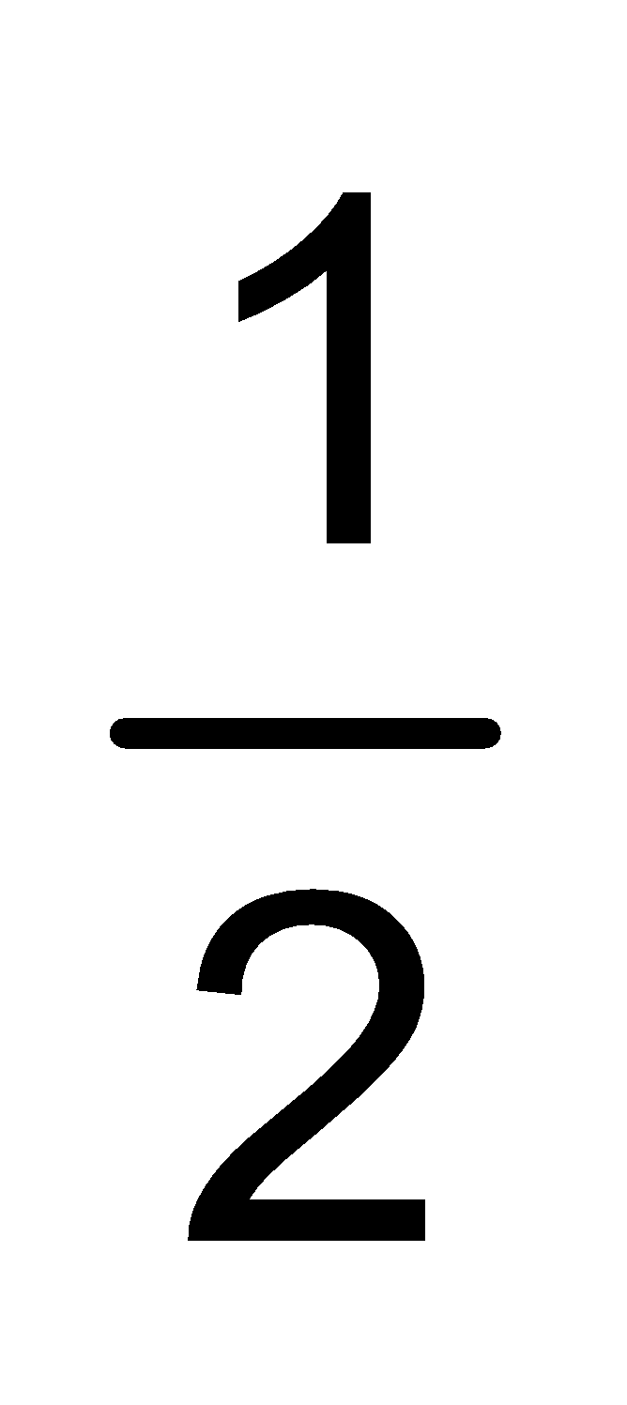pound of chocolate. How much of a pound of chocolate does each person get?  Solution: Each person gets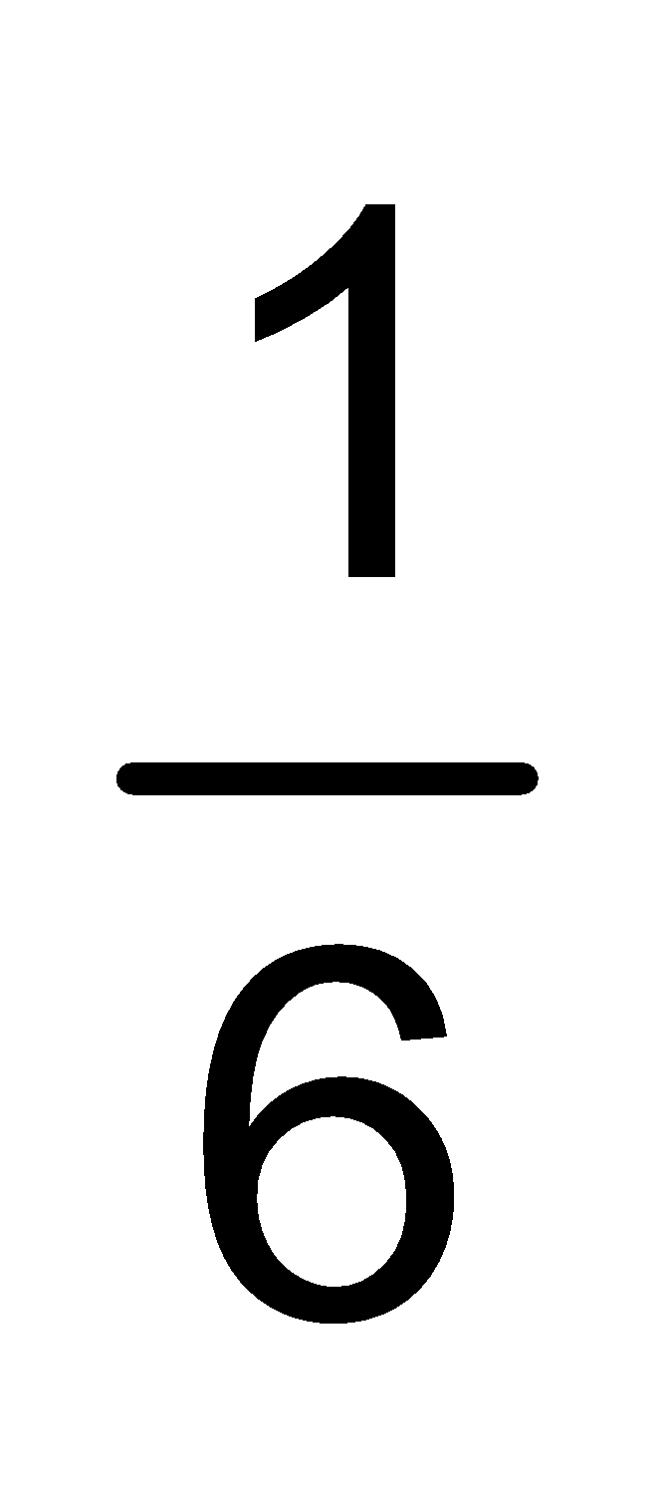lb of chocolate.  - Manny has yard of fabric to make book covers. Each book is made from 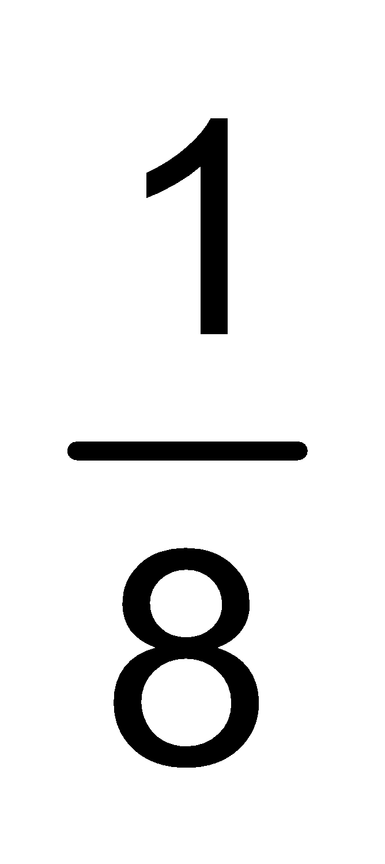 yard of fabric. How many book covers can Manny make? Solution: Manny can make 4 book covers.  yd  - Represent 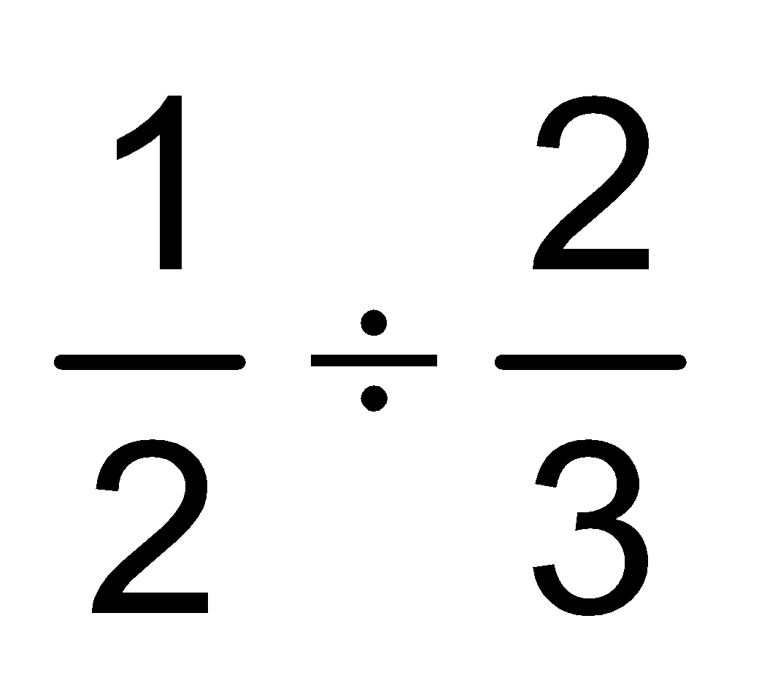in a problem context and draw a model to show your solution.  Context: You are making a recipe that calls for 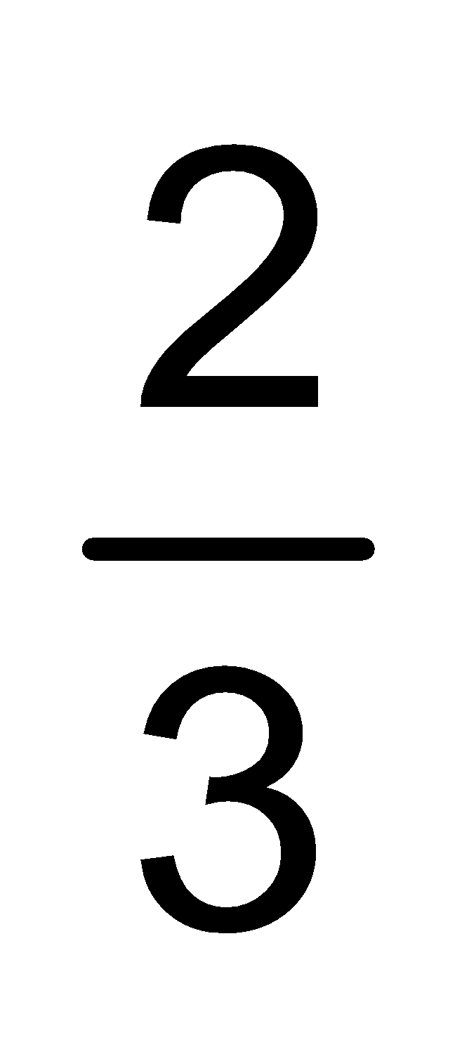cup of yogurt. You have cup of yogurt from a snack pack. How much of the recipe can you make?  Explanation of Model:  The first model showscup. The shaded squares in all three models show cup.  The second model shows cup and also shows 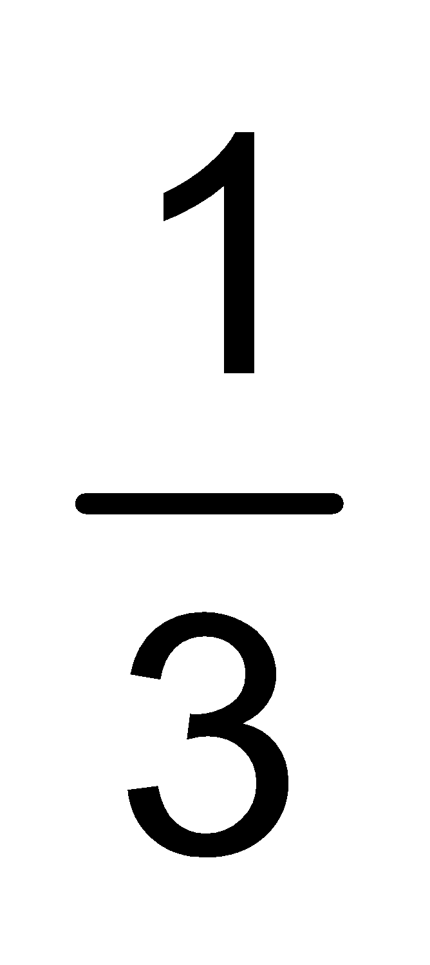 cups horizontally.  The third model shows cup moved to fit in only the area shown by of the model.  is the new referent unit (whole) .  Three out of the 4 squares in the portion are shaded. A cup is only 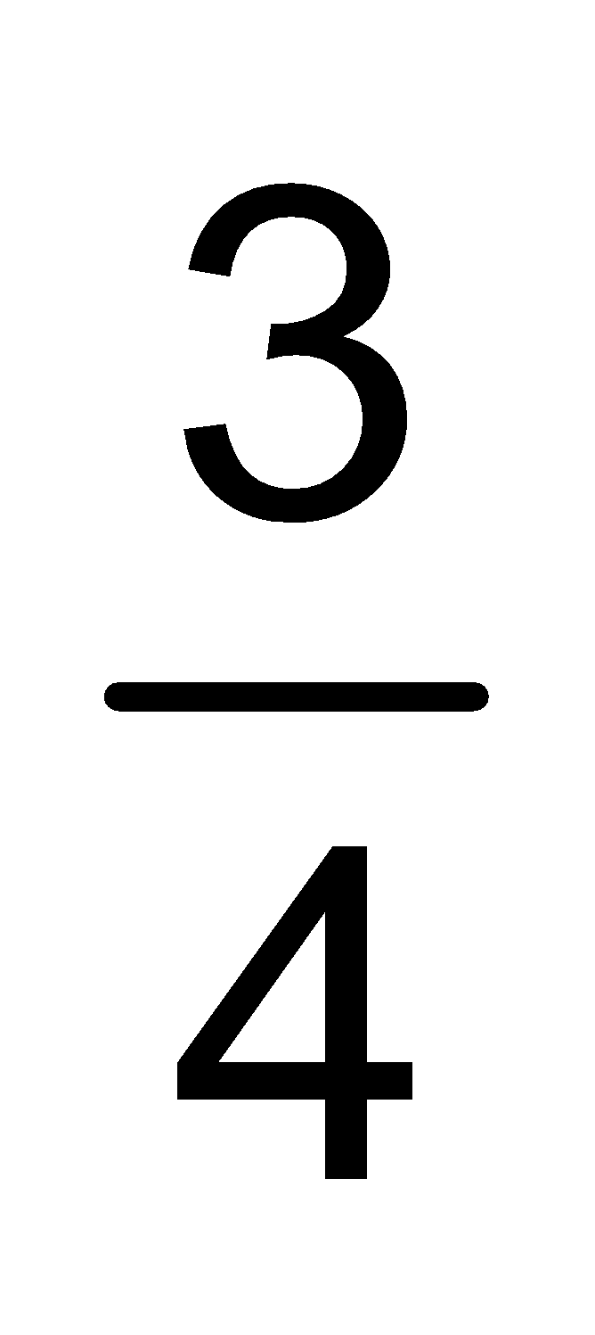 of a cup portion, so you can only make ¾ of the recipe.  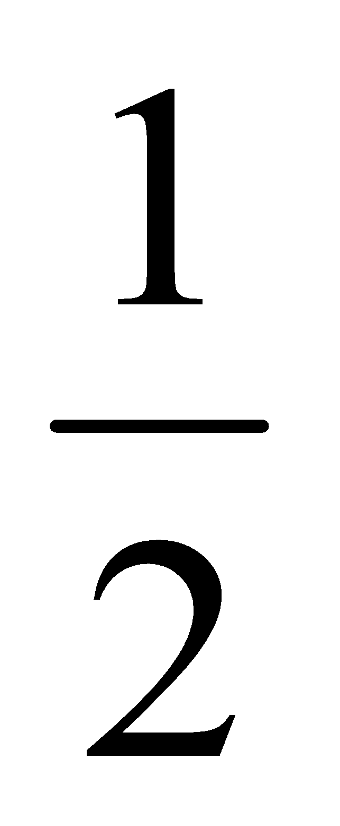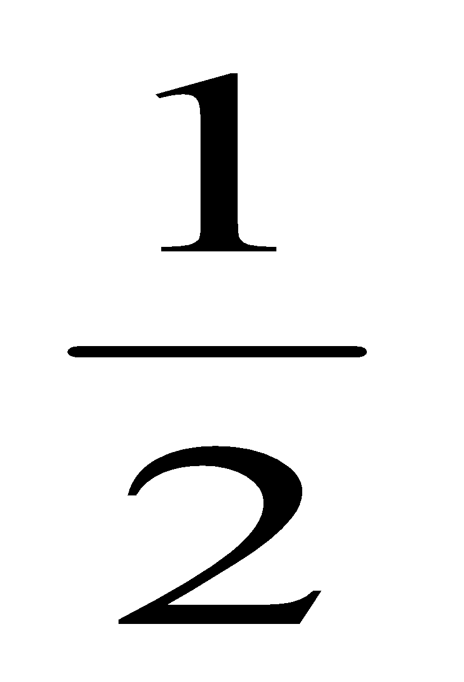
Differentiation/Accommodations/Modifications
Gifted and Talented |  | English Language Learners |  | Students with Disabilities |  | Students at Risk of School Failure
- Solve multi-step word problems involving divisions of fractions.  - Convert mixed fractions to improper fractions.  - Create real-world word problems  - Create how-to video presentation involving fractions multiplication and division |  | - Video clips  - Choose excerpt(s) from book to focus on vocabulary development, comprehension  - Read aloud  - Word Wall  - Build background knowledge  - Picture Associations  - Partner Work |  | - Extended time  - Modified assignments  - Small group, alternate location  - Real world fraction scenarios  - Modeling  - Read aloud problems  - Calculator  - Build background knowledge  - Oral/visual reminders  - Peer assistance  - Picture associations with vocabulary  - Build background knowledge of fractions  - Refer to each student’s IEP for more specific modifications |  | - RTI strategies including: reciprocal teaching, teacher modeling,  - Tier II and Tier III intervention  - More frequent STAR assessments  - Morning tutoring  - After school program  - Parental contact

Math Curriculum
Grade Six

Content: The Number System
Essential Question(s):
How do we use prior knowledge to improve fluency in division and all operations with decimals?
Why would one need to find common factors and multiples?
In what situation would one want to use the distributive property to add two whole numbers?
What type(s) of problems require using multi-digit decimal operations?
Standards: 6.NS
B. Compute fluently with multi-digit numbers and find common factors
Vocabulary: distributive property, rational numbers, prime number, composite number, common factor, common multiple, addend, divisor, dividend, quotient, greatest common factor (GCF), least common multiple (LCM)
Standards for Mathematical Practice: MP 7
Grade Specific Standard | Skills |  | Instructional Procedures |  | Explanations and Examples
2. Fluently divide multi-digit numbers using the standard algorithm. | - Fluently divide using the standard algorithm. |  | - Review division  - Perform time tasks to improve fluency |  | Students are expected to fluently and accurately divide multi-digit whole numbers. Divisors can be any number of digits at this grade level.  As students divide, they should continue to use their understanding of place value to describe what they are doing. When using the standard algorithm, students’ language should reference place value. For example, when dividing 32 into 8456, as they write a 2 in the quotient they should say, “there are 200 thirty-twos in 8456” and could write 6400 beneath the 8456 rather than only writing 64.  There are 200 thirty twos in 8456.  200 times 32 is 6400.  8456 minus 6400 is 2056.  There are 60 thirty twos in 2056.  60 times 32 is 1920.  2056 minus 1920 is 136.  There are 4 thirty twos in 136.  4 times 32 is 128.  The remainder is 8. There is not a full thirty two in 8; there is only part of a thirty two in 8.  This can also be written as or. There is ¼ of a thirty two in 8.  8456 = 264 * 32 + 8
3. Fluently add, subtract, multiply, and divide multi-digit decimals using the standard algorithm for each operation. | - Fluently add multi-digit decimals using the standard algorithm.  - Fluently subtract multi-digit decimals using the standard algorithm.  - Fluently multiply multi-digit decimals using the standard algorithm.  - Fluently divide multi-digit decimals using the standard algorithm. |  | - Review procedure to add, subtract, multiply and divide decimals  - Provide practice to improve fluency |  | The use of estimation strategies supports student understanding of operating on decimals.  Example:  - First, students estimate the sum and then find the exact sum of 14.4 and 8.75. An estimate of the sum might be 14 + 9 or 23. Students may also state if their estimate is low or high. They would expect their answer to be greater than 23. They can use their estimates to self-correct.  Answers of 10.19 or 101.9 indicate that students are not considering the concept of place value when adding (adding tenths to tenths or hundredths to hundredths) whereas answers like 22.125 or 22.79 indicate that students are having difficulty understanding how the four-tenths and seventy-five hundredths fit together to make one whole and 25 hundredths.  - Students will use decimals in real-world scenarios related to finances where they create a plan to collect a designated amount of money to receive a desired item.  Students use the understanding they developed in 5th grade related to the patterns involved when multiplying and dividing by powers of ten to develop fluency with operations with multi-digit decimals.
4. Find the greatest common factor of two whole numbers less than or equal to 100 and the least common multiple of two whole numbers less than or equal to 12. Use the distributive property to express a sum of two whole numbers 1–100 with a common factor as a multiple of a sum of two whole numbers with no common factor. For example, express 36 + 8 as 4 (9 + 2). Apply and extend previous understandings of numbers to the system of rational numbers.  (MP 7) | - Find the greatest common factor of two whole numbers less than or equal to 100  - Find the least common multiple of two whole numbers less than or equal to 100  - Use the distributive property to express a sum of two whole numbers 1-100 with a common factor as a multiple of the sum of two whole numbers with no common factor. For example express 36+8 as 4(9+2). |  | - Identify the common factors of two whole numbers  - Find the greatest common factor of two whole numbers  - Find the common multiples of two whole numbers.  - Find the least common multiple of two whole numbers  - Use the greatest common factor with the distributive property |  | Examples:  - What is the greatest common factor (GCF) of 24 and 36? How can you use factor lists or the prime factorizations to find the GCF?  Solution: 2² 3 = 12. Students should be able to explain that both 24 and 36 have 2 factors of 2 and one factor of 3, thus 2 x 2 x 3 is the greatest common factor.)  - What is the least common multiple (LCM) of 12 and 8? How can you use multiple lists or the prime factorizations to find the LCM?  Solution: 2³ 3 = 24. Students should be able to explain that the least common multiple is the smallest number that is a multiple of 12 and a multiple of 8. To be a multiple of 12, a number must have 2 factors of 2 and one factor of 3 (2 x 2 x 3). To be a multiple of 8, a number must have 3 factors of 2 (2 x 2 x 2). Thus the least common multiple of 12 and 8 must have 3 factors of 2 and one factor of 3 ( 2 x 2 x 2 x 3).  - Rewrite 84 + 28 by using the distributive property. Have you divided by the largest common factor? How do you know?  - Given various pairs of addends using whole numbers from 1-100, students should be able to identify if the two numbers have a common factor. If they do, they identify the common factor and use the distributive property to rewrite the expression. They prove that they are correct by simplifying both expressions.  - 27 + 36 = 9 (3 + 4)  63 = 9 x 7  63 = 63  - 31 + 80  There are no common factors. I know that because 31 is a prime number, it only has 2 factors, 1 and 31. I know that 31 is not a factor of 80 because 2 x 31 is 62 and 3 x 31 is 93
Differentiation/Accommodations/Modifications
Gifted and Talented |  | English Language Learners |  | Students with Disabilities |  | Students at Risk of School Failure
- Students can solve a real-world financial problem, such as: saving for a trip or desired vacation. They will create a brochure demonstrating their savings plan and expenses related.  - Students will be given a situation where they have to purchase supplies for the school store. They will track their expenses using a checkbook.  - Students will find the greatest common factor between three or more numbers  - Students will find the greatest common factor for numbers greater than 100 |  | - Video clips  - Graphic organizers  - Choose excerpt(s) from book to focus on vocabulary development, comprehension  - Read aloud  - Word Wall  - Build background knowledge  - Partner Work  - For more, see http://www.state.nj.us/education/modelcurriculum/ela/ellscaffolding/3u1.pdf |  | - Extended time  - Modified assignments  - Small group, alternate location  - Real world decimal scenarios  - Modeling  - Money manipluatives  - Read aloud problems  - Calculator  - Build background knowledge  - Oral/visual reminders  - Peer assistance  - Picture associations with vocabulary  - Build background knowledge of decimals/decimal placement  - Decimal place value chart  - Graph paper for organization of number placement  - Factor diagrams  - Refer to each student’s IEP for more specific modifications |  | - RTI strategies including: reciprocal teaching, teacher modeling,  - Tier II and Tier III intervention  - More frequent STAR assessments  - Morning tutoring  - After school program  - Parental contact

Math Curriculum
Grade Six

Content: The Number System
Essential Question(s):
How do we use the numbers or a number line to represent real-world values and quantities?
How can these values be graphed on a coordinate plane?
What are some rational numbers around us?
What are some non-rational numbers around us?
When is the absolute value of a rational number used in real life?
Standards: 6.NS
C. Apply and extend previous understandings of numbers to the system of rational numbers.
Vocabulary: rational number, number line, positive numbers, negative numbers, absolute value, inequality, reflection, magnitude, coordinate plane, x-axis, y-axis, quadrant
Standards for Mathematical Practice: MP 1, MP 2, MP 3, MP 4, MP 5, MP 8
Grade Specific Standard | Skills |  | Instructional Procedures |  | Explanations and Examples
5. Understand that positive and negative numbers are used together to describe quantities having opposite directions or values (e.g., temperature above/below zero, elevation above/below sea level, credits/debits, positive/negative electric charge); use positive and negative numbers to represent quantities in real-world contexts, explaining the meaning of 0 in each situation.  (MP 2, MP 5) | - Use positive and negative numbers to represent quantities in real-world context  - Explain the meaning of 0 in situations using positive and negative numbers |  | - Represent numbers on a number line, both horizontal and vertical  - Use positive and negative numbers to represent quantities in real-world contests  - Define the meaning of 0 in each situation  - Place rational numbers on a number line |  | Draw a variety of number lines to demonstrate placement.
6. Understand a rational number as a point on the number line. Extend number line diagrams and coordinate axes familiar from previous grades to represent points on the line and in the plane with negative number coordinates.  6a: Recognize opposite signs of numbers as indicating locations on opposite sides of 0 on the number line; recognize that the opposite of the opposite of a number is the number itself.  6b: Understand signs of numbers in ordered pairs as indicating locations in quadrants of the coordinate plane; recognize that when two ordered pairs differ only by signs, the locations of the points are related by reflections across one or both axes.  6c: Find and position integers and other rational numbers on a horizontal or vertical number line diagram; find and position pairs of integers and other rational numbers on a coordinate plane.  (MP 5, MP 8) | - Extend number-line diagrams and coordinate axes to represent points on the line and in the plane with negative number coordinates  - Find and position integers and other rational numbers on a horizontal or vertical number line diagram  - Find and position pairs of integers and other rational numbers on a coordinate plane |  | - Review coordinate plane  - Find the coordinates of points on the coordinate plane  - Given a number identify its opposite  - Use graph paper to show reflections about the x and y axes  - Use graph paper to plot a pair of points on a coordinate plane |  | Number lines can be used to show numbers and their opposites. Both 3 and -3 are 3 units from zero on the number line. Graphing points and reflecting across zero on a number line extends to graphing and reflecting points across axes on a coordinate grid. The use of both horizontal and vertical number line models facilitates the movement from number lines to coordinate grids.  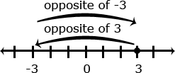  Example:  - Graph the following points in the correct quadrant of the coordinate plane. If you reflected each point across the x-axis, what are the coordinates of the reflected points? What similarities do you notice between coordinates of the original point and the reflected point?  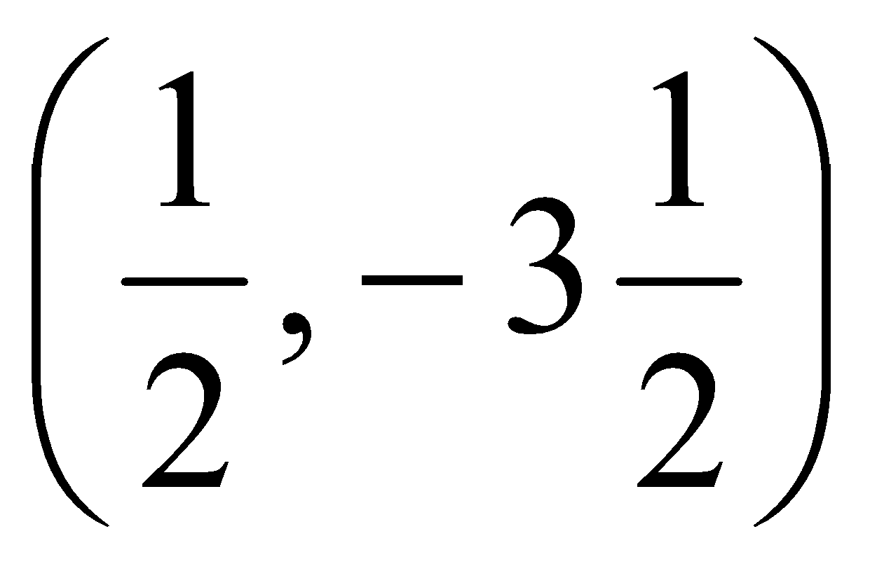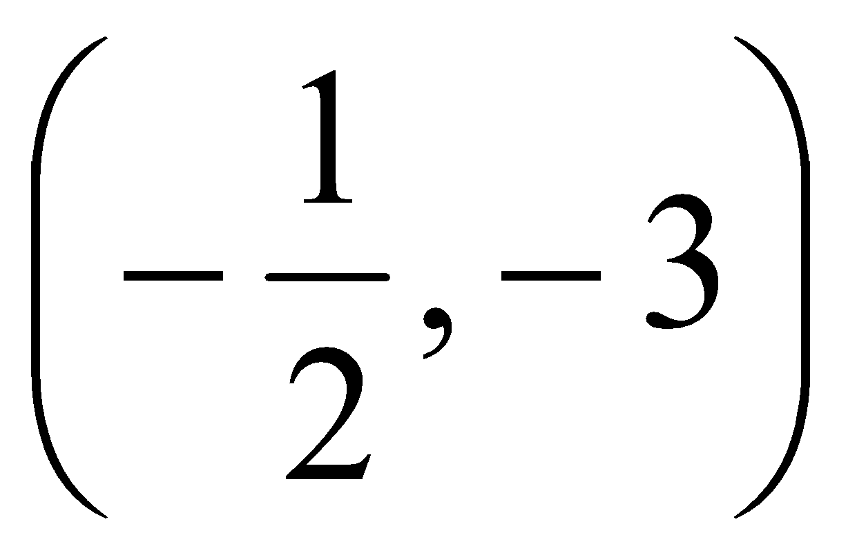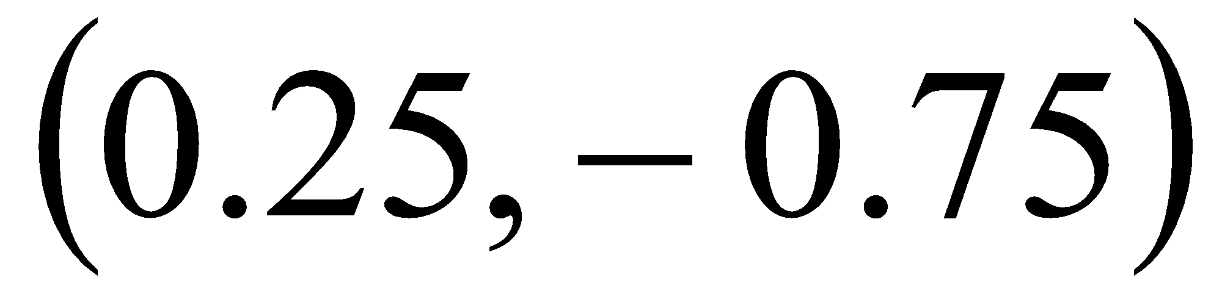
7. Understand ordering and absolute value of rational numbers.  7a: Interpret statements of inequality as statements about the relative position of two numbers on a number line diagram.  7b: Write, interpret, and explain statements of order for rational numbers in real-world contexts.  7c: Understand the absolute value of a rational number as its distance from 0 on the number line; interpret absolute value as magnitude for a positive or negative quantity in a real-world situation.  7d: Distinguish comparisons of absolute value from statements about order.  (MP 2, MP 3, MP 5) | - Interpret statements of inequality as statements about the relative positions of two numbers on a number line diagram. For example: interpret -3>-7 on a number line oriented from left to right.  - Write, interpret, and explain statements of order for rational numbers in real world contexts. For example, -3$℃$ >-7$℃$ to express that -3$℃$is warmer then -7$℃$.  - Interpret absolute values as magnitude as positive or negative quantity in a real world situation. For example, an account balance of -30 dollars, write l-30l=30 to describe the size of the debt in dollars.  - Distinguish comparisons of absolute value from statements about order. For example, recognize that an account balance less than -30 dollars represents a debt greater than 30 dollars. |  | - Write the absolute value of a number  - Review definition of inequality symbols  - Write statements of inequalities comparing two numbers  - Draw a number line to represent an interval of numbers.  - Interpret and explain statements of order for positive and negative numbers in real-world contexts  - Extend the application of absolute value from whole numbers to rational numbers  - Distinguish statements about order from absolute value |  | The absolute value of a number is the distance of that number from 0 on a number line.  Because distances are always positive, the absolute value of a positive or negative number is always positive.  Absolute value bars are used to show the absolute value of a number.  Example:  The absolute value of -5 is 5. This can be written as |-5| = 5.  The absolute value of 5 is 5. This can be written as |5| = 5.  Common models to represent and compare integers include number line models, temperature models and the profit-loss model. On a number line model, the number is represented by an arrow drawn from zero to the location of the number on the number line; the absolute value is the length of this arrow. The number line can also be viewed as a thermometer where each point of on the number line is a specific temperature. In the profit-loss model, a positive number corresponds to profit and the negative number corresponds to a loss. Each of these models is useful for examining values but can also be used in later grades when students begin to perform operations on integers.  In working with number line models, students internalize the order of the numbers; larger numbers on the right or top of the number line and smaller numbers to the left or bottom of the number line. They use the order to correctly locate integers and other rational numbers on the number line. By placing two numbers on the same number line, they are able to write inequalities and make statements about the relationships between the numbers.  Case 1: Two positive numbers  5 > 3  5 is greater than 3  Case 2: One positive and one negative number  3 > -3  positive 3 is greater than negative 3  negative 3 is less than positive 3  Case 3: Two negative numbers  -3 > -5  negative 3 is greater than negative 5  negative 5 is less than negative 3  Continued on next page  Comparative statements generate informal experience with operations and lay the foundation for formal work with operations on integers in grade 7.  Example:  - One of the thermometers shows -3°C and the other shows -7°C. Which thermometer shows which temperature? Which is the colder temperature? How much colder? Write an inequality to show the relationship between the temperatures and explain how the model shows this relationship.  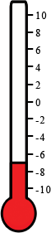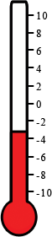  Students recognize the distance from zero as the absolute value or magnitude of a rational number. Students need multiple experiences to understand the relationships between numbers, absolute value, and statements about order.  Example:  The Great Barrier Reef is the world’s largest reef system and is located off the coast of Australia. It reaches from the surface of the ocean to a depth of 150 meters. Students could represent this value as less than 150 meters or a depth no greater than 150 meters below sea level.  - Clarence owes $240 to his brother Joe and $166 to his best friend Tristan. His sister Chloe owes $275 to Clarence, and his friend Luke owes $150 to Clarence.  Clarence writes the number -240 to represent the amount he owes his brother Joe. What numbers should Clarence use to represent the other amounts given above?  (Amount owed to Tristan: -166, amount owed by Chloe: 275, amount owed by Luke 150)
8. Solve real-world and mathematical problems by graphing points in all four quadrants of the coordinate plane. Include use of coordinates and absolute value to find distances between points with the same first coordinate or the same second coordinate.  (MP 1, MP 2, MP 4, MP 5) | - Solve real-world and mathematical problems by graphing points in all four quadrants of the coordinate plane.  - Find distances between points with the same first coordinate or the same second coordinate, using coordinate and absolute value. |  | - Review plotting points on a coordinate plane  - Plot points on the coordinate plane to solve real-world problems |  | Example:  - If the points on the coordinate plane below are the three vertices of a rectangle, what are the coordinates of the fourth vertex? How do you know? What are the length and width of the rectangle?  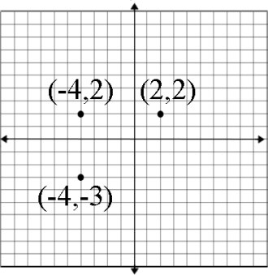  To determine the distance along the x-axis between the point (-4, 2) and (2, 2) a student must recognize that -4 is $|-4|$ or 4 units to the left of 0 and 2 is $|2|$ or 2 units to the right of zero, so the two points are total of 6 units apart along the x-axis. Students should represent this on the coordinate grid and numerically with an absolute value expression, $|-4|$ + $|2|$.
Differentiation/Accommodations/Modifications
Gifted and Talented |  | English Language Learners |  | Students with Disabilities |  | Students at Risk of School Failure
- Students find location given longitude and latitude using the coordinate plane.  - Research and compare temperature of cities around the world. |  | - Video clips  - Graphic organizers  - development, comprehension  - Read aloud  - Word Wall  - Build background knowledge  - Partner Work  - For more, see http://www.state.nj.us/education/modelcurriculum/ela/ellscaffolding/3u1.pdf |  | - Extended time  - Modified assignments  - Small group, alternate location  - Real world coordinate plane scenarios  - Modeling  - Read aloud problems  - Calculator  - Build background knowledge  - Oral/visual reminders  - Peer assistance  - Picture associations with vocabulary  - Labeled coordinate plane graph paper  - Labeled number lines  - Refer to each student’s IEP for more specific modifications |  | - RTI strategies including: reciprocal teaching, teacher modeling,  - Tier II and Tier III intervention  - More frequent STAR assessments  - Morning tutoring  - After school program  - Parental contact

Math Curriculum
Grade Six

Content: Expressions and Equations
Essential Question(s): How can you identify, simplify, and evaluate various algebraic expressions?
Standards: 6.EE
A. Apply and extend previous understandings of arithmetic to algebraic expressions.
Vocabulary: Distributive property, algebraic expression, exponential notation, variable, coefficient
Standards for Mathematical Practice: MP 2, MP 7
Grade Specific Standards | Skills | Instructional Procedures | Explanations and Examples
1. Write and evaluate numerical expressions involving whole-number exponents.  (MP 2, MP 7) | - Write numerical expressions involving whole-number exponents.  - Write numerical expressions involving whole-number exponents. | - Recall order of operations  - Introduce new vocabulary  - Model examples of standard expanded and exponential form  - Practice translating between numerical and written expressions  - Apply to problem-solving | Examples:  - Write the following as a numerical expressions using exponential notation.  - The area of a square with a side length of 8 m (Solution: (8m)²  - The volume of a cube with a side length of 5 ft: (Solution: (5ft)³  - Yu-Lee has a pair of mice. The mice each have 2 babies. The babies grow up and have two babies of their own: (Solution: 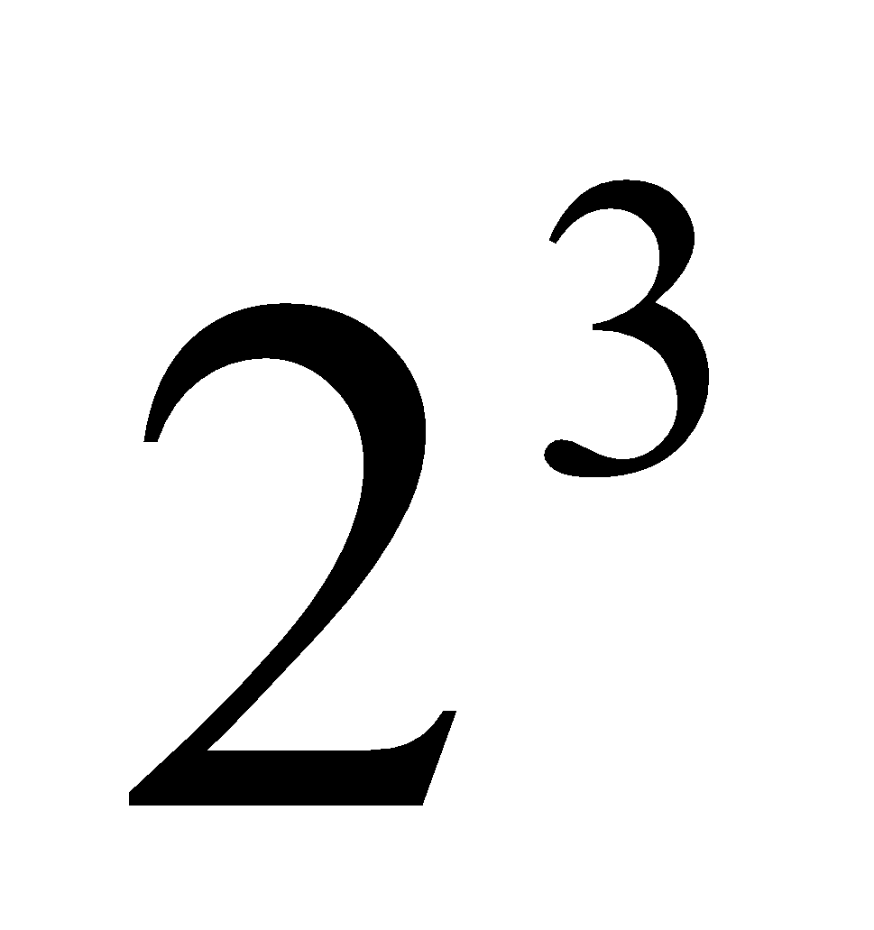mice)  - Evaluate:  - 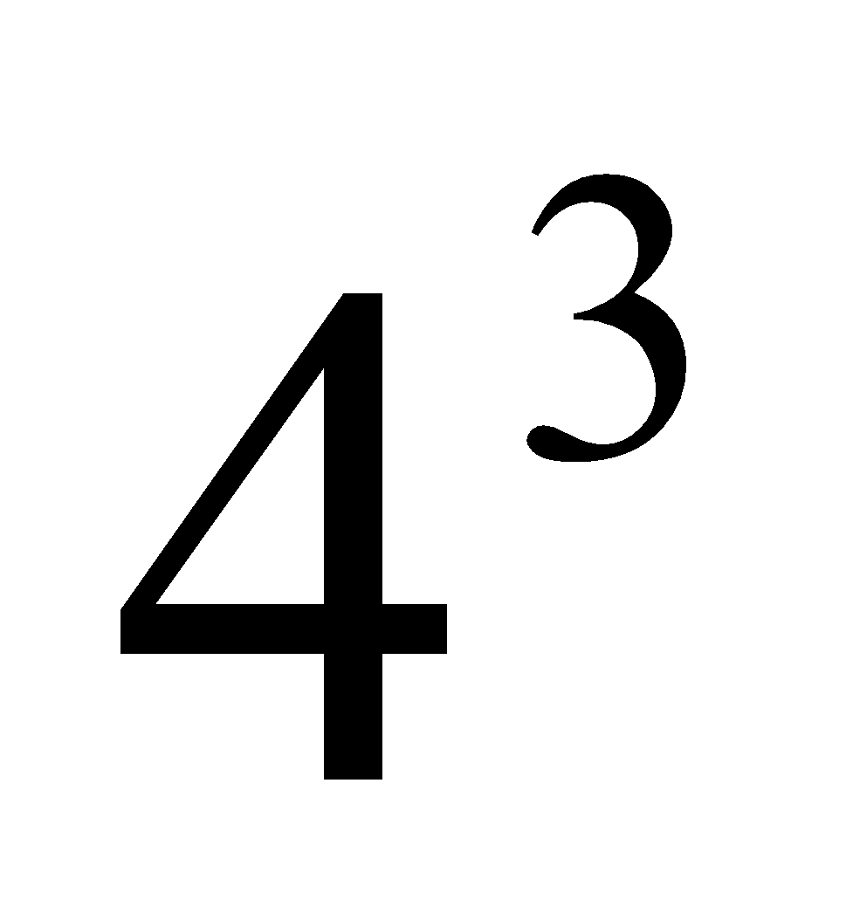 (Solution: 64)  - 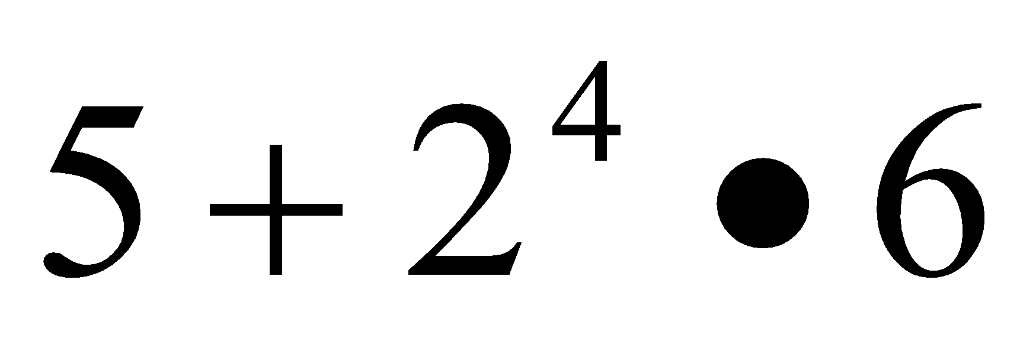 (Solution: 101)  - 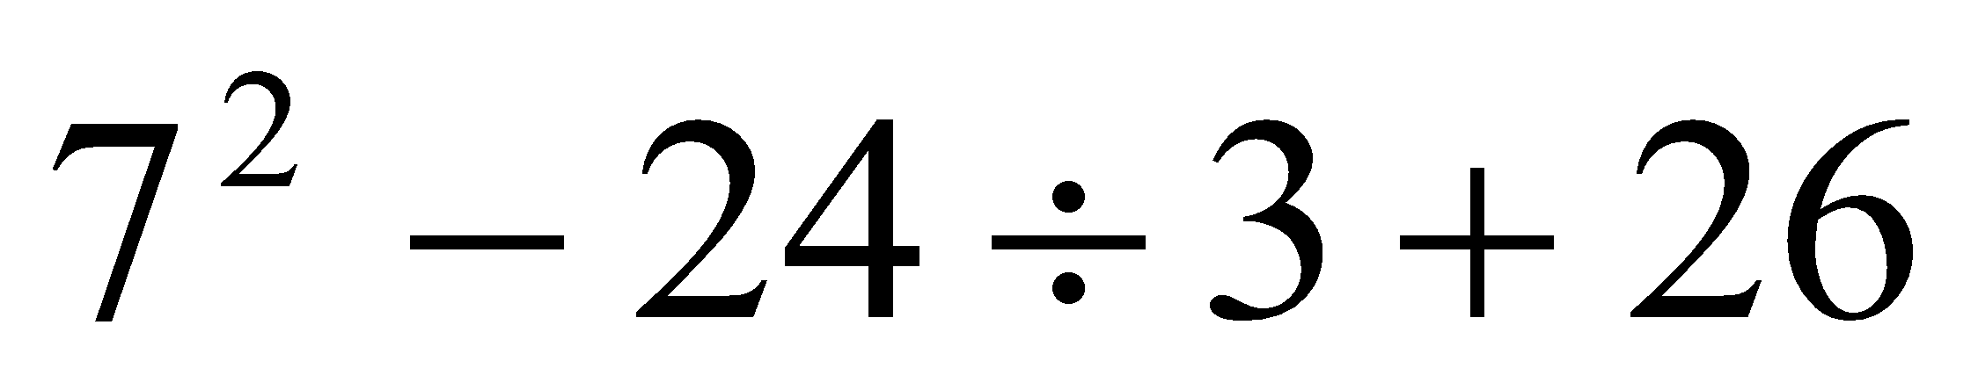 (Solution: 67)
2. Write, read, and evaluate expressions in which letters stand for numbers.  2a: Write expressions that record operations with numbers and with letters standing for numbers. For example, express the calculation “Subtract y from 5” as 5 – y.  2b: Identify parts of an expression using mathematical terms (sum, term, product, factor, quotient, coefficient); view one or more parts of an expression as a single entity.  2c: Evaluate expressions at specific values of their variables. Include expressions that arise from formulas used in real-world problems. Perform arithmetic operations, including those involving whole-number exponents, in the conventional order when there are no parentheses to specify a particular order (Order of Operations).  (MP 2, MP 7) | - Write expressions in which letters stand for numbers  - Read expressions in which letters stand for numbers  - Evaluate expressions in which letters stand for numbers  - Identify parts of an expression using mathematical terms (sum, term, product, factor, quotient, coefficient); view one or more parts of an expression as a single entity. For example, describe the expression 2 (8 + 7) as a product of two factors; view (8 + 7) as both a single entity and a sum of two terms.  - Evaluate expressions at specific values of their variables. Include expressions that arise from formulas used in real-world problems. Perform arithmetic operations, including those involving whole-number exponents, in the conventional order when there are no parentheses to specify a particular order (Order of Operations). For example, use the formulas V = s³ and A = 6 s² to find the volume and surface area of a cube with sides of length s = 1/2. | - Reinforce vocabulary  - Identify parts of algebraic expressions by showing example  - Practice translating between algebraic and written expressions  - Evaluate for a given value  - Expand translating to include more complex expressions with a greater number of terms  - Evaluate multiple term algebraic expressions for given values using order of operations  - Apply knowledge to solve real-world problems | It is important for students to read algebraic expressions in a manner that reinforces that the variable represents a number.  - r + 21 as “some number plus 21 as well as “r plus 21”  - n ∙ 6 as “some number times 6 as well as “n times 6”  - and s ÷ 6 as “as some number divided by 6” as well as “s divided by 6”  Students should identify the parts of an algebraic expression including variables, coefficients, constants, and the names of operations (sum, difference, product, and quotient). Development of this common language helps students to understand the structure of expressions and explain their process for simplifying expressions.  Terms are the parts of a sum. When the term is an explicit number, it is called a constant. When the term is a product of a number and a variable, the number is called the coefficient of the variable.  Variables are letters that represent numbers. There are various possibilities for the numbers they can represent; students can substitute these possible numbers for the letters in the expression for various different purposes.  Consider the following expression:  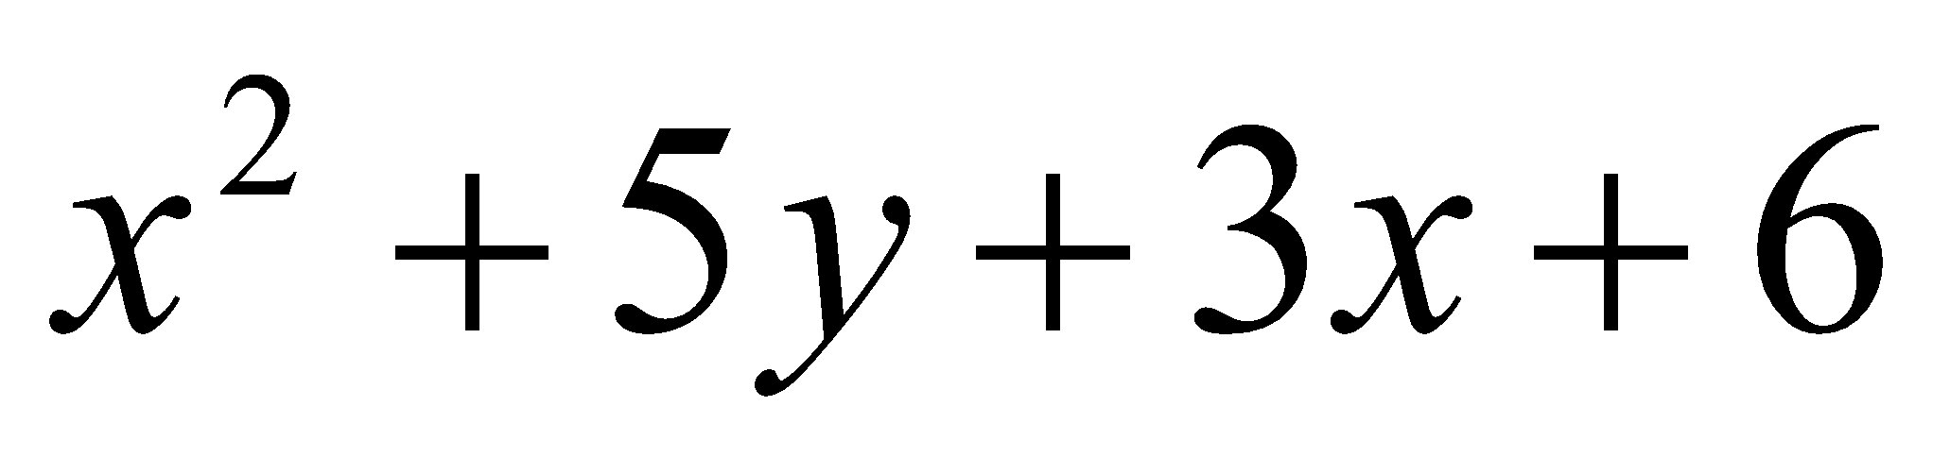  The variables are x and y.  There are 4 terms, x², 5y, 3x, and 6.  There are 3 terms with variables, x², 5y, 3x.  They have coefficients of 1, 5, and 3 respectively.  The coefficient of x² is 1, since x² = 1 x².  The term 5y represent 5 y’s or 5 * y.  There is one constant term, 6.  The expression shows a sum of all four terms.  Examples:  - 7 more than 3 times a number (Solution: 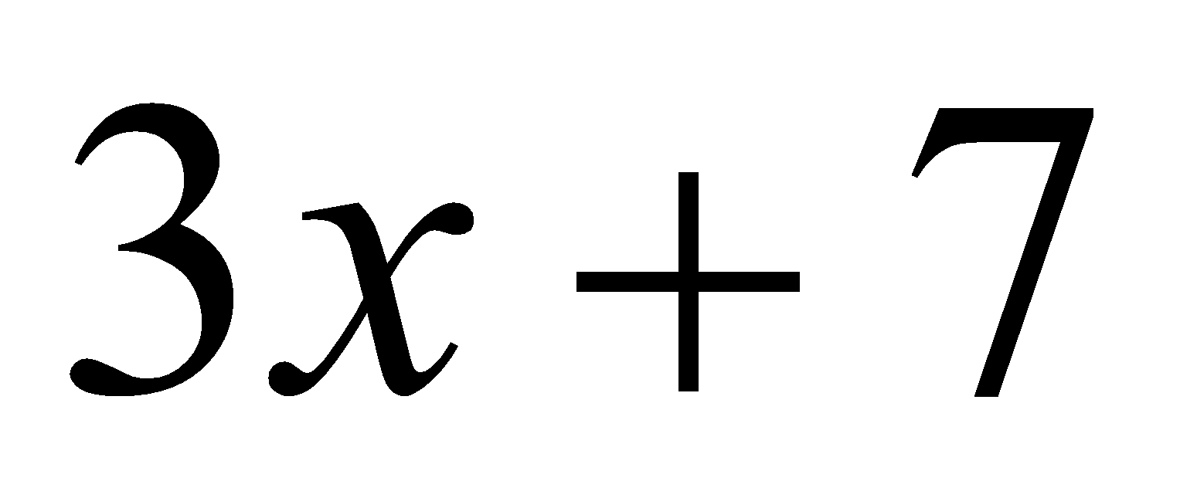)  - 3 times the sum of a number and 5 (Solution: 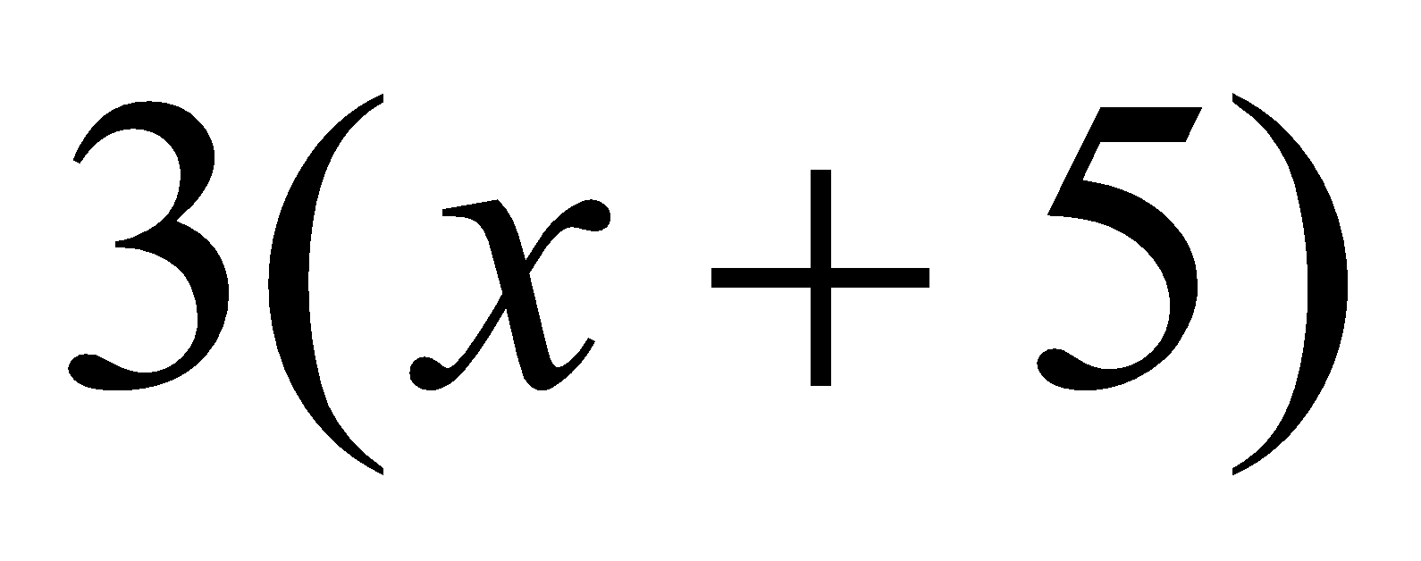  - 7 less than the product of 2 and a number (Solution: 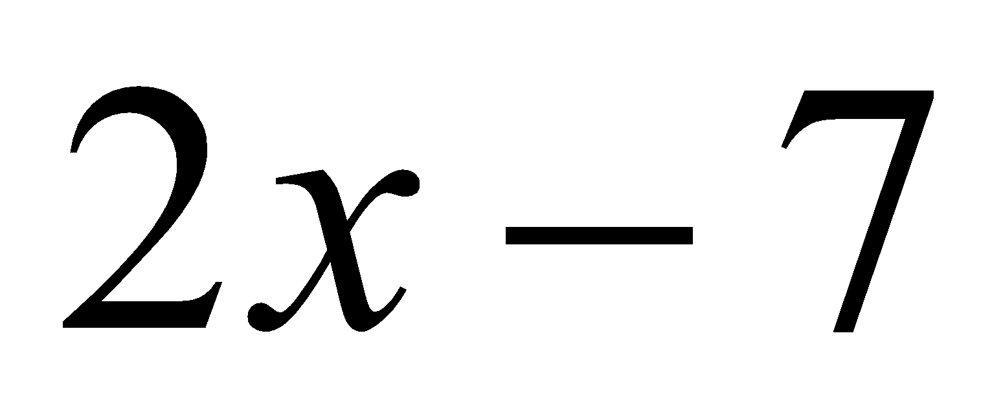)  - Twice the difference between a number and 5 (Solution: 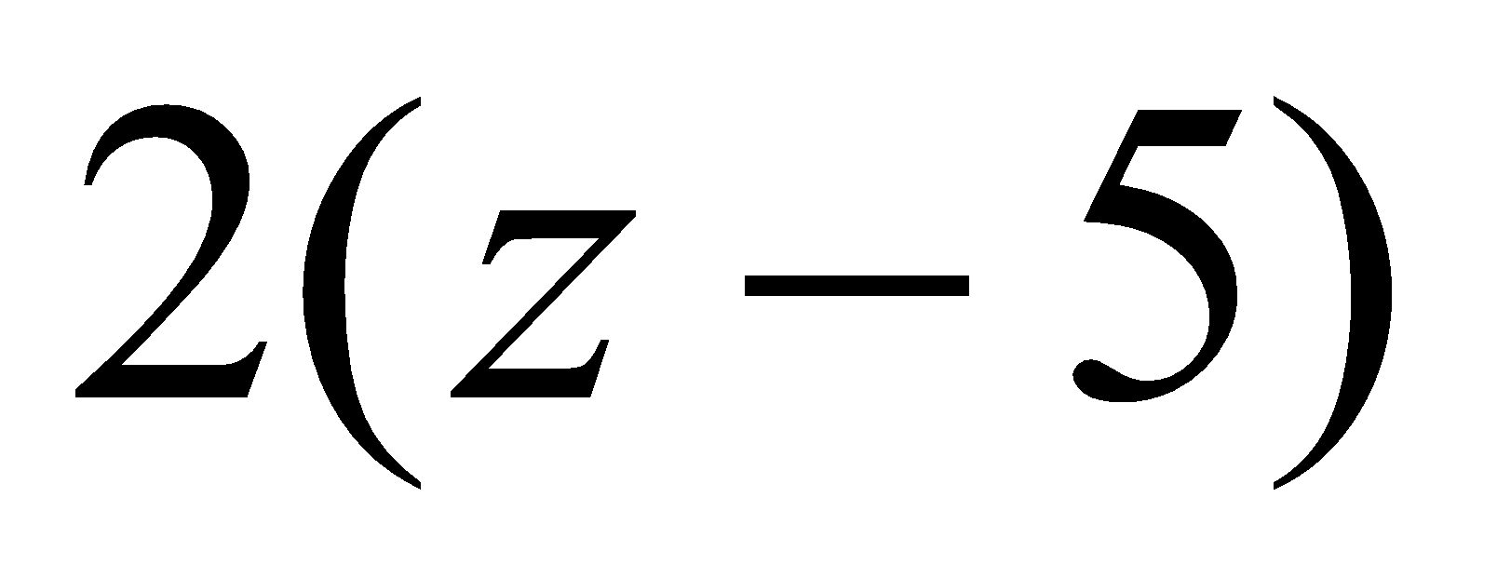)  - Evaluate 5(n + 3) – 7n, when n =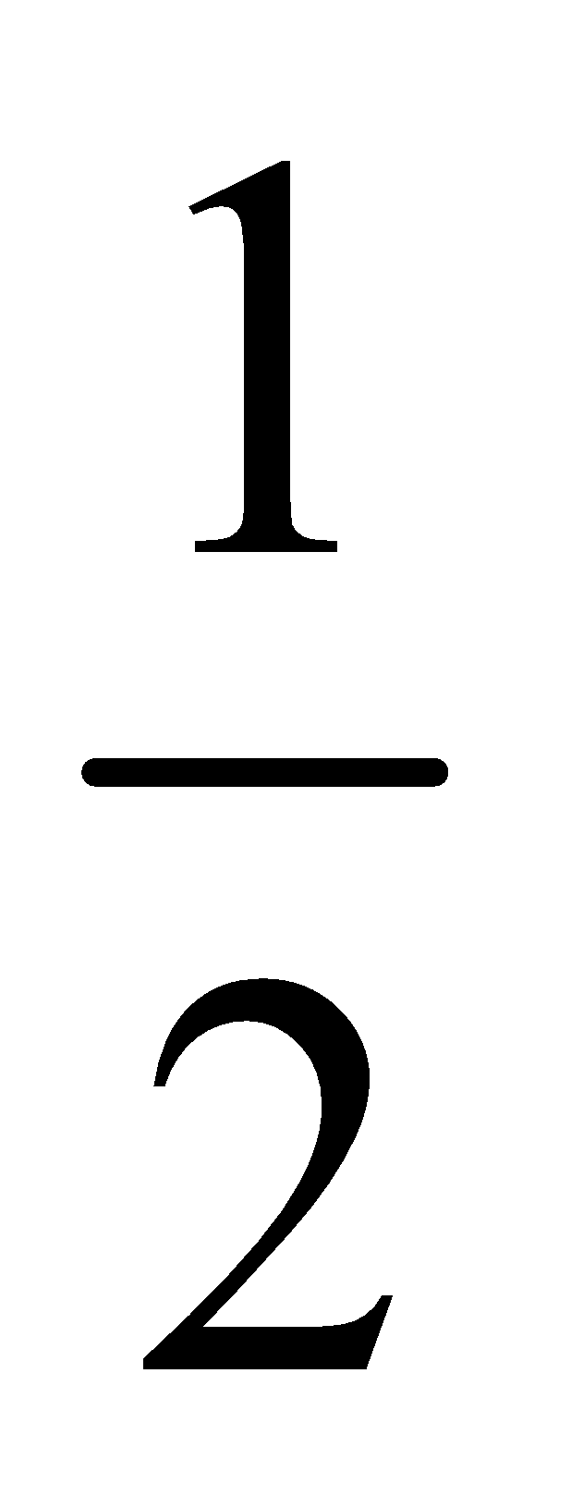.  - The expression c + 0.07c can be used to find the total cost of an item with 7% sales tax, where c is the pre-tax cost of the item. Use the expression to find the total cost of an item that cost $25.  - The perimeter of a parallelogram is found using the formula p = 2l + 2w. What is the perimeter of a rectangular picture frame with dimensions of 8.5 inches by 11 inches?
3. Apply the properties of operations to generate equivalent expressions.  (MP 2, MP 7) | - Apply the properties of operations to generate equivalent expressions. For example, apply the distributive property to the expression 3 (2 + x) to produce the equivalent expression 6 + 3x; apply the distributive property to the expression 24x + 18y to produce the equivalent expression 6 (4x + 3y); apply properties of operations to y + y + y to produce the equivalent expression 3y. | - Illustrate the distributive property using a visual representation (ex. algebra tiles)  - Apply distributive property to produce equivalent expressions | Students use their understanding of multiplication to interpret 3 (2 + x). For example, 3 groups of (2 + x). They use a model to represent x, and make an array to show the meaning of 3(2 + x). They can explain why it makes sense that 3(2 + x) is equal to 6 + 3x.  An array with 3 columns and x + 2 in each column:  Students interpret y as referring to one y. Thus, they can reason that one y plus one y plus one y must be 3y. They also the distributive property, the multiplicative identity property of 1, and the commutative property for multiplication to prove that y + y + y = 3y:  y + y + y = y ∙ 1 + y ∙ 1 + y ∙ 1 = y(1 + 1 + 1) = y ∙ 3 = 3y  Find the GCF of the following expression and then write an equivalent expression using the distributive property.  24x +18y = 6 ∙ 4x + 6 ∙ 3y  = 6(4x+3y)
4. Identify when two expressions are equivalent (i.e., when the two expressions name the same number regardless of which value is substituted into them).  (MP 2, MP 7) | - Identify when two expressions are equivalent (i.e., when the two expressions name the same number regardless of which value is substituted into them). For example, the expressions y + y + y and 3y are equivalent because they name the same number regardless of which number y stands for. Reason about and solve one-variable equations and inequalities. | - Apply prior knowledge of properties to simplify expressions  - Introduce combining like terms (ex. x² is different that x)  - Identify equivalent expressions | Students connect their experiences with finding and identifying equivalent forms of whole numbers and can write expressions in various forms. Students generate equivalent expressions using the associative, commutative, and distributive properties. They can prove that the expressions are equivalent by simplifying each expression into the same form.  Example:  - Are the expressions equivalent? How do you know?  4m + 8 4(m+2) 3m + 8 + m 2 + 2m + m + 6 + m  Solution:  Expression Simplifying the Expression Explanation  4m + 8 4m + 8 Already in simplest form  4(m+2) 4(m+2) 4m + 8 Distributive property  3m + 8 + m 3m + 8 + m 3m + m + 8 (3m + m) + 8 4m + 8 Combined like terms  2 + 2m + m + 6 + m 2 + 2m + m + 6 + m 2 + 6 + 2m + m + m (2 + 6) + (2m + m + m) 8 + 4m 4m + 8 Combined like terms

Differentiation/Accommodations/Modifications
Gifted and Talented | English Language Learners | Students with Disabilities | Students at Risk of School Failure
- About Me poster using writing numerical and algebraic expressions.  - Distance Project: Students are given two locations and they must write the expression that represents their distance apart.  - Exponent Challenge Problems | - Video clips  - Manipulatives  - Graphic organizers  development, comprehension  - Read aloud  - Word Wall  - Build background knowledge  - Partner Work  - Word problems in simpler English.  - For more, see http://www.state.nj.us/education/modelcurriculum/ela/ellscaffolding/3u1.pdf | - Extended time  - Modified assignments  - Small group, alternate location  - Real world expression and equation scenarios  - Modeling  - Read aloud problems  - Calculator  - Build background knowledge  - Oral/visual reminders  - Numbered steps  - Colored cues for combining like terms  - Peer assistance  - Picture associations with vocabulary  - Refer to each student’s IEP for more specific modifications | - RTI strategies including: reciprocal teaching, teacher modeling,  - Tier II and Tier III intervention  - More frequent STAR assessments  - Morning tutoring  - After school program  - Parental contact

Math Curriculum
Grade Six

Content: Expressions and Equations
Essential Question(s):
How can you use equations and inequalities to solve real-world problems?
What is the difference between and equation and an inequality?
What des it mean when a a number does not satisfy an equation or inequality?
Standards: 6.EE
B. Reason about and solve one-variable equations and inequalities.
Vocabulary: equation, inequality, inverse operations, solution set
Standards for Mathematical Practice: MP 1, MP 2, MP 5, MP 6, MP 7,
Standards | Skills | Instructional Procedures | Explanations and Examples
5. Understand solving an equation or inequality as a process of answering a question: which values from a specified set, if any, make the equation or inequality true? Use substitution to determine whether a given number in a specified set makes an equation or inequality true.  (MP 5, MP 6) | - Use substitution to determine whether a given number in a specified set makes an equation or inequality true | - Demonstrate various strategies to solve equations (ex. fact families, inverse operations, on the bar model)  - Introduce the concept of inequalities as it relates to equations  - Solve inequalities and equations | Beginning experiences in solving equations should require students to understand the meaning of the equation as well as the question being asked. Solving equations using reasoning and prior knowledge should be required of students to allow them to develop effective strategies such as using reasoning, fact families, and inverse operations. Students may use balance models in representing and solving equations and inequalities.  Consider the following situation: Joey had 26 papers in his desk. His teacher gave him some more and now he has 100. How many papers did his teacher give him?  This situation can be represented by the equation 26 + n = 100 where n is the number of papers the teacher gives to Joey. This equation can be stated as “some number was added to 26 and the result was 100”. Students ask themselves “What number was added to 26 to get 100?” to help them determine the value of the variable that makes the equation true. Students could use several different strategies to find a solution to the problem.  - Reasoning: 26 + 70 is 96. 96 + 4 is 100, so the number added to 26 to get 100 is 74.  - Use knowledge of fact families to write related equations:  n + 26 = 100, 100 - n = 26, 100 - 26 = n. Select the equation that helps you find n easily.  - Use knowledge of inverse operations: Since subtraction “undoes” addition then subtract 26 from 100 to get the numerical value of n  - Scale model: There are 26 blocks on the left side of the scale and 100 blocks on the right side of the scale. All the blocks are the same size. 74 blocks need to be added to the left side of the scale to make the scale balance.  - Bar Model: Each bar represents one of the values.  - Students use this visual representation to demonstrate that 26 and the unknown value together make 100.  100  26  n  Examples:  - The equation 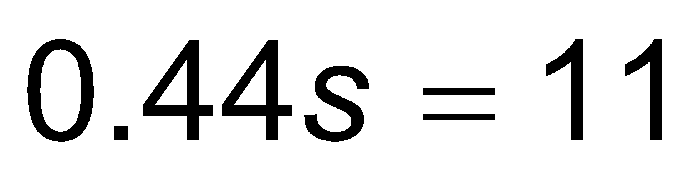 where s represents the number of stamps in a booklet. The booklet of stamps costs 11 dollars and each stamp costs 44 cents. How many stamps are in the booklet? Explain the strategies you used to determine your answer. Show that your solution is correct using substitution.  Twelve is less than 3 times another number can be shown by the inequality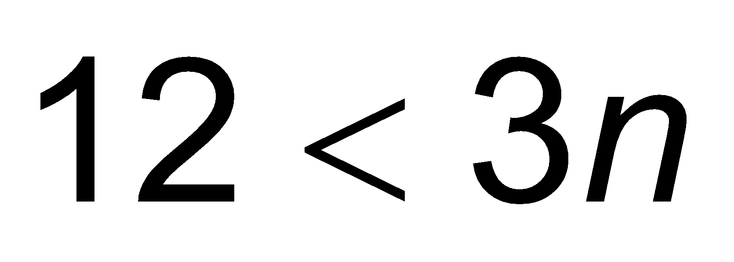$12<3n$. What numbers could possibly make this a true statement?  Example:  - The youth group is going on a trip to the state fair. The trip costs $52. Included in that price is $11 for a concert ticket and the cost of 2 passes, one for the rides and one for the game booths. Each of the passes cost the same price. Write an equation representing the cost of the trip and determine the price of one pass.  x  x  11  52  2x + 11 = 52  2x = 41  x = $20.50
6. Use variables to represent numbers and write expressions when solving a real-world or mathematical problem; understand that a variable can represent an unknown number, or, depending on the purpose at hand, any number in a specified set.  (MP 2, MP 6, MP 7) | - Use variables to represent numbers | - Translate word problems to algebraic expression  - Use variables to represent parts of a problem  - Review key terms that indicate operations  (+, -, ∙, ⎟, =) | Connecting writing expressions with story problems and/or drawing pictures will give students a context for this work. It is important for students to read algebraic expressions in a manner that reinforces that the variable represents a number.  Examples:  - Maria has three more than twice as many crayons as Elizabeth. Write an algebraic expression to represent the number of crayons that Maria has.  (Solution: 2c + 3 where c represents the number of crayons that Elizabeth has.)  - An amusement park charges $28 to enter and $0.35 per ticket. Write an algebraic expression to represent the total amount spent. (Solution: 28 + 0.35t where t represents the number of tickets purchased)  - Andrew has a summer job doing yard work. He is paid $15 per hour and a $20 bonus when he completes the yard. He was paid $85 for completing one yard. Write an equation to represent the amount of money he earned.  (Solution: 15h + 20 = 85 where h is the number of hours worked)  - Describe a problem situation that can be solved using the equation 2c + 3 = 15; where c represents the cost of an item  - Bill earned $5.00 mowing the lawn on Saturday. He earned more money on Sunday. Write an expression that shows the amount of money Bill has earned. (Solution: $5.00 + n)
7. Solve real-world and mathematical problems by writing and solving equations of the form x + p = q and px = q for cases in which p, q and x are all non-negative rational numbers.  (MP 1, MP 2, MP 6, MP 7) | - Solve real-world and mathematical problems by writing and solving equations of the form x + p = q for cases in which p, q and x are all non-negative rational numbers.  - Solve real-world and mathematical problems by writing and solving equations of the form px = q for cases in which p, q and x are all non-negative rational numbers. | - Apply knowledge of translating words to algebra to write and solve equations  - Illustrate and model various word problems using equations involving variables | Students create and solve equations that are based on real world situations. It may be beneficial for students to draw pictures that illustrate the equation in problem situations. Solving equations using reasoning and prior knowledge should be required of students to allow them to develop effective strategies.  Example:  - Meagan spent $56.58 on three pairs of jeans. If each pair of jeans costs the same amount, write an algebraic equation that represents this situation and solve to determine how much one pair of jeans cost.  $56.58  J  J  J  Sample Solution: Students might say: “I created the bar model to show the cost of the three pairs of jeans. Each bar labeled J is the same size because each pair of jeans costs the same amount of money. The bar model represents the equation 3J = $56.58. To solve the problem, I need to divide the total cost of 56.58 between the three pairs of jeans. I know that it will be more than $10 each because 10 x 3 is only 30 but less than $20 each because 20 x 3 is 60. If I start with $15 each, I am up to $45. I have $11.58 left. I then give each pair of jeans $3. That’s $9 more dollars. I only have $2.58 left. I continue until all the money is divided. I ended up giving each pair of jeans another $0.86. Each pair of jeans costs $18.86 (15+3+0.86). I double check that the jeans cost $18.86 each because $18.86 x 3 is $56.58.”  - Julio gets paid $20 for babysitting. He spends $1.99 on a package of trading cards and $6.50 on lunch. Write and solve an equation to show how much money Julio has left.  (Solution: 20 = 1.99 + 6.50 + x, x = $11.51)  20  1.99  6.50  money left over (m)  - Students will be given various investment options, such as stocks. Each stock will have a different equation showing the earnings from the investment. Students will have to calculate the earning given a certain dollar amount and identify and explain which option they determine is the more beneficial option.
8. Write an inequality of the form x > c or x < c to represent a constraint or condition in a real-world or mathematical problem. Recognize that inequalities of the form x > c or x < c have infinitely many solutions; represent solutions of such inequalities on number line diagrams.  (MP 2, MP 6, MP 7) | - Write an inequality of the form x > c or x < c to represent a constraint or condition in a real-world or mathematical problem.  - Recognize that inequalities of the form x > c or x < c have infinitely many solutions  - represent solutions of such inequalities on number line diagrams. | - Introduce graphing inequalities  - Determine if a given number is part of the solution set  - Review the difference between graphing:  x > 5 and x ≥ 5 | Examples:  - Graph x ≤ 4.  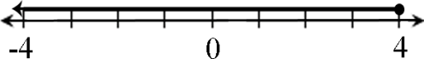  - Jonas spent more than $50 at an amusement park. Write an inequality to represent the amount of money Jonas spent. What are some possible amounts of money Jonas could have spent? Represent the situation on a number line.  - Less than $200.00 was spent by the Flores family on groceries last month. Write an inequality to represent this amount and graph this inequality on a number line.  Solution: 200 > x  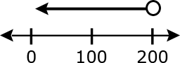

Differentiation/Accommodations/Modifications
Gifted and Talented | English Language Learners | Students with Disabilities | Students at Risk of School Failure
- Multimedia project, such as how to or presentation.  - Career project- Students will research careers of interest. Students will write and graph salary ranges as inequalities. Students will create a multimedia project explain how to acquire that job. | - Video clips  - Graphic organizers  development, comprehension  - Read aloud  - Word Wall  - Build background knowledge  - Partner Work  - Word problems in simpler English.  - Manipulative  - For more, see http://www.state.nj.us/education/modelcurriculum/ela/ellscaffolding/3u1.pdf | - Extended time  - Modified assignments  - Small group, alternate location  - Real world expression and equation scenarios  - Modeling  - Read aloud problems  - Calculator  - Build background knowledge  - Oral/visual reminders  - Peer assistance  - Picture associations with vocabulary  - Already numbered number lines  - Algebra tiles  - Refer to each student’s IEP for more specific modifications | - RTI strategies including: reciprocal teaching, teacher modeling,  - Tier II and Tier III intervention  - More frequent STAR assessments  - Morning tutoring  - After school program  - Parental contact

Math Curriculum
Grade Six

Content: Expression and Equations
Essential Question(s):
How can you use a graph to visually represent and interpret a relationship between two variables?
How is a relation represented in tables?
How is a relationship represented in graphs?
How is a relationship represented in an equation?
How can one tell that there is a relationship between two quantities?
Why is it useful to write an equation to express one quantity in terms of another quantity?
Standards: 6.EE
C. Represent and analyze quantitative relationships between dependent and independent variables.
Vocabulary: function, independent and dependent variables, ordered pairs, quadrant, origin
Standards for Mathematical Practice: MP 2, MP 4, MP 6
Standards | Skills |  | Instructional Procedures |  | Explanations and Examples
9. Use variables to represent two quantities in a real-world problem that change in relationship to one another; write an equation to express one quantity, thought of as the dependent variable, in terms of the other quantity, thought of as the independent variable. Analyze the relationship between the dependent and independent variables using graphs and tables, and relate these to the equation. For example, in a problem involving motion at constant speed, list and graph ordered pairs of distances and times, and write the equation d = 65t to represent the relationship between distance and time.  (MP 2, MP 4,  MP 6) | - Use variables to represent two quantities in a real-world problem that change in relationship to one another  - Write an equation to express one quantity, thought of as the dependent variable, in terms of the other quantity, thought of as the independent variable.  - Analyze the relationship between the dependent and independent variables using graphs and tables, and relate these to the equation.  - Use the equation of the relationship between two dependent and independent variables to predict ordered pairs that are not displaced in a given graph or table. |  | - Introduce the concept of functions and related vocabulary (dependent & independent)  - Teach how to graph the function within the four quadrants  - Explain and demonstrate what various graphs indicate about the relationship of the x- and y- variables (dependent/independent)  - Write and graph equations for various problems |  | Students can use many forms to represent relationships between quantities. Multiple representations include describing the relationship using language, a table, an equation, or a graph. Translating between multiple representations helps students understand that each form represents the same relationship and provides a different perspective on the function.  Examples:  - What is the relationship between the two variables? Write an expression that illustrates the relationship.  x 1 2 3 4  y 2.5 5 7.5 10  - Use the graph below to describe the change in y as x increases by 1.  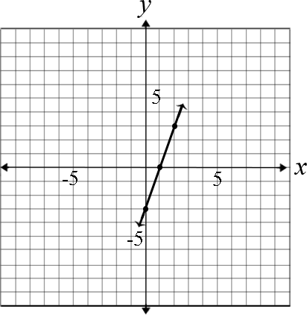  - Susan started with $1 in her savings. She plans to add $4 per week to her savings. Use an equation, table and graph to demonstrate the relationship between the number of weeks that pass and the amount in her savings account.  - Language: Susan has $1 in her savings account. She is going to save $4 each week.  - Equation: y = 4x + 1  - Table:  x y  0 1  1 5  2 9  - Graph:  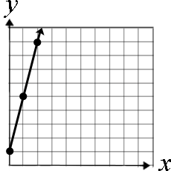
Differentiation/Accommodations/Modifications
Gifted and Talented |  | English Language Learners |  | Students with Disabilities |  | Students at Risk of School Failure
- Illustrative Mathematics-Chocolate Bar Sales  - Create tables from multi-step equations and word problems.  - Students will create graphs representing relationship between two researched variables, such as cost/lb, quarts/min, distance/bus fare. |  | - Video clips  - Graphic organizers  development, comprehension  - Read aloud  - Word Wall  - Build background knowledge  - Partner Work  - Word problems in simpler English.  - Manipulative  - For more, see http://www.state.nj.us/education/modelcurriculum/ela/ellscaffolding/3u1.pdf |  | - Extended time  - Modified assignments  - Small group, alternate location  - Real world expression and equation scenarios  - Modeling  - Read aloud problems  - Calculator  - Build background knowledge  - Oral/visual reminders  - Peer assistance  - Picture associations with vocabulary  - Already numbered number lines  - Algebra tiles  - Refer to each student’s IEP for more specific modifications |  | - RTI strategies including: reciprocal teaching, teacher modeling,  - Tier II and Tier III intervention  - More frequent STAR assessments  - Morning tutoring  - After school program  - Parental contact

Math Curriculum
Grade Six

Content: Geometry
Essential Question(s):
How are area, surface area, and volume used to solve real world problems?
Why would one want to calculate the areas of polygons?
How are areas of polygons found?
How are volume and surface area of a right rectangular prism found?
Why are volumes represented in cubic units?
What is the connection between the net and surface area of 3-D figures?
Standards: 6.G
A. Solve real-world and mathematical problems involving area, surface area, and volume.
Vocabulary: area, right triangle, quadrilateral, polygon, rectangles, squares, parallelogram, trapezoid, rhombus, right rectangular prism, volume, base, height, edges, vertices, faces, surface area, net, plane figure
Standards for Mathematical Practice: MP 1, MP 2, MP 4, MP 5, MP 7
Grade Specific Standards | Skills |  | Instructional Procedures |  | Explanations and Examples
1. Find the area of right triangles, other triangles, special quadrilaterals, and polygons by composing into rectangles or decomposing into triangles and other shapes; apply these techniques in the context of solving real-world and mathematical problems.  (MP 1, MP 2, MP 5, MP 7) | - Find the area of right triangles.  - Find the area of other triangles.  - Find the area of special quadrilaterals.  - . Find the area of polygons by composing into rectangles or decomposing into triangles. |  | - Review the process of finding the area of a rectangle  - Derive the formula for area of a triangle  - Find the area of a parallelogram, trapezoid, rhombus, and other regular polygons  - Recognize that a plane figure can be divided into other polygons  - Apply formulas to solving real-world problems |  | Special quadrilaterals include rectangles, squares, parallelograms, trapezoids, and rhombi. Students can use tools such as the Isometric Drawing Tool on NCTM’s Illuminations site to shift, rotate, color, decompose and view figures in 2D or 3D (http://illuminations.nctm.org/ActivityDetail.aspx?ID=125)  Examples:  - Find the area of a triangle with a base length of three units and a height of four units.  - Find the area of the trapezoid shown below using the formulas for rectangles and triangles.  12  7  3  - A rectangle measures 3 inches by 4 inches. If the lengths of each side double, what is the effect on the area?  - The area of the rectangular school garden is 24 square units. The length of the garden is 8 units. What is the length of the fence needed to enclose the entire garden?  - The sixth grade class at Hernandez School is building a giant wooden H for their school. The H will be 10 feet tall and 10 feet wide and the thickness of the block letter will be 2.5 feet.  - What is the area of the H if measured in square feet?  - The truck that will be used to bring the wood from the lumber yard to the school can only hold a piece of wood that is 60 inches by 60 inches. How many pieces of wood are needed? What are the dimensions of each piece of wood?  H
2. Find the volume of a right rectangular prism with fractional edge lengths by packing it with unit cubes of the appropriate unit fraction edge lengths, and show that the volume is the same as would be found by multiplying the edge lengths of the prism. Apply the formulas V = l w h and V = B h to find volumes of right rectangular prisms with fractional edge lengths in the context of solving real-world and mathematical problems.  (MP 2) |  |  | - Identify prisms  - Review areas of rectangles, triangles and trapezoids  - Calculate the volume of a cube  - Use this information to determine the formula for the volume of a rectangular prism |  | Students need multiple opportunities to measure volume by filling rectangular prisms with blocks and looking at the relationship between the total volume and the area of the base. Through these experiences, students derive the volume formula (volume equals the area of the base times the height). Students can explore the connection between filling a box with unit cubes and the volume formula using interactive applets such as the Cubes Tool on NCTM’s Illuminations (http://illuminations.nctm.org/ActivityDetail.aspx?ID=6).  In addition to filling boxes, students can draw diagrams to represent fractional side lengths, connecting with multiplication of fractions. This process is similar to composing and decomposing two-dimensional shapes.  Examples:  - The model shows a cubic foot filled with cubic inches. A cubic inch can also be labeled as a fractional cubic unit with dimensions of 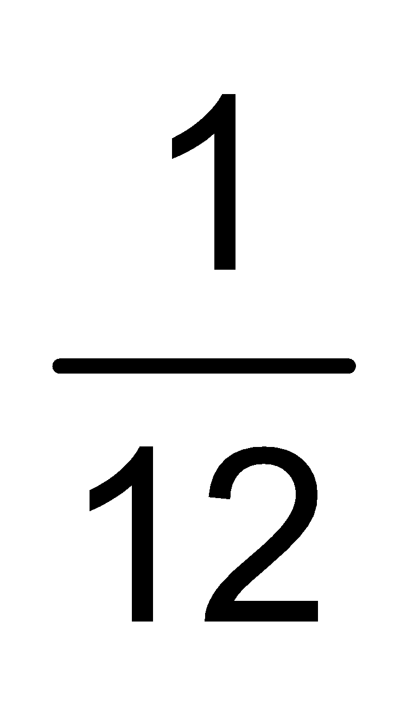 ∙ ∙ or (ft)³.  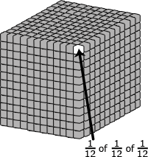  - A rectangular fish tank 60 centimeters by 15 centimeters by 34 centimeters is 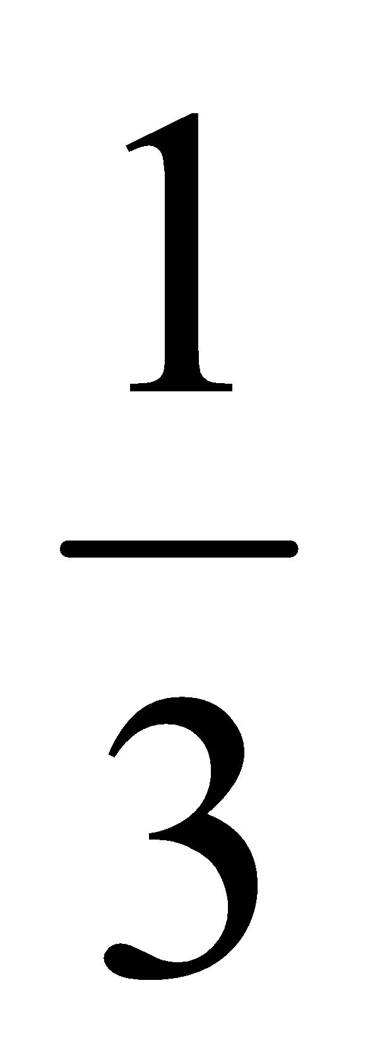full of water.  Find the volume of water needed to fill the tank completely.  Volume of water needed = volume of empty space in the tank  Height of empty space = 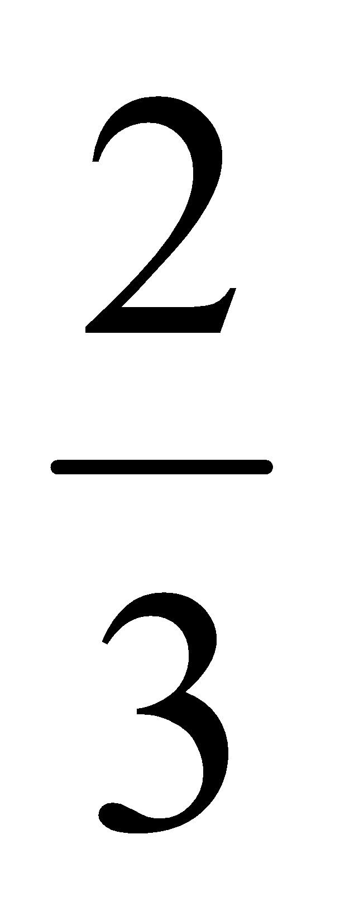∙ 34  =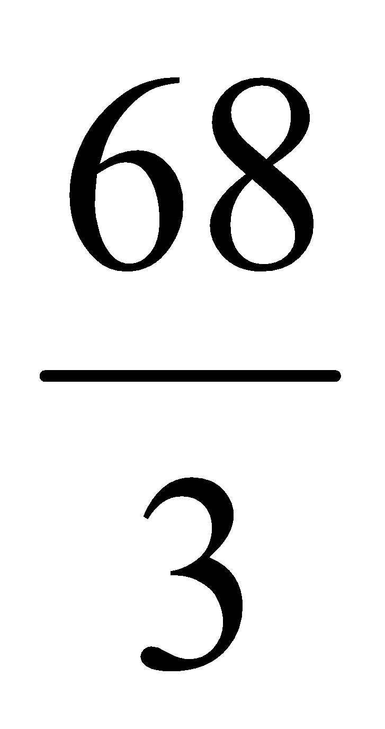cm  Volume of water needed to fill the tank = l ∙ w ∙ h  = 60 ∙ 15 ∙  =60 ∙ 5 ∙ 68  =20,400 cm³  To fill the tank, 20,400 cubic centimeters more water are needed.  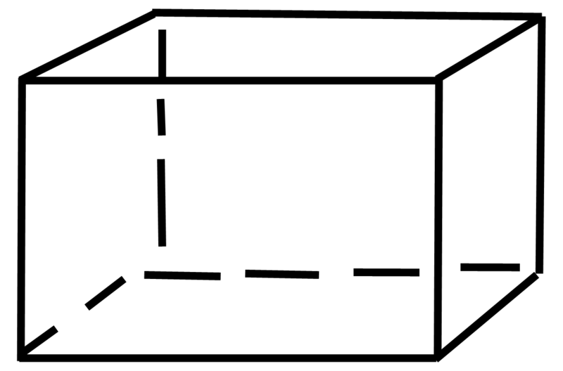  34 cm  15 cm  60 cm
3. Draw polygons in the coordinate plane given coordinates for the vertices; use coordinates to find the length of a side joining points with the same first coordinate or the same second coordinate. Apply these techniques in the context of solving real-world and mathematical problems.  (MP 1, MP 2, MP 4, MP 5) |  |  | - Review coordinate plane  - Review how to find the length of a segment joining two points  - Extend knowledge of distance to solve real-world problems, including perimeter |  | Example:  - On a map, the library is located at (-2, 2), the city hall building is located at (0, 2), and the high school is located at (0, 0). Represent the locations as points on a coordinate grid with a unit of 1 mile.  - What is the distance from the library to the city hall building? The distance from the city hall building to the high school? How do you know?  - What shape is formed by connecting the three locations? The city council is planning to place a city park in this area. How large is the area of the planned park?
4. Represent three-dimensional figures using nets made up of rectangles and triangles, and use the nets to find the surface area of these figures. Apply these techniques in the context of solving real-world and mathematical problems.  (MP 1, MP 4, MP 5) | - Represent three-dimensional figures using nets.  - Find surface area of a 3-D figure by finding the total area of its 2-D net. |  | - Review knowledge of three-dimensional figures to determine the number of edges, vertices, and faces  - Recognize the net of various figures  - Determine the surface area using nets |  | Students construct models and nets of three dimensional figures, describing them by the number of edges, vertices, and faces. Solids include rectangular and triangular prisms. Students are expected to use the net to calculate the surface area.  Students can create nets of 3D figures with specified dimensions using the Dynamic Paper Tool on NCTM’s Illuminations (http://illuminations.nctm.org/ActivityDetail.aspx?ID=205).  Students also describe the types of faces needed to create a three-dimensional figure. Students make and test conjectures by determining what is needed to create a specific three-dimensional figure.  Examples:  - Describe the shapes of the faces needed to construct a rectangular pyramid. Draw the net, cut out the shapes and create a model. Did your net form a rectangular pyramid? Why or why not?  - Create the net for a given prism or pyramid, and then use the net to calculate the surface area.  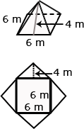
Differentiation/Accommodations/Modifications
Gifted and Talented |  | English Language Learners |  | Students with Disabilities |  | Students at Risk of School Failure
- Students will be given composite figures, made up of rectangles and triangles, to find the area.  - Design and color a new school flag. Must consist of parallelograms, squares, triangles, and rectangles. On the back, students find the area and perimeter of the shapes.  - Write a story that discusses and teaches area, volume, and surface area of rectangles and triangles. |  | - Video clips  - Graphic organizers  development, comprehension  - Read aloud  - Word Wall  - Build background knowledge  - Partner Work  - Word problems in simpler English.  - Manipulative  - For more, see http://www.state.nj.us/education/modelcurriculum/ela/ellscaffolding/3u1.pdf |  | - Extended time  - Modified assignments  - Small group, alternate location  - Real world geometry scenarios  - Modeling  - Read aloud problems  - Calculator  - Build background knowledge  - Oral/visual reminders  - Peer assistance  - Picture associations with vocabulary  - Highlighter to identify shapes  - Reference sheet with picture presentation  - Refer to each student’s IEP for more specific modifications |  | - RTI strategies including: reciprocal teaching, teacher modeling,  - Tier II and Tier III intervention  - More frequent STAR assessments  - Morning tutoring  - After school program  - Parental contact

Math Curriculum
Grade Six

Content: Statistics and Probability
Essential Question(s):
How can you describe a statistical graph using appropriate vocabulary?
What is a statistical question?
What is a distribution?
What is the difference between the center and the spread of a numerical set?
How are data sets described?
Standards: 6. SP
A. Develop understanding of statistical variability.
Vocabulary: statistics, statistical questions, variability, data sets, clusters, gaps, peaks, measures of center, survey, symmetry
Standards for Mathematical Practice: MP 2, MP 4, MP 6
Grade Specific Standard | Skills | Instructional Procedures | Explanations and Examples
1. Recognize a statistical question as one that anticipates variability in the data related to the question and accounts for it in the answers. For example, “How old am I?” is not a statistical question, but “How old are the students in my school?” is a statistical question because one anticipates variability in students’ ages.  (MP 2, MP 6) | - Recognize a statistical question as one that anticipates variability in the data related to the question and accounts for it in the answers. | - Introduce and define statistical questions  - Provide examples and non-examples and then have students create their own original examples of statistical questions | Statistics are numerical data relating to an aggregate of individuals; statistics is also the name for the science of collecting, analyzing and interpreting such data. A statistical question anticipates an answer that varies from one individual to the next and is written to account for the variability in the data. Data are the numbers produced in response to a statistical question. Data are frequently collected from surveys or other sources (i.e. documents).  Questions can result in a narrow or wide range of numerical values. For example, asking classmates “How old are the students in my class in years?” will result in less variability than asking “How old are the students in my class in months?”  Students might want to know about the fitness of the students at their school. Specifically, they want to know about the exercise habits of the students. So rather than asking "Do you exercise?" they should ask about the amount of exercise the students at their school get per week. A statistical question for this study could be: “How many hours per week on average do students at Jefferson Middle School exercise?”  To collect this information, students might design a survey question that anticipates variability by providing a variety of possible anticipated responses that have numerical answers, such as: 3 hours per week, 4 hours per week, and so on. Be sure that students ask questions that have specific numerical answers.
2. Understand that a set of data collected to answer a statistical question has a distribution which can be described by its center, spread, and overall shape.  (MP 4) | - Understand that a set of data collected to answer a statistical question has a distribution which can be described by its center, spread, and overall shape. | ∙ Introduce vocabulary  and use these new terms to describe graphs that represent data sets | The two dot plots show the 6-trait writing scores for a group of students on two different traits, organization and ideas. The center, spread and overall shape can be used to compare the data sets. Students consider the context in which the data were collected and identify clusters, peaks, gaps, and symmetry. Showing the two graphs vertically rather than side by side helps students make comparisons. For example, students would be able to see from the display of the two graphs that the ideas scores are generally higher than the organization scores. One observation students might make is that the scores for organization are clustered around a score of 3 whereas the scores for ideas are clustered around a score of 5.  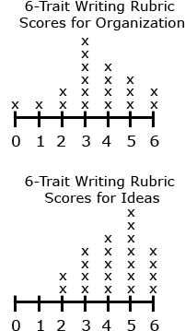
3. Recognize that a measure of center for a numerical data set summarizes all of its values with a single number, while a measure of variation describes how its values vary with a single number.  (MP 4) | - Recognize that a measure of center for a numerical data set summarizes all of its values with a single number, while a measure of variation describes how its values vary with a single number. | - Use a graph to find the measures of center and range | When using measures of center (mean, median, and mode) and range, students are describing a data set in a single number. The range provides a single number that describes how the values vary across the data set. The range can also be expressed by stating the minimum and maximum values.  Example:  - Consider the data shown in the dot plot of the six trait scores for organization for a group of students.  - How many students are represented in the data set?  - What are the mean, median, and mode of the data set? What do these values mean? How do they compare?  - What is the range of the data? What does this value mean?

Differentiation/Accommodations/Modifications
Gifted and Talented | English Language Learners | Students with Disabilities | Students at Risk of School Failure
- Students will conduct their own statistical research and create a graph to display their data. | - Video clips  - Graphic organizers  development, comprehension  - Read aloud  - Word Wall  - Build background knowledge  - Partner Work  - Word problems in simpler English.  - Manipulative  - Sentence Frame  - For more, see http://www.state.nj.us/education/modelcurriculum/ela/ellscaffolding/3u1.pdf | - Extended time  - Modified assignments  - Small group, alternate location  - Real world geometry scenarios  - Modeling  - Read aloud problems  - Calculator  - Build background knowledge  - Oral/visual reminders  - Peer assistance  - Sentence Frame  - Picture associations with vocabulary  - Refer to each student’s IEP for more specific modifications | - RTI strategies including: reciprocal teaching, teacher modeling,  - Tier II and Tier III intervention  - More frequent STAR assessments  - Morning tutoring  - After school program  - Parental contact

Math Curriculum
Grade Six

Content: Statistics and Probability
Essential Question(s):
How do you correctly gather and analyze data and use data to compute statistics?
How do measure of center and variability help us make sense of the world around us?
In what context are the measures of center and variability preferred description of the data?
Why do we need multiple ways of describing numerical data?
Standards: 6.SP.
B. Summarize and describe distributions.
Vocabulary: dot plots, histograms, box plot, frequency table, quartile, range, measures of center, absolute deviation, outlier, skew
Standards for Mathematical Practice: MP 2, MP 4, MP 5

Grade Specific Standards | Skills |  | Instructional Procedures |  | Explanations and Examples
4. Display numerical data in plots on a number line, including dot plots, histograms, and box plots.  (MP 4) | - Construct dot plots, histograms, and box plots. |  | - Read and create various graphs |  | In order to display numerical data in dot plots, histograms or box plots, students need to make decisions and perform calculations. Students are expected to display data graphically in a format appropriate for that data set as well as reading data from graphs generated by other students or contained in reference materials. Students can use applets to create data displays. Examples of applets include the Box Plot Tool and Histogram Tool on NCTM’s Illuminations.  Box Plot Tool - http://illuminations.nctm.org/ActivityDetail.aspx?ID=77  Histogram Tool -- http://illuminations.nctm.org/ActivityDetail.aspx?ID=78  Dot plots are simple plots on a number line where each dot represents a piece of data in the data set. Dot plots are suitable for small to moderate size data sets and are useful for highlighting the distribution of the data including clusters, gaps, and outliers.  In most real data sets, there is a large amount of data and many numbers will be unique. A graph (such as a dot plot) that shows how many ones, how many twos, etc. would not be meaningful; however, a histogram can be used. Students organize the data into convenient ranges and use these intervals to generate a frequency table and histogram. Note that changing the size of the range changes the appearance of the graph and the conclusions you may draw from it.  Box plots are another useful way to display data and are plotted horizontally or vertically on a number line. Box plots are generated from the five number summary of a data set consisting of the minimum, maximum, median, and two quartile values. Students can readily compare two sets of data if they are displayed with side by side box plots on the same scale. Box plots display the degree of spread of the data and the extent to which the data are skewed.  Examples:  - Nineteen students completed a writing sample that was scored using the six traits rubric. The scores for the trait of organization were 0, 1, 2, 2, 3, 3, 3, 3, 3, 3, 4, 4, 4, 4, 5, 5, 5, 6, 6. Create a data display. What are some observations that can be made from the data display?  - Grade 6 students were collecting data for a math class project. They decided they would survey the other two grade 6 classes to determine how many DVDs each student owns. A total of 38 students were surveyed. The data are shown in the table below in no specific order. Create a data display. What are some observations that can be made from the data display?  11 21 5 12 10 31 19 13 23 33  10 11 25 14 34 15 14 29 8 5  22 26 23 12 27 4 25 15 7  2 19 12 39 17 16 15 28 16  A histogram using 5 ranges (0-9, 10-19, …30-39) to organize the data is displayed below.  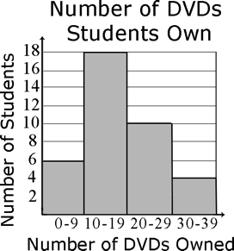  - Ms. Wheeler asked each student in her class to write their age in months on a sticky note. The 28 students in the class brought their sticky notes to the front of the room and posted them in order on the white board. The data set is listed below in order from least to greatest. Create a data display. What are some observations that can be made from the data display?  130 130 131 131 132 132 132 133 134 136  137 137 138 139 139 139 140 141 142 142  142 143 143 144 145 147 149 150  Five number summary  Minimum – 130 months  Quartile 1 (Q1) – (132 + 133) ÷ 2 = 132.5 months  Median (Q2) – 139 months  Quartile 3 (Q3) – (142 + 143) ÷ 2 = 142.5 months  Maximum – 150 months  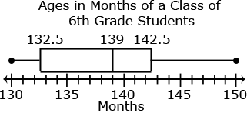  This box plot shows that  - ¼ of the students in the class are from 130 to 132.5 months old  - ¼ of the students in the class are from 142.5 months to 150 months old  - ½ of the students in the class are from 132.5 to 142.5 months old  - The median class age is 139 months.
5. Summarize numerical data sets in relation to their context, such as by:  5a: Reporting the number of observations.  5b: Describing the nature of the attribute under investigation, including how it was measured and its units of measurement.  5c: Giving quantitative measures of center (median and/or mean) and variability (interquartile range and/or mean absolute deviation), as well as describing any overall pattern and any striking deviations from the overall pattern with reference to the context in which the data were gathered.  5d: Relating the choice of measures of center and variability to the shape of the data distribution and the context in which the data were gathered.  (MP 2, MP 4, MP 5) | - Summarize numerical data by:  - Reporting the number of observations.  - Describing the nature of the attribute under investigation, including how it was measured and its units of measurement  - Giving quantitative measures of center (median and/or mean)  - Giving quantitative measures of variability (interquartile range and/or mean absolute deviation)  - Describing any overall pattern and any striking deviations from the overall pattern with reference to the context in which the data were gathered.  - Relating the choice of measures of center and variability to the shape of the data distribution and the context in which the data were gathered. |  | - Choose an appropriate measure of center based on the given data set  - Determine how you collect and conduct a survey  - Find the measures of center and variability and describe patterns  - Use the best measures of center to describe the data |  | Students summarize numerical data by providing background information about the attribute being measured, methods and unit of measurement, the context of data collection activities, the number of observations, and summary statistics. Summary statistics include quantitative measures of center, spread, and variability including extreme values (minimum and maximum), mean, median, mode, range, quartiles, interquartile ranges, and mean absolute deviation.  The measure of center that a student chooses to describe a data set will depend upon the shape of the data distribution and context of data collection. The mode is the value in the data set that occurs most frequently. The mode is the least frequently used as a measure of center because data sets may not have a mode, may have more than one mode, or the mode may not be descriptive of the data set. The mean is a very common measure of center computed by adding all the numbers in the set and dividing by the number of values. The mean can be affected greatly by a few data points that are very low or very high. In this case, the median or middle value of the data set might be more descriptive. In data sets that are symmetrically distributed, the mean and median will be very close to the same. In data sets that are skewed, the mean and median will be different, with the median frequently providing a better overall description of the data set.  Understanding the Mean  The mean measures center in the sense that it is the value that each data point would take on if the total of the data values were redistributed equally, and also in the sense that it is a balance point. Students develop understanding of what the mean represents by redistributing data sets to be level or fair. The leveling process can be connected to and used to develop understanding of the computation of the mean.  For example, students could generate a data set by measuring the number of jumping jacks they can perform in 5 seconds, the length of their feet to the nearest inch, or the number of letters in their names. It is best if the data generated for this activity are 5 to 10 data points which are whole numbers between 1 and 10 that are easy to model with counters or stacking cubes.  Students generate a data set by drawing eight student names at random from the popsicle stick cup. The number of letters in each of the names is used to create the data set. If the names drawn were Carol, Mike, Maria, Luis, Monique, Sierra, John, and Karen there would be 3 names with 4 letters each, 3 names with 5 letters each, 1 name with 6 letters and 1 name with 7 letters.  This data set could be represented with stacking cubes.  Students can model the mean by “leveling” the stacks or distributing the blocks so the stacks are “fair.” Students are seeking to answer the question, “If all of the students had the same number of letters in their name, how many letters would each person have?”  One block from the stack of six and two blocks from the stack of 7 can be moved down to the stacks of 4 and then all the stacks have five blocks. If all students had the same number of letters in their name, they would have five letters. The mean number of letters in a name in this data set is 5.  If it was not possible to make the stacks exactly even, students could begin to consider what part of the extra blocks each stack would have.  Understanding Mean Absolute Deviation  The use of mean absolute deviation in 6th grade is mainly exploratory. The intent is to build a deeper understanding of variability. Students would understand the mean distance between the pieces of data and the mean of the data set expresses the spread of the data set. Students can see that the larger the mean distance, the greater the variability. Comparisons can be made between different data sets.  In the previous data set, the names drawn were Carol, Mike, Maria, Luis, Monique, Sierra, John, and Karen. There were 3 names with 4 letters each, 3 names with 5 letters each, 1 name with 6 letters and 1 name with 7 letters. This data can be represented on a dot plot. The mean of the data set is 5.  3  4  5  6  7  8  To find the mean absolute deviation, students examine each of the data points and its difference from the mean. This analysis can be represented on the dot plot itself or in a table. Each of the names with 4 letters has one fewer letter than the mean, each of the names with 5 letters has zero difference in letters as compared to the mean, each of the names with 6 letters has one more letter than the mean, and each of the names with 7 letters has two more letters than the mean. The absolute deviations are the absolute value of each difference.  3  4  5  6  7  8  -1  -1  -1  0  0  0  +1  +2  Deviations from the mean  3  4  5  6  7  8  1  1  1  0  0  0  1  2  Absolute Deviations  Name Number of letters in a name Deviation from the Mean Absolute Deviation from the Mean  John 4 -1 1  Luis 4 -1 1  Mike 4 -1 1  Carol 5 0 0  Maria 5 0 0  Karen 5 0 0  Sierra 6 +1 1  Monique 7 +2 2  Total 40 0 6  The mean of the absolute deviations is found by summing the absolute deviations and dividing by the number of data points. In this case, the mean absolute deviation would be 6 ÷ 8 or ¾ or 0.75. The mean absolute deviation is a small number, indicating that there is little variability in the data set.  Consider a different data set also containing 8 names. If the names were Sue, Joe, Jim, Amy, Sabrina, Monique, Timothy, and Adelita. Summarize the data set and its variability. How does this compare to the first data set?  The mean of this data set is still 5. 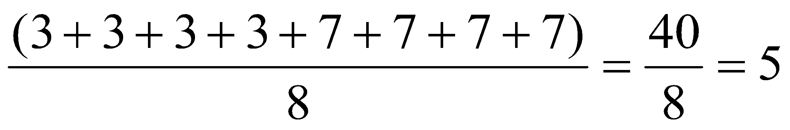  Name Number of letters in a name Deviation from the Mean Absolute Deviation from the Mean  Sue 3 -2 2  Joe 3 -2 2  Jim 3 -2 2  Amy 3 -2 2  Sabrina 7 +2 2  Timothy 7 +2 2  Adelita 7 +2 2  Monique 7 +2 2  Total 40 0 16  The mean deviation of this data set is 16 ÷ 8 or 2. Although the mean is the same, there is much more variability in this data set.  Understanding Medians and Quartiles  Students can also summarize and describe the center and variability in data sets using the median and a five number summary consisting of the minimum, quartiles, and maximum as seen in the box plot example in 6.SP.4. The median is the middle number of the data set with half the number below the median and half the numbers above the median. The quartiles partition the data set into four parts by dividing each of the halves of the data set into half again. Quartile 1 (Q1 or the lower quartile) is the middle value of the lower half of the data set and quartile 3 (Q3 or the upper quartile) is the middle value of the upper half of the data set. The median can also be referred to as quartile 2 (Q2). The range of the data is the difference between the minimum and maximum values. The interquartile range of the data is the difference between the lower and upper quartiles (Q3 – Q1). The interquartile range is a measure of the dispersion or spread of the data set: a small value indicates values that are clustered near the median whereas a larger value indicates values that are more distributed.  Consider the first data set again. Recall that the names drawn were Carol, Mike, Maria, Luis, Monique, Sierra, John, and Karen. The data set can be represented in a numerical list. To find the median and quartile, the values are placed in order from least to greatest.  5 4 5 4 7 6 4 5 4 4 4 5 5 5 6 7  The middle value in the ordered data set is the median. If there are an even number of values, the median is the mean of the middle two values. In this case, the median would be 5 because 5 is the average of the 4th and 5th values which are both 5. Students find quartile 1 (Q1) by examining the lower half of the data. Again there are 4 values which is an even number of values. Q1 would be the average of the 2nd and 3rd value in the data set or 4. Students find quartile 3 (Q3) by examining the upper half of the data. Q3 would be the average of the 6th and 7th value in the data set or 5.5. The mean of the data set was 5 and the median is also 5, showing that the values are probably clustered close to the mean. The interquartile range is 1.5 (5.5 – 4). The interquartile range is small, showing little variability in the data.  Median = 5  Q1 = 4  Q3 = 5.5  4 4 4 5 5 5 6 7
Differentiation/Accommodations/Modifications
Gifted and Talented |  | English Language Learners |  | Students with Disabilities |  | Students at Risk of School Failure
- Given a set of data, the students will create three displays.  - Students will create questions pertaining to data for other students to answer.  - Illustrative Mathematics- Electoral College |  | - Video clips  - Graphic organizers  development, comprehension  - Read aloud  - Word Wall  - Build background knowledge  - Partner Work  - Word problems in simpler English.  - Manipulative  - For more, see http://www.state.nj.us/education/modelcurriculum/ela/ellscaffolding/3u1.pdf |  | - Extended time  - Modified assignments  - Small group, alternate location  - Real world geometry scenarios  - Modeling  - Read aloud problems  - Calculator  - Build background knowledge  - Oral/visual reminders  - Peer assistance  - Graphic Organizer  - Picture associations with vocabulary  - Written steps for completion.  - Refer to each student’s IEP for more specific modifications |  | - RTI strategies including: reciprocal teaching, teacher modeling,  - Tier II and Tier III intervention  - More frequent STAR assessments  - Morning tutoring  - After school program  - Parental contact

